Trigonometry: Practice test 3
Year 9 Maths · Test · Test 3
Name: ____________________ Date: ______________
Time: 45 minutes
Total: 40 marks
Show your working in the boxes. Then write each final answer on the answer sheet on the last page. Diagrams marked “Not to scale” are not drawn accurately. In Section B, round each answer as the question asks.

 Section A: No calculator
- Use the right-angled triangle to answer each part.
- 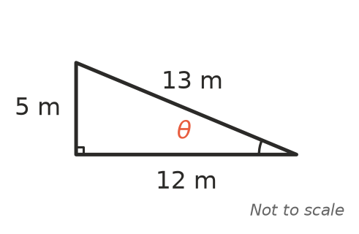
  - Which length is adjacent to the angle $θ$? (1 mark)

  - Write $sinθ$ as a fraction. (1 mark)

  - Write $cosθ$ as a fraction. (1 mark)

  - Write $tanθ$ as a fraction. (1 mark)

- This right-angled triangle has two acute angles, $θ$ and $ϕ$. Write each ratio as a fraction.
- 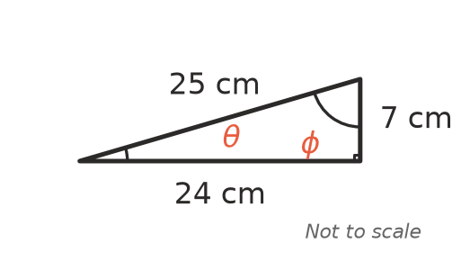
  - $tanθ$ (1 mark)

  - $tanϕ$ (1 mark)

  - $sinϕ$ (1 mark)

- Find the exact length of the hypotenuse, x. Leave your answer as a square root. (2 marks)
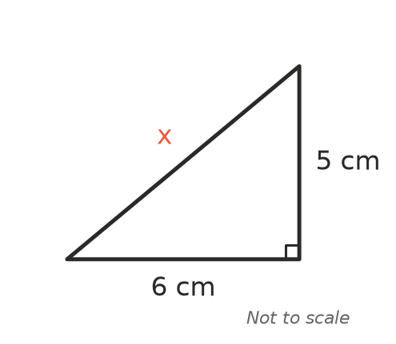

- Find the exact value of x. Leave your answer as a square root. (2 marks)
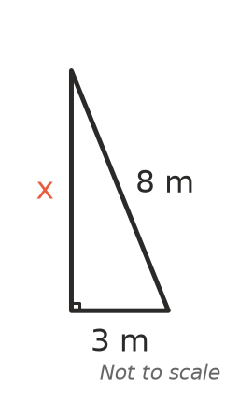

- Ben says he can draw a triangle with sides of 6 cm, 10 cm and 16 cm. Is he right? Explain your answer. (2 marks)

- At the same time of day, a 2 m stick standing straight up casts a shadow 1.5 m long, and a gum tree casts a shadow 9 m long. The sun’s rays make the same angle with the ground in both triangles.
- 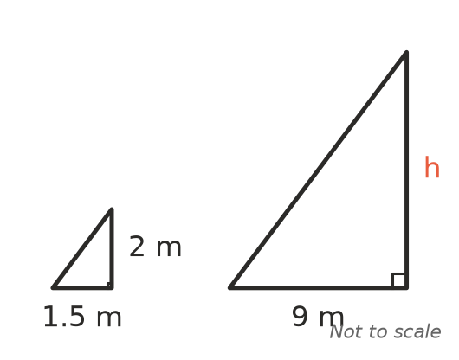
- Find the height of the tree, h. (2 marks)

- You are told that $cos{60}^{∘}$ = 0.5. Use this to find the value of x. (2 marks)
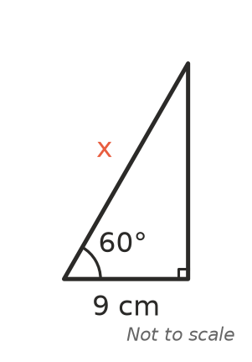

- Which equation is correct for this triangle? Answer: ______________ (1 mark)
- 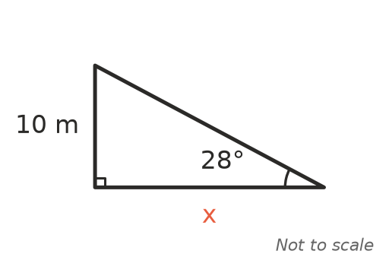
  - x = 10 $tan{28}^{∘}$
  - x = 10 $cos{28}^{∘}$
  - x = $\frac{10}{tan{28}^{∘}}$
  - x = $\frac{10}{sin{28}^{∘}}$

- Write an equation that you could use to find the angle $θ$. You do not need to solve it. (1 mark)
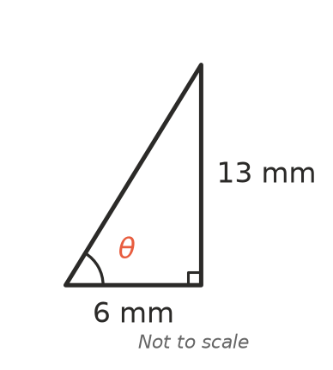

- Ava stands at the top of a building and Sam stands on the flat ground nearby. The angle of elevation of Ava from Sam is 37°.
- 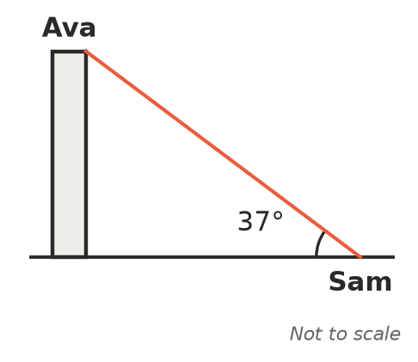
  - What is the angle of depression of Sam from Ava? (1 mark)

  - What is the angle between the vertical wall of the building and Ava’s line of sight to Sam? (1 mark)

- For an acute angle $θ$ in a right-angled triangle, $sinθ=\frac{12}{13}$. Find the exact values of $cosθ$ and $tanθ$. (2 marks)

- Lily says: “If I make every side of a right-angled triangle twice as long, then $sinθ$ will be twice as big.” Explain why Lily is wrong. (2 marks)

- A phone screen is a rectangle 8 cm long and 4 cm wide. Find the exact length of its diagonal. Leave your answer as a square root. (2 marks)

 Section B: Calculator allowed
- Find the value of x, correct to 1 decimal place. (2 marks)
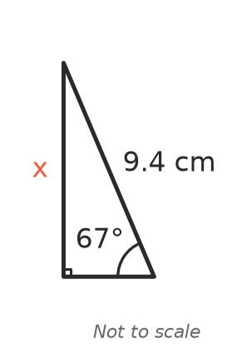

- Find the value of x, correct to 2 decimal places. (2 marks)
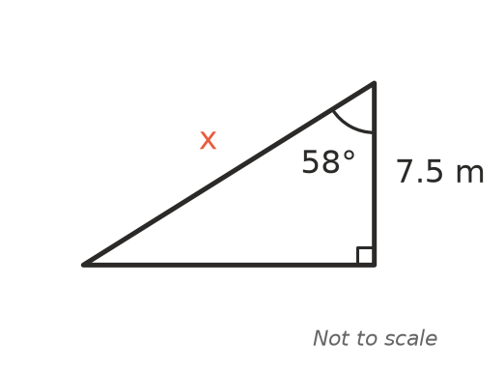

- Find the size of the angle $θ$, correct to the nearest degree. (2 marks)
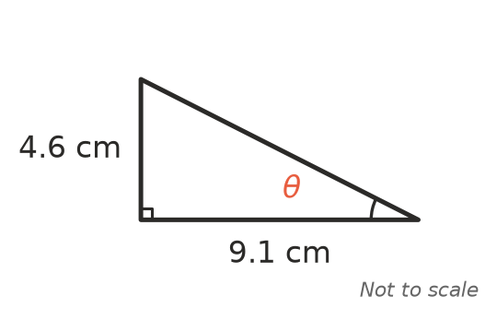

- Sophie stands 55 m from the base of a radio mast. Her eyes are 1.6 m above the ground. The angle of elevation of the top of the mast from her eyes is 41°. Find the height of the mast, correct to 1 decimal place. (3 marks)
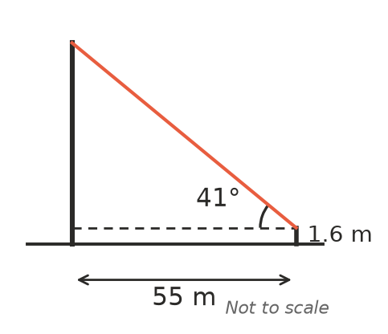

- A plane flying at a height of 2400 m begins its descent. The pilot sees the start of the runway at an angle of depression of 9°. Find the horizontal distance from the plane to the start of the runway, in kilometres, correct to 1 decimal place. (2 marks)

- The sloping surface of a boat ramp at the beach is 9 m long. The ramp rises 1.2 m from the water’s edge to the top. Find the angle the ramp makes with the horizontal, correct to 1 decimal place. (2 marks)

 Answer sheet
Name: ____________________
Write your final answer for each question in the table.
Question | Answer | Marks | Question | Answer | Marks
1a |  | /1 | 9 |  | /1
1b |  | /1 | 10a |  | /1
1c |  | /1 | 10b |  | /1
1d |  | /1 | 11 |  | /2
2a |  | /1 | 12 |  | /2
2b |  | /1 | 13 |  | /2
2c |  | /1 | 14 |  | /2
3 |  | /2 | 15 |  | /2
4 |  | /2 | 16 |  | /2
5 |  | /2 | 17 |  | /3
6 |  | /2 | 18 |  | /2
7 |  | /2 | 19 |  | /2
8 |  | /1
 |  |  |  | Total | /40

