Trigonometry: Practice test 2
Year 9 Maths · Test · Test 2
Name: ____________________ Date: ______________
Time: 45 minutes
Total: 40 marks
Show your working in the boxes. Then write each final answer on the answer sheet on the last page. Diagrams marked “Not to scale” are not drawn accurately. In Section B, round each answer as the question asks.

 Section A: No calculator
- The sides of this right-angled triangle are labelled p, q and r. It has two acute angles, $θ$ and $ϕ$.
- 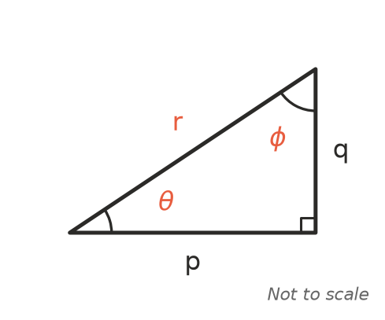
  - Which side is the hypotenuse? (1 mark)

  - Which side is opposite the angle $θ$? (1 mark)

  - Which side is opposite the angle $ϕ$? (1 mark)

- Write each ratio for the angle $θ$ as a fraction.
- 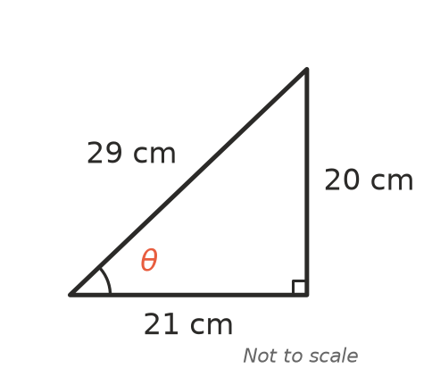
  - $sinθ$ (1 mark)

  - $cosθ$ (1 mark)

  - $tanθ$ (1 mark)

- Find the exact length of the hypotenuse, x. Leave your answer as a square root. (2 marks)
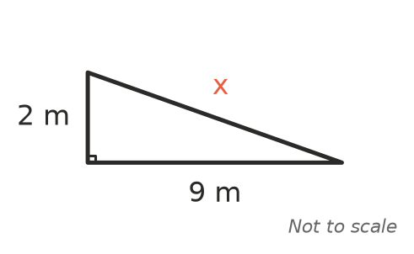

- Find the exact value of x. Leave your answer as a square root. (2 marks)
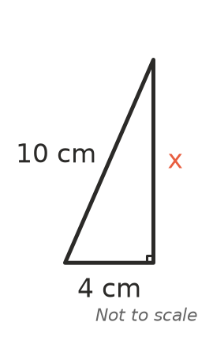

- Two sides of a triangle are 5 cm and 9 cm long. The third side is a whole number of centimetres.
  - What is the shortest the third side could be? (1 mark)

  - What is the longest the third side could be? (1 mark)

- Tomas draws three right-angled triangles. Each one has an angle of 50°. He measures the side opposite the 50° angle and the side adjacent to it.
Triangle | Adjacent side (cm) | Opposite side (cm)
A | 2 | 2.4
B | 5 | 6
C | 8

  - Find the missing opposite side for triangle C. (1 mark)

  - Use the table to estimate $tan{50}^{∘}$ as a decimal. (1 mark)

- You are told that $tan{60}^{∘}$ ≈ 1.73. Use this to find the value of x. (2 marks)
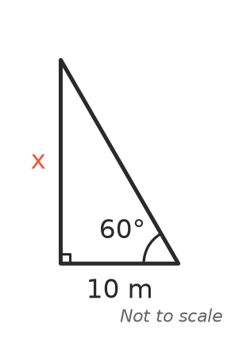

- Which equation is correct for this triangle? Answer: ______________ (1 mark)
- 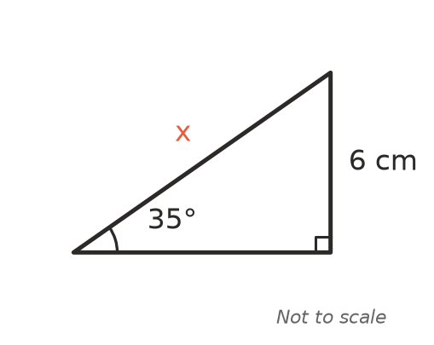
  - x = 6 $sin{35}^{∘}$
  - x = $\frac{6}{sin{35}^{∘}}$
  - x = $\frac{6}{cos{35}^{∘}}$
  - x = 6 $tan{35}^{∘}$

- Write an equation that you could use to find the angle $θ$. You do not need to solve it. (1 mark)
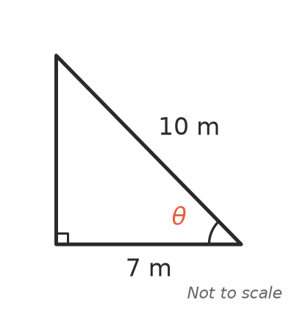

- From the top of a cliff, Ruby sees a boat, B. The angle of depression of the boat is 32°.
- 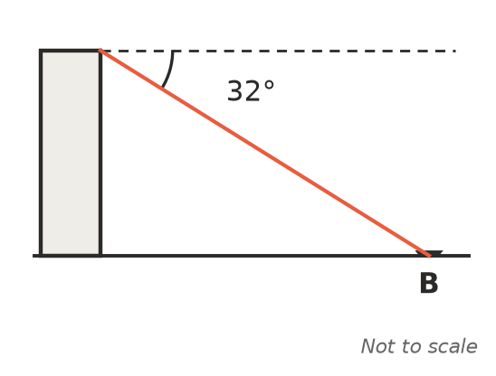
  - What is the angle between the vertical cliff face and Ruby’s line of sight to the boat? (1 mark)

  - What is the angle of elevation of the top of the cliff from the boat? (1 mark)

- For an acute angle $θ$ in a right-angled triangle, $cosθ=\frac{2}{3}$. Find the exact value of $sinθ$. (2 marks)

- Ella says that for one of the angles in her right-angled triangle, $sinθ$ = 1.2. Explain why Ella must have made a mistake. (2 marks)

- A rectangular garden bed is 6 m long and 3 m wide. Find the exact length of its diagonal. Leave your answer as a square root. (2 marks)

 Section B: Calculator allowed
- Find the value of x, correct to 1 decimal place. (2 marks)
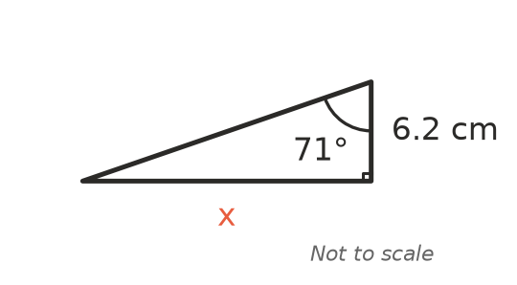

- Find the value of x, correct to 1 decimal place. (2 marks)
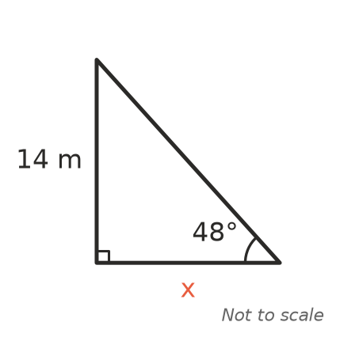

- Use the triangle to answer each part.
- 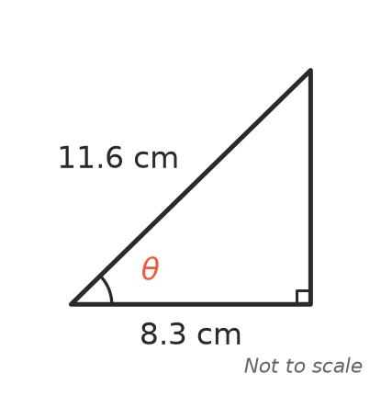
  - Find the size of the angle $θ$, correct to the nearest degree. (2 marks)

  - Use your answer to part a to find the size of the third angle of the triangle. (1 mark)

- A ladder 5.5 m long leans against the wall of a house. It makes an angle of 72° with the flat ground. How far up the wall does the ladder reach? Give your answer correct to 2 decimal places. (2 marks)

- On a road trip, a straight road climbs a hill at an angle of 6° to the horizontal. A car drives 850 m along the road. How much height does the car gain? Give your answer correct to 1 decimal place. (2 marks)

- A firefighting helicopter hovers 150 m above flat ground. The pilot sees two small fires, A and B, in a straight line on the same side of the helicopter. The angle of depression of fire A is 52° and the angle of depression of fire B is 31°. How far apart are the two fires? Give your answer correct to the nearest metre. (3 marks)
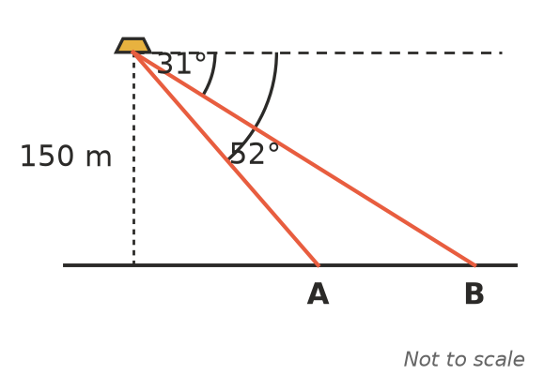

 Answer sheet
Name: ____________________
Write your final answer for each question in the table.
Question | Answer | Marks | Question | Answer | Marks
1a |  | /1 | 9 |  | /1
1b |  | /1 | 10a |  | /1
1c |  | /1 | 10b |  | /1
2a |  | /1 | 11 |  | /2
2b |  | /1 | 12 |  | /2
2c |  | /1 | 13 |  | /2
3 |  | /2 | 14 |  | /2
4 |  | /2 | 15 |  | /2
5a |  | /1 | 16a |  | /2
5b |  | /1 | 16b |  | /1
6a |  | /1 | 17 |  | /2
6b |  | /1 | 18 |  | /2
7 |  | /2 | 19 |  | /3
8 |  | /1
 |  |  |  | Total | /40

