Trigonometry: Practice test 1
Year 9 Maths · Test · Test 1
Name: ____________________ Date: ______________
Time: 45 minutes
Total: 40 marks
Show your working in the boxes. Then write each final answer on the answer sheet on the last page. Diagrams marked “Not to scale” are not drawn accurately. In Section B, round each answer as the question asks.

 Section A: No calculator
- Use the right-angled triangle XYZ to answer each part.
- 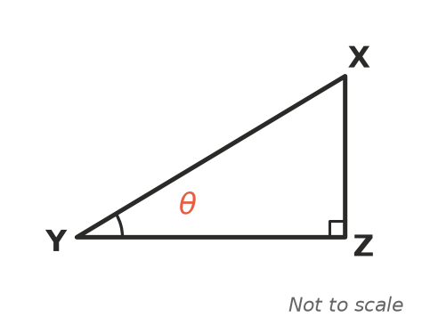
  - Which side is the hypotenuse? (1 mark)

  - Which side is opposite the angle $θ$? (1 mark)

  - Which side is adjacent to the angle $θ$? (1 mark)

- Write each ratio for the angle $θ$ as a fraction in simplest form.
- 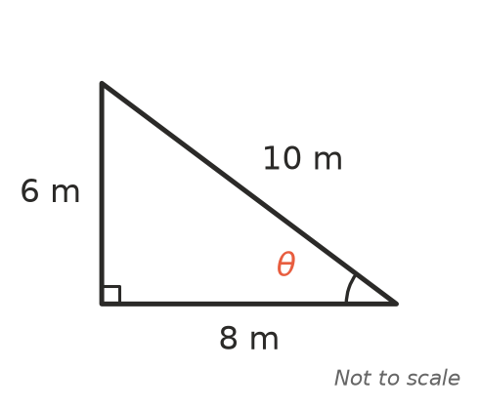
  - $sinθ$ (1 mark)

  - $cosθ$ (1 mark)

  - $tanθ$ (1 mark)

- Find the exact length of the hypotenuse, x. Leave your answer as a square root. (2 marks)
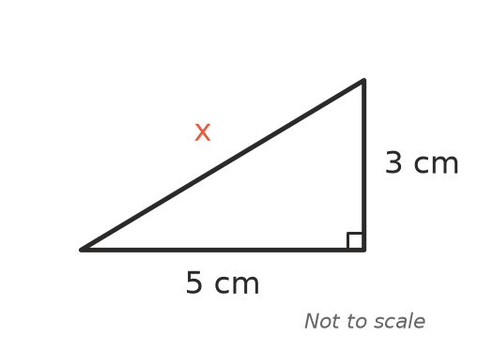

- Find the exact value of x. Leave your answer as a square root. (2 marks)
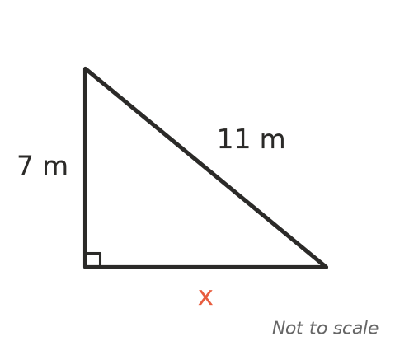

- Can three sticks of length 3 cm, 8 cm and 4 cm be joined end to end to make a triangle? Explain your answer. (2 marks)

- These two right-angled triangles have the same angle $θ$.
- 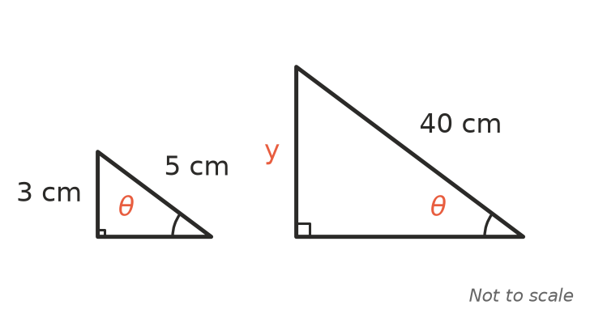
  - Use the small triangle to find the value of $sinθ$ as a decimal. (1 mark)

  - Use your answer to part a to find the value of y in the large triangle. (1 mark)

- You are told that $sin{30}^{∘}=\frac{1}{2}$. Use this to find the value of x. (2 marks)
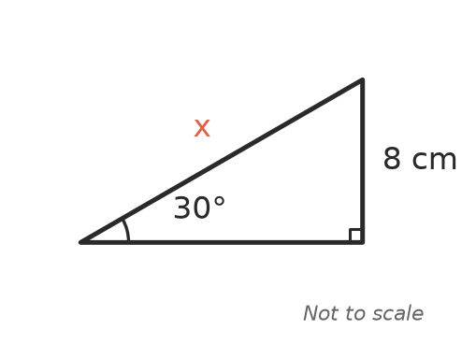

- Which equation is correct for this triangle? Answer: ______________ (1 mark)
- 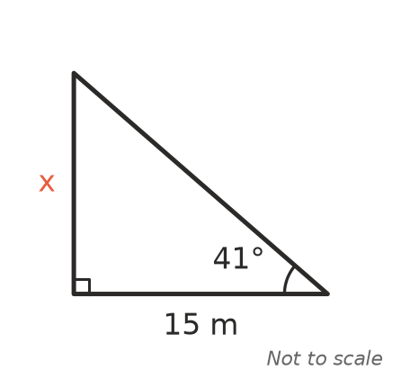
  - x = 15 $sin{41}^{∘}$
  - x = 15 $cos{41}^{∘}$
  - x = 15 $tan{41}^{∘}$
  - x = $\frac{15}{tan{41}^{∘}}$

- Write an equation that you could use to find the angle $θ$. You do not need to solve it. (1 mark)
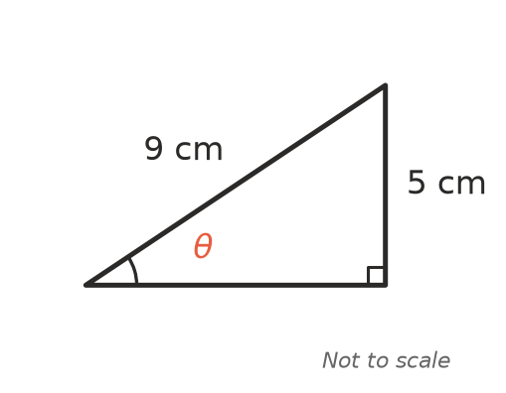

- A drone hovers above a park. The operator of the drone stands at point P. The angle between the horizontal line through the drone and the line from the drone to P is 50°.
- 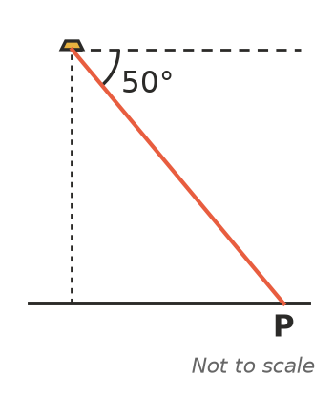
  - Is the 50° angle an angle of elevation or an angle of depression? (1 mark)

  - What is the angle of elevation of the drone from P? (1 mark)

- For an acute angle $θ$ in a right-angled triangle, $sinθ=\frac{8}{17}$. Find the exact value of $tanθ$. (2 marks)

- Josh wants to find x in this triangle. He writes x = 12 $sin{30}^{∘}$ = 6 cm.
- 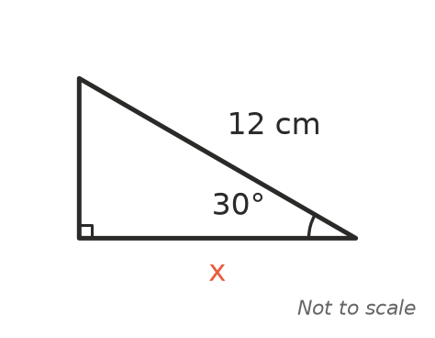
- Explain Josh’s mistake, and write the correct equation for x. (2 marks)

- Without a calculator, explain why $tan{45}^{∘}=1$. A sketch may help. (2 marks)

 Section B: Calculator allowed
- Find the value of x, correct to 1 decimal place. (2 marks)
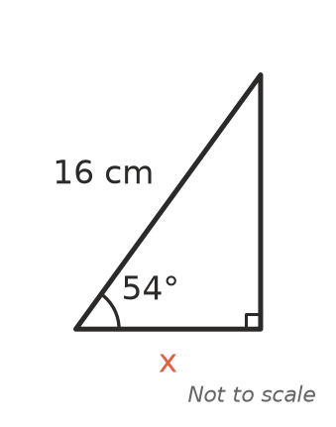

- Find the value of x, correct to 2 decimal places. (2 marks)
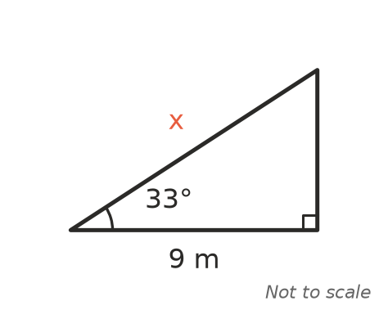

- Find the size of the angle $θ$, correct to the nearest degree. (2 marks)
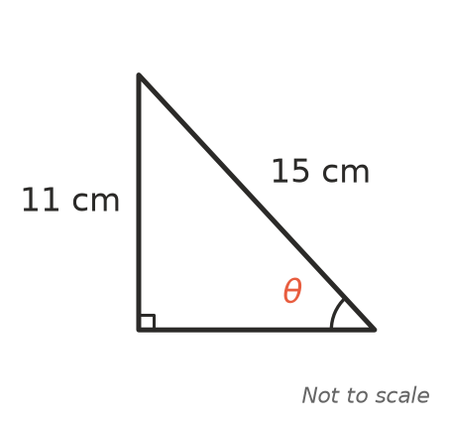

- A flagpole 12 m tall stands on flat ground at the school. It casts a shadow 17 m long. Find the angle of elevation of the sun, correct to the nearest degree. (2 marks)

- From a lookout 85 m above the sea, a fisher sees a boat. The angle of depression of the boat is 14°. How far is the boat from the foot of the cliff below the lookout? Give your answer correct to the nearest metre. (2 marks)

- The front of a garden shed roof is an isosceles triangle. It is 8.4 m wide, and each sloping side makes an angle of 25° with the horizontal.
- 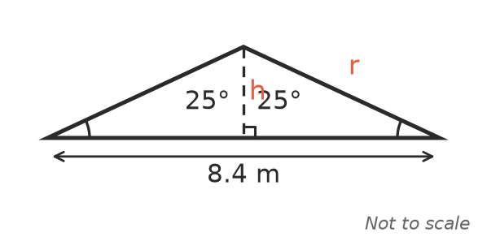
  - Find the height of the roof, h, correct to 1 decimal place. (2 marks)

  - Find the length of each sloping side, r, correct to 2 decimal places. (2 marks)

 Answer sheet
Name: ____________________
Write your final answer for each question in the table.
Question | Answer | Marks | Question | Answer | Marks
1a |  | /1 | 9 |  | /1
1b |  | /1 | 10a |  | /1
1c |  | /1 | 10b |  | /1
2a |  | /1 | 11 |  | /2
2b |  | /1 | 12 |  | /2
2c |  | /1 | 13 |  | /2
3 |  | /2 | 14 |  | /2
4 |  | /2 | 15 |  | /2
5 |  | /2 | 16 |  | /2
6a |  | /1 | 17 |  | /2
6b |  | /1 | 18 |  | /2
7 |  | /2 | 19a |  | /2
8 |  | /1 | 19b |  | /2
 |  |  |  | Total | /40

