8.05 Applications of trigonometry
Year 9 Maths · A5 question sheet · Level 3 · Challenge
This worksheet uses trigonometry to solve multi-step problems with angles of elevation and depression, bearings and speeds. Tip: many of these problems have two right-angled triangles. Label each one, decide which side they share, and keep full calculator values until the final answer. Round lengths to 1 decimal place and angles to the nearest degree.

 Understanding
- Answer each question about angles and bearings.
  - The bearing of Q from P is 125°T. Find the bearing of P from Q.
  - The bearing of S from R is 300°T. Find the bearing of R from S.
  - From the top of a tower, the angle of depression to a car is 37°. What is the angle of elevation from the car to the top of the tower?

 Fluency
- From point A, the angle of elevation to the top of a tower is 30°. Ruby walks 50 m straight towards the tower to point B, where the angle of elevation is 45°. Find the height of the tower, h. Hint: at B, the distance to the tower equals h. Why?
- 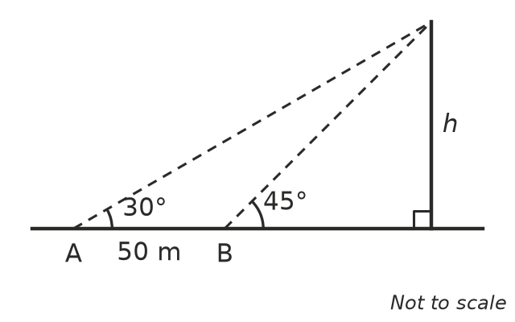
- From the top of a 40 m lighthouse, the angles of depression to two boats P and Q, in a straight line out to sea, are 25° and 15°. Find the distance between the boats, x.
- 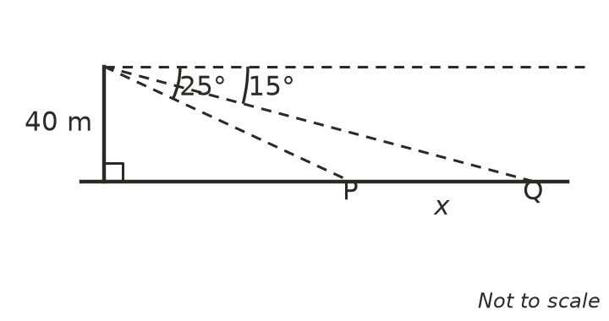
- A ship sails 12 km from port on a bearing of 150°T.
  - How far south of port is the ship?
  - How far east of port is the ship?
  - The ship then sails 8 km due east. How far is it from port now?
  - Find its bearing from port now.
- A hot-air balloon is tied to the ground by a straight 120 m rope. When the rope makes an angle of 64° with the ground, how high is the balloon? The wind picks up and the angle drops to 50°. How far does the balloon drop?

 Reasoning
- Use a diagram with two horizontal lines to explain why the angle of depression from A to B is always equal to the angle of elevation from B to A.
- Explain why the bearing of A from B always differs from the bearing of B from A by exactly 180°.

 Problem solving
- A straight mountain road is 3.2 km long and climbs at an angle of 6° to the horizontal.
  - How many metres higher is the top of the road than the bottom?
  - What horizontal distance does the road cover?
- Liam wants to know the width of a river. He stands at A, directly opposite a tree T on the far bank. He walks 40 m along the bank to B and measures the angle ABT as 58°.
- 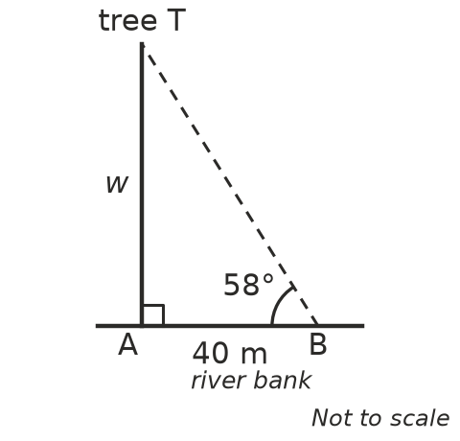
- Find the width of the river, w.
- A plane flies level at a height of 2000 m towards a lighthouse. The angle of depression from the plane to the lighthouse is 20°. Fifteen seconds later it is 35°.
  - How far does the plane fly in the 15 seconds?
  - Find the speed of the plane in kilometres per hour.
- An orienteer runs 600 m on a bearing of 220°T, then turns and runs 800 m on a bearing of 310°T.
  - Explain why her two paths are at right angles.
  - How far is she from her starting point?
  - Find her bearing from her starting point.
- At the same time of day, a person 1.8 m tall casts a shadow 2.5 m long, and a building casts a shadow 30 m long on flat ground.
  - Find the angle of elevation of the sun.
  - Find the height of the building.

