8.05 Applications of trigonometry
Year 9 Maths · A5 question sheet · Level 2 · Core
This worksheet uses trigonometry for real problems with angles of elevation and depression, and true bearings. Tip: draw a diagram with a horizontal line wherever the angle is measured from. The angle of depression from A to B equals the angle of elevation from B to A. Round lengths to 1 decimal place and angles to the nearest degree.

 Understanding
- P is a point on flat ground and T is the top of a building. The dashed line at T is horizontal.
- 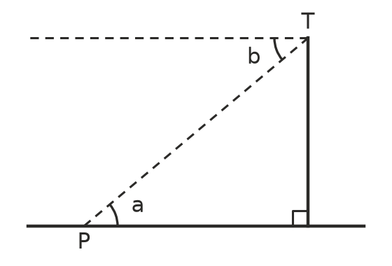
  - Which angle is the angle of elevation of T from P?
  - Which angle is the angle of depression of P from T?
  - Explain why angles a and b are equal.
- True bearings are measured clockwise from north.
  - Write the true bearing of south-west.
  - Write the true bearing of north-west.
  - The bearing of B from A is 060°T. Find the bearing of A from B.

 Fluency
- Lucas stands 35 m from a building on flat ground. His eyes are 1.6 m above the ground, and the angle of elevation from his eyes to the top of the building is 52°.
- 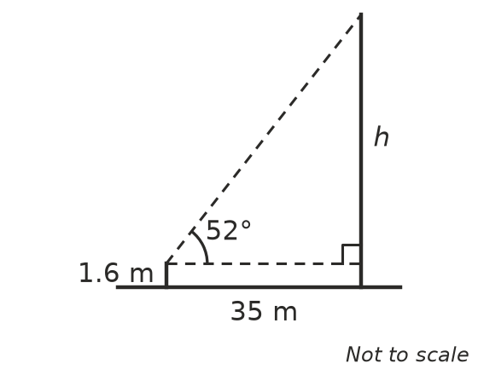
  - Find h.
  - Find the height of the building.
- From the top of an 85 m cliff, the angle of depression to a surfer is 18°. How far is the surfer from the base of the cliff?
- A kite is 30 m above the ground on a straight string 42 m long. Find the angle of elevation of the kite from the hand holding the string, which is at ground level.
- A plane is flying at a height of 1500 m. The pilot sees the start of the runway at an angle of depression of 9°. How far is the plane from the runway horizontally, in kilometres to 1 decimal place?

 Reasoning
- Grace says, “The angle of depression from my balcony to a parked car is 40°, so the angle of elevation from the car to my balcony is 50°.” Is she correct? Explain.
- A tower is 30 m tall. Find the angle of elevation to the top from 30 m away and from 60 m away. Does doubling the distance halve the angle?
- From 30 m: ______________ From 60 m:

 Problem solving
- A ship leaves port and sails 24 km on a bearing of 090°T, then 10 km on a bearing of 180°T.
  - How far is the ship from port?
  - Find the bearing of the ship from port.
- A hiker walks 5 km from camp on a bearing of 040°T to a hut H.
- 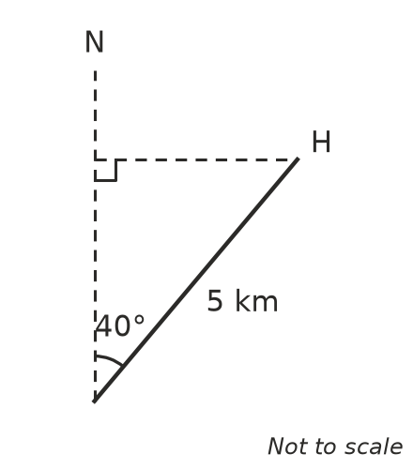
  - How far north of camp is the hut?
  - How far east of camp is the hut?
- Two buildings are 40 m apart. The shorter one is 20 m tall. From its roof, the angle of elevation to the top of the taller building is 28°. How tall is the taller building?
- 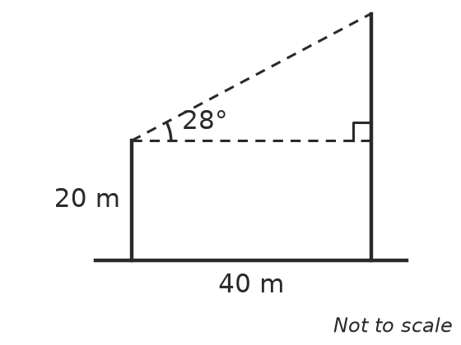
- A wheelchair ramp must make an angle of no more than 5° with the ground. It needs to rise 0.6 m to reach a doorway. What is the shortest horizontal distance the ramp can cover?

