8.05 Applications of trigonometry
Year 9 Maths · A5 question sheet · Level 1 · Warm-up
This worksheet uses trigonometry to solve real problems with angles of elevation and depression, and simple bearings. Tip: an angle of elevation is measured up from the horizontal, and an angle of depression is measured down from the horizontal. Draw a diagram, find the right-angled triangle, then use SOH CAH TOA. Round lengths to 1 decimal place and angles to the nearest degree.

 Understanding
- Look at the two diagrams.
- 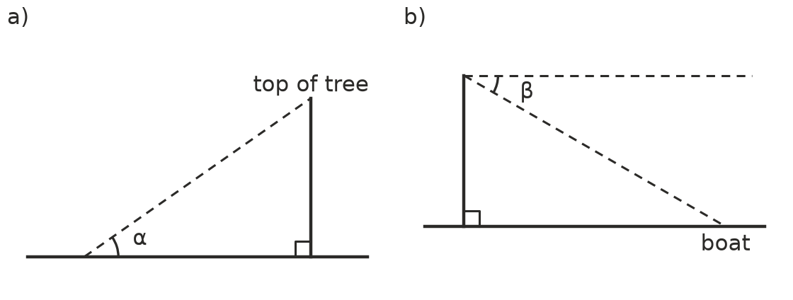
  - Is α an angle of elevation or an angle of depression?
  - Is β an angle of elevation or an angle of depression?
  - Complete: an angle of depression is measured down from the ______________ line.
- From the top of a cliff A, the angle of depression to a boat B is 30°. The dashed line at A is horizontal, so it is parallel to the flat water.
- 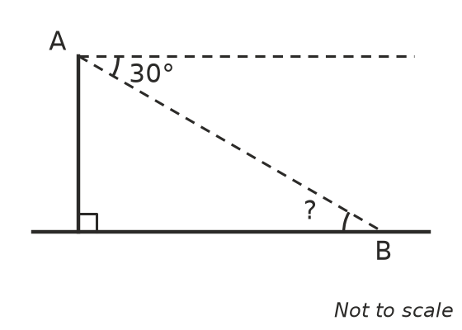
  - What is the angle of elevation from the boat up to A (the angle marked ?)?
  - Why are the two angles equal?

 Fluency
- A person stands 20 m from the base of a tree. The angle of elevation to the top of the tree is 35°. Find the height of the tree, h.
- 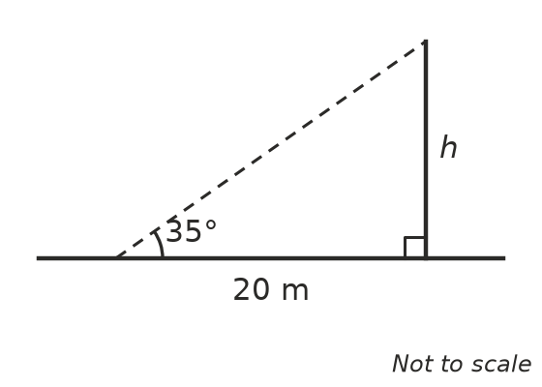
- A cliff is 60 m high. From the top, the angle of depression to a boat is 25°. How far is the boat from the bottom of the cliff, d?
- 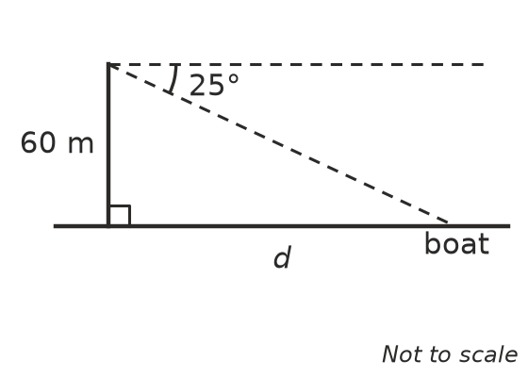
- A flagpole is 12 m tall. Mia stands 18 m from its base on flat ground. Find the angle of elevation from the ground where she stands to the top of the pole.

 Reasoning
- Ethan walks towards a tall building. Does the angle of elevation to the top of the building get bigger or smaller as he gets closer? Explain.
- A true bearing gives a direction as an angle measured clockwise from north, written with three digits and °T. For example, east is 090°T. Write the true bearing of each direction.
  - North
  - South
  - West
  - North-east (halfway between north and east)

 Problem solving
- A drone hovers 45 m above flat ground. From the controller on the ground, the angle of elevation to the drone is 50°. How far is the controller from the point on the ground directly below the drone?
- A lighthouse is 32 m tall. From the top, the angle of depression to a fishing boat is 12°. How far is the boat from the base of the lighthouse?
- Zoe walks 300 m east and then 400 m north.
  - How far is she from her starting point?
  - Find the angle between her straight-line path from the start and the east direction.
  - Use your answer to b to find her true bearing from the starting point.

