8.04 Angles
Year 9 Maths · Worksheet · Level 3 · Challenge
Name: ____________________ Date: ______________
This worksheet uses inverse ratios to find angles in harder problems: exact values, mixed units, two-step problems and shapes. Tip: change all lengths to the same unit before you divide, and when you need a side first, keep its full calculator value. Round angles to the nearest degree.

 Understanding
- Find θ exactly, without a calculator. Use the exact values for 30°, 45° and 60°.
  - $tanθ=\sqrt{3}$ ______________
  - $sinθ=\frac{1}{\sqrt{2}}$ ______________
  - $cosθ=\frac{\sqrt{3}}{2}$ ______________
  - $sinθ$ = 0.5 ______________

 Fluency
- Find θ in each triangle, to the nearest degree. Watch the units.
- 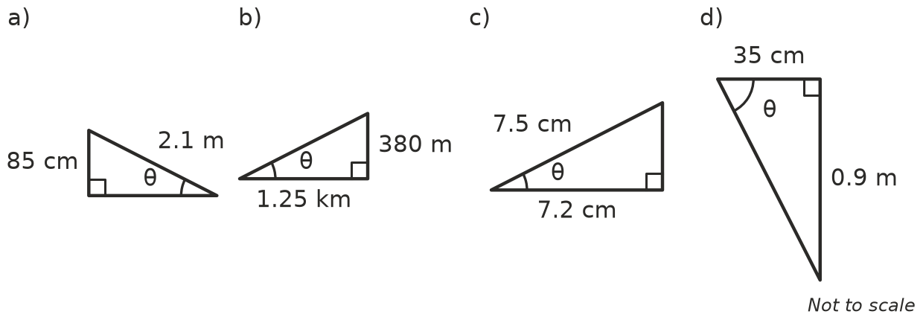
  - θ = ______________
  - θ = ______________
  - θ = ______________
  - θ = ______________
- Find BD, then θ.
- 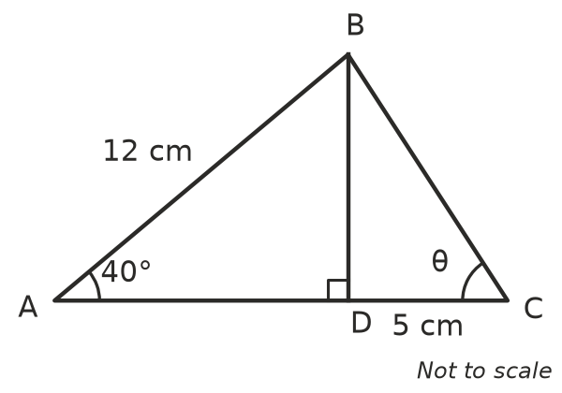
  - BD = ______________ (to 2 decimal places)
  - θ = ______________
- A straight line passes through the points P(−2, 1) and Q(4, 5). Find the angle the line makes with the horizontal. Hint: sketch the right-angled triangle under PQ.

 Reasoning
- Explain why, if $tanθ$ > 1, the angle θ must be more than 45°.

- A triangle has an opposite side of 4 cm and a hypotenuse of 9 cm. Sam types $\sin^{−1}(9÷4)$ and his calculator shows “Math ERROR”.
  - Explain why the calculator gives an error. ______________

  - Find θ correctly. ______________
- A triangle has sides 7, 24 and 25.
  - Find the angle opposite the 7 side, to the nearest degree. ______________
  - Find the other acute angle without using the inverse buttons. Explain your method. ______________

 Problem solving
- A house is 10 m wide. The roof is symmetrical, and its ridge is 2.2 m above the top of the walls. Find the pitch of the roof (the angle the roof makes with the horizontal).

- A rhombus has diagonals of 10 cm and 24 cm. Its diagonals cut each other in half at right angles. Find the four angles of the rhombus, to the nearest degree.

- A rectangular gate is 2 m long and 70 cm high, with a diagonal brace.
  - Find the angle between the brace and the bottom of the gate. ______________
  - A second brace is added along the other diagonal. Find the acute angle between the two braces where they cross. ______________
- A bushwalker follows a straight track 2.4 km long and climbs 310 m in height. At what angle does the track rise?

- A 6 m ladder is safe when it makes an angle between 70° and 80° with the ground.
  - Find the closest and furthest distances the foot of the ladder can be from the wall, to 1 decimal place. ______________

  - The foot of the ladder is placed 1.5 m from the wall. Find the angle it makes with the ground. Is it safe? ______________

