8.04 Angles
Year 9 Maths · A5 question sheet · Level 2 · Core
This worksheet practises finding unknown angles in right-angled triangles with the inverse ratios $\sin^{−1}$, $\cos^{−1}$ and $\tan^{−1}$. Tip: label O, A and H from the angle you want, pick the ratio that uses the two sides you know, and type the whole fraction into the calculator so you don’t round too early. Round angles to the nearest degree.

 Understanding
- For each triangle, write an equation for θ using an inverse ratio, then find θ.
- 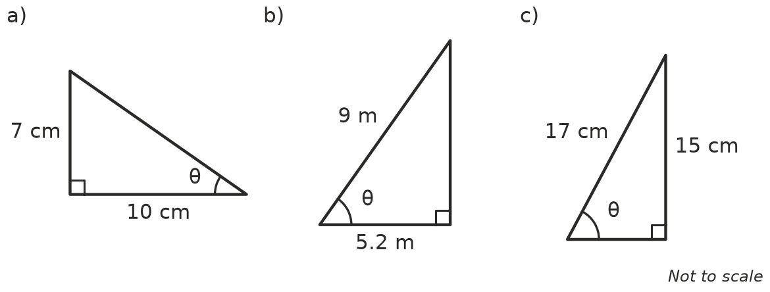
  - θ = ______________ =
  - θ = ______________ =
  - θ = ______________ =

 Fluency
- Find θ to the nearest degree.
  - $sinθ$ = 0.2588
  - $cosθ$ = 0.4
  - $tanθ$ = 0.2
  - $sinθ=\frac{3}{7}$
  - $tanθ=\frac{12}{5}$
  - $cosθ$ = 0.95
- Find θ in each triangle, to the nearest degree.
- 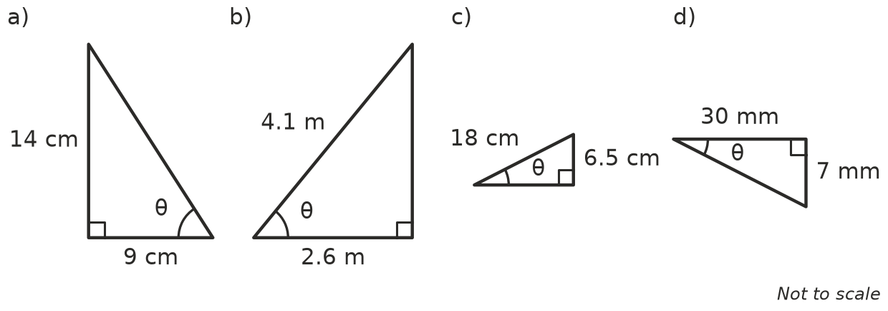
  - θ =
  - θ =
  - θ =
  - θ =
- A right-angled triangle has shorter sides of 8 cm and 15 cm. Find both of its acute angles, to the nearest degree.

 Reasoning
- A triangle has sides 5, 12 and 13, and θ is opposite the side of 5. Ben finds θ with $\sin^{−1}$ and Ava finds θ with $\tan^{−1}$.
  - Write each of their calculations and answers. Ben: ______________ Ava:
  - Explain why they get the same answer.
- A triangle has an opposite side of 2.4 cm and a hypotenuse of 3.7 cm. Lily works out 2.4 ÷ 3.7, rounds it to 0.6, then finds $\sin^{−1}(0.6)$.
  - Find θ correctly.
  - What answer does Lily get, and why is it wrong?
- Without a calculator, decide which angle is bigger: θ with $tanθ$ = 0.8, or α with $tanα$ = 1.2. Explain using 45°.

 Problem solving
- A 5.5 m ladder reaches 5.2 m up a wall.
  - Find the angle between the ladder and the ground.
  - Ladders are safest at about 75° to the ground. Should the foot of the ladder be moved closer to the wall or further away?
- Find the angle each ramp makes with the ground.
  - A ramp rises 1 m over a horizontal distance of 14 m.
  - A ramp is 9.5 m long (along the slope) and rises 0.9 m.
- A rectangle is 16 cm long and 9 cm wide.
  - Find the angle between a diagonal and a long side.
  - Find the acute angle between the two diagonals where they cross.
- An isosceles triangle has two sides of 12 cm and a base of 10 cm. Find all three of its angles, to the nearest degree.
- A fence post 3 m tall casts a shadow 4.2 m long on flat ground. Find the angle between the ground and the line from the end of the shadow to the top of the post.

