8.04 Angles
Year 9 Maths · A5 question sheet · Level 1 · Warm-up
This worksheet practises finding an unknown angle when you know two sides of a right-angled triangle. Tip: work out the ratio first, then use the inverse button on your calculator (SHIFT then sin, cos or tan). If $sinθ$ = 0.5, then $θ=\sin^{−1}(0.5)$ = 30°. Round angles to the nearest degree.

 Understanding
- Use the inverse buttons on your calculator to find θ. Round to the nearest degree.
  - $sinθ$ = 0.5, θ =
  - $cosθ$ = 0.5, θ =
  - $tanθ$ = 1, θ =
  - $sinθ$ = 0.8, θ =
  - $tanθ$ = 2.5, θ =
  - $cosθ$ = 0.35, θ =
- For each triangle, write which ratio (sin, cos or tan) uses the two sides you know, then write the ratio as a fraction.
- 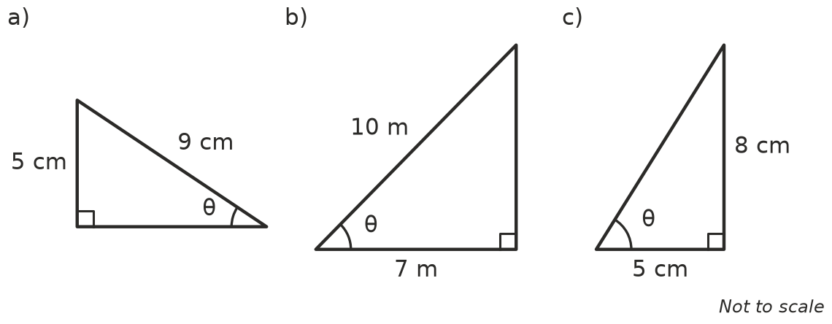
  - Ratio ______________ =
  - Ratio ______________ =
  - Ratio ______________ =

 Fluency
- Find θ in each triangle in Question 2, to the nearest degree.
  - θ =
  - θ =
  - θ =
- Find θ in each triangle, to the nearest degree.
- 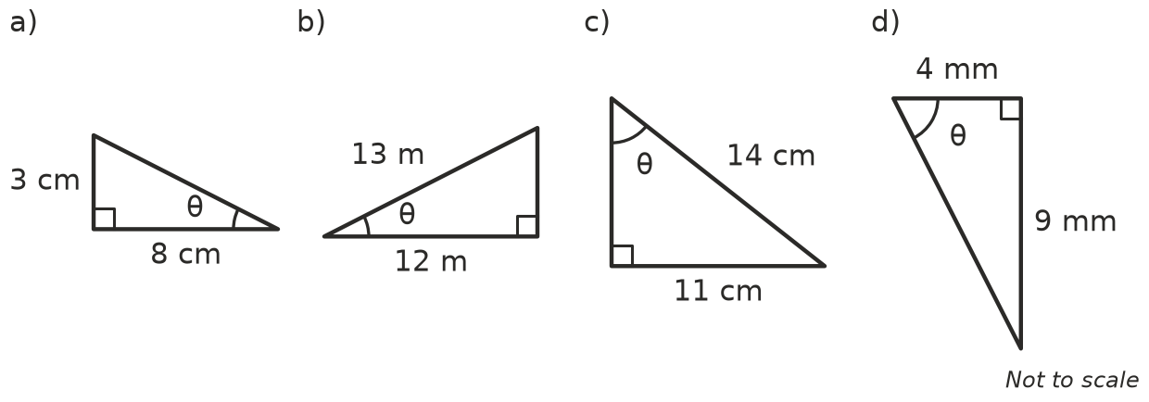
  - θ =
  - θ =
  - θ =
  - θ =

 Reasoning
- In a right-angled triangle, $tanθ=\frac{3}{4}$. Jack types tan 0.75 into his calculator and gets 0.01, so he writes θ = 0.01°.
  - What did Jack do wrong?
  - Find θ correctly.
- Explain why there is no angle with $cosθ$ = 1.3. Hint: which side is always the longest?
- A triangle has sides 3 cm, 4 cm and 5 cm, and θ is opposite the 3 cm side. Find θ three times: once with sin, once with cos and once with tan. What do you notice?

 Problem solving
- A 4 m ladder leans against a wall with its foot 1.2 m from the wall. What angle does the ladder make with the ground?
- A ramp rises 0.5 m over a horizontal distance of 6 m. What angle does the ramp make with the ground?
- A kite is flying 35 m above the ground on a straight 50 m string. What angle does the string make with the ground?
- A straight road climbs 120 m over a horizontal distance of 1000 m. What angle does the road make with the horizontal?

