8.03 Side lengths
Year 9 Maths · Worksheet · Level 3 · Challenge
Name: ____________________ Date: ______________
This worksheet uses sin, cos and tan to find sides in harder problems: mixed units, two triangles joined together, and shapes built from right-angled triangles. Tip: when two triangles share a side, find the shared side first and keep its full calculator value for the next step. Round lengths to 1 decimal place.

 Understanding
- For each triangle, write an equation, rearrange it to make x the subject, then find x.
- 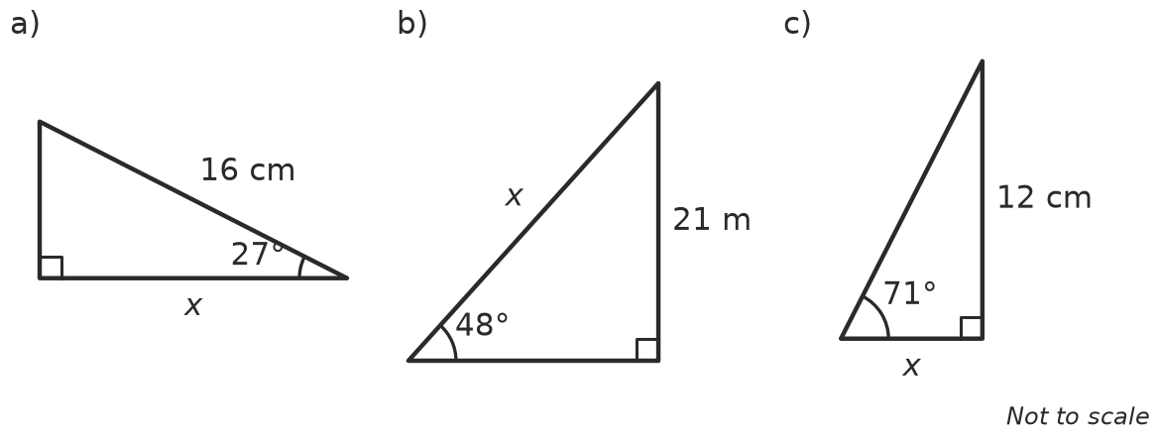
  - Equation: ______________ x = ______________
  - Equation: ______________ x = ______________
  - Equation: ______________ x = ______________

 Fluency
- Find x in each triangle. Round to 1 decimal place.
- 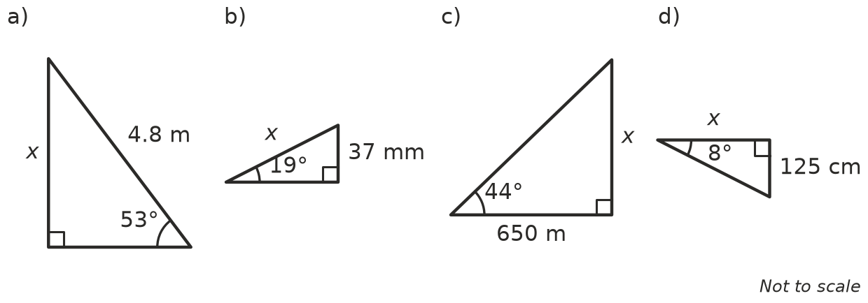
  - x = ______________
  - x = ______________
  - x = ______________
  - x = ______________
- Find BD, then x.
- 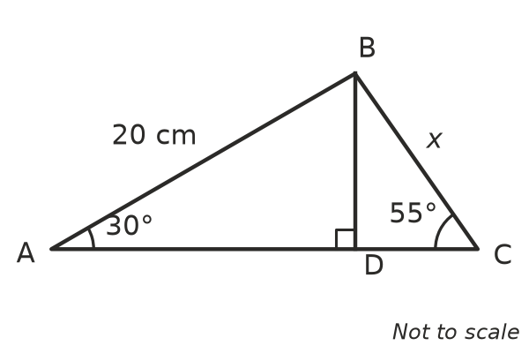
  - BD = ______________
  - x = ______________
- A right-angled triangle has a hypotenuse of 24 cm and an angle of 37°.
  - Find the lengths of the two shorter sides. ______________
  - Find its perimeter. ______________
  - Find its area. ______________

 Reasoning
- A right-angled triangle has a hypotenuse of 20 cm and an angle of 30°. Without a calculator, find the side opposite the 30° angle. Explain how you know.

- Joel is solving $sin{40}^{∘}=\frac{8}{x}$. He writes x = $\frac{sin{40}^{∘}}{8}$ ≈ 0.08.
  - Explain why his answer can’t be right. ______________

  - Find the correct value of x. ______________
- A right-angled triangle has a hypotenuse of 10 cm and an angle of 50°. Without a calculator, decide whether the side opposite the 50° angle is more or less than 7.07 cm (which is 10 × $sin{45}^{∘}$). Explain.

 Problem solving
- Ana flies a kite on a 60 m string. The string makes an angle of 48° with the horizontal, and she holds it 1.5 m above the ground. How high is the kite above the ground?

- Find the perimeter of this trapezium.
- 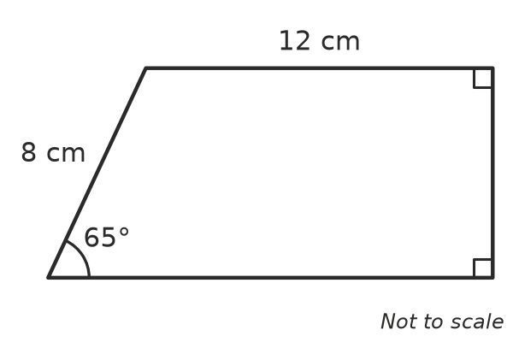

- A roof truss is an isosceles triangle with a base (span) of 9 m. Each sloping side makes an angle of 25° with the base.
  - How long is each sloping side? ______________
  - How high is the top of the truss above the base? ______________
- A rhombus has sides of 10 cm and one angle of 70°. Its diagonals cut each other in half at right angles, and they also cut its angles in half. Find the lengths of both diagonals.

- From point A on flat ground, 40 m from the base D of a cliff, the angle up to a bird’s nest B is 25°. The angle from the nest up to the top of the cliff C is another 25°.
- 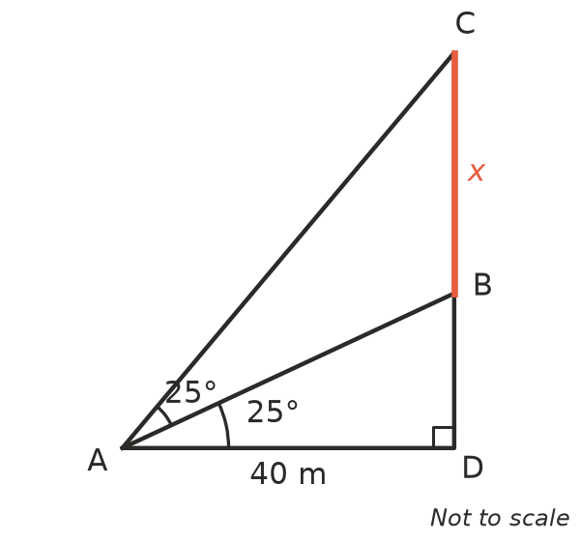
  - Find DB, the height of the nest. ______________
  - Find DC, the height of the cliff. ______________
  - How far is the nest below the top of the cliff (x)? ______________

