8.03 Side lengths
Year 9 Maths · A5 question sheet · Level 2 · Core
This worksheet practises finding missing sides with sin, cos and tan, including when the unknown ends up on the bottom of the fraction. Tip: write the ratio as an equation first. If x is on top, multiply; if x is on the bottom, swap x and the ratio, so $sin{34}^{∘}=\frac{9}{x}$ becomes x = $\frac{9}{sin{34}^{∘}}$. Round lengths to 1 decimal place.

 Understanding
- Write an equation for each triangle using sin, cos or tan. Don’t solve it yet.
  - 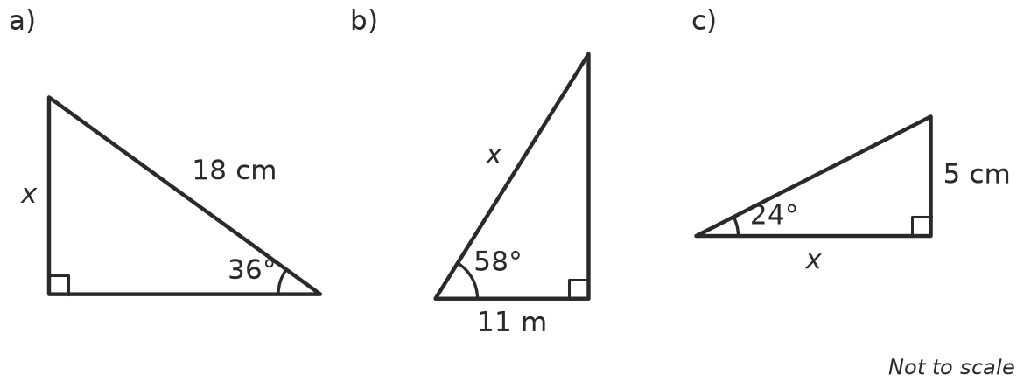

 Fluency
- Find x in each triangle. Round to 1 decimal place.
- 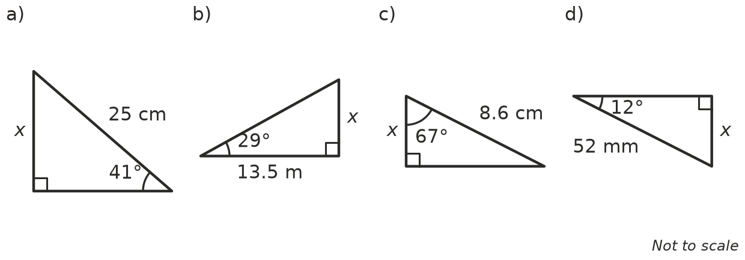
  - x =
  - x =
  - x =
  - x =
- In these triangles x is on the bottom of the fraction. Find x, to 1 decimal place.
- 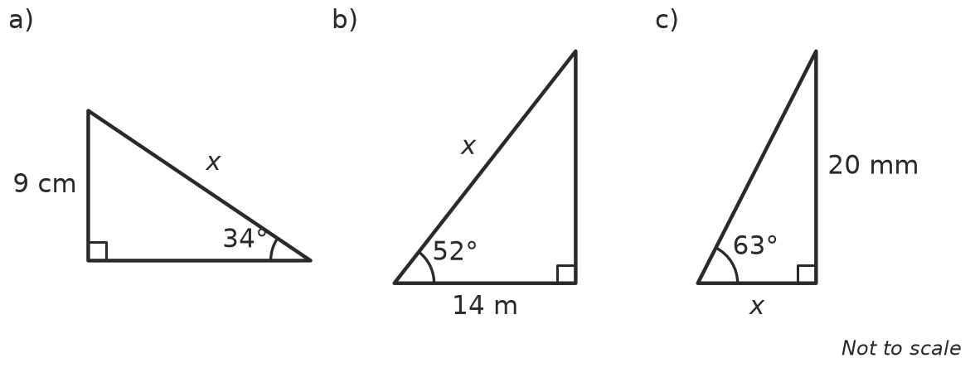
  - x =
  - x =
  - x =
- Find x and y.
- 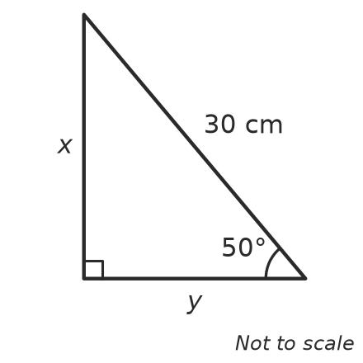
  - x =
  - y =

 Reasoning
- A right-angled triangle has angles of 35° and 55°. The side adjacent to the 35° angle is 10 cm. Rachel finds the third side with x = 10 × $tan{35}^{∘}$. Tom uses the 55° angle and writes x = $\frac{10}{tan{55}^{∘}}$.
  - Work out both answers. Rachel: ______________ Tom:
  - Explain why both methods work.
- In Question 3a, explain how you can tell straight away that x must be more than 9 cm.
- Mai finds x in $sin{23}^{∘}=\frac{12}{x}$. She rounds $sin{23}^{∘}$ to 0.4 first and gets x = 12 ÷ 0.4 = 30.
  - Find x correct to 1 decimal place without rounding early.
  - Explain why Mai’s answer is not accurate.

 Problem solving
- A ladder leans against a wall, making an angle of 72° with the ground. The top of the ladder is 5.5 m above the ground. How long is the ladder?
- A ramp rises 0.8 m and makes an angle of 5° with the ground.
  - How long is the sloping surface of the ramp?
  - How far along the ground does it go?
- An isosceles triangle has two equal sides of 10 cm. The two equal angles are 40°.
  - Find its height.
  - Find the length of its base.
  - Find its area.
- A plane takes off at an angle of 14° to the runway and flies in a straight line for 2.5 km. How high is it now, to the nearest metre?
- A rectangle is 6 cm high. Its diagonal makes an angle of 34° with the base.
  - Find the length of the base.
  - Find the length of the diagonal.

