8.03 Side lengths
Year 9 Maths · A5 question sheet · Level 1 · Warm-up
This worksheet practises using sin, cos and tan to find a missing side in a right-angled triangle. Tip: label the sides O, A and H from the marked angle. Tick the side you know and the side you want, then choose the ratio that uses both of them (SOH CAH TOA). Round lengths to 1 decimal place.

 Understanding
- For each triangle, write which two sides are involved (O, A or H) and which ratio you would use. Don’t solve yet.
- 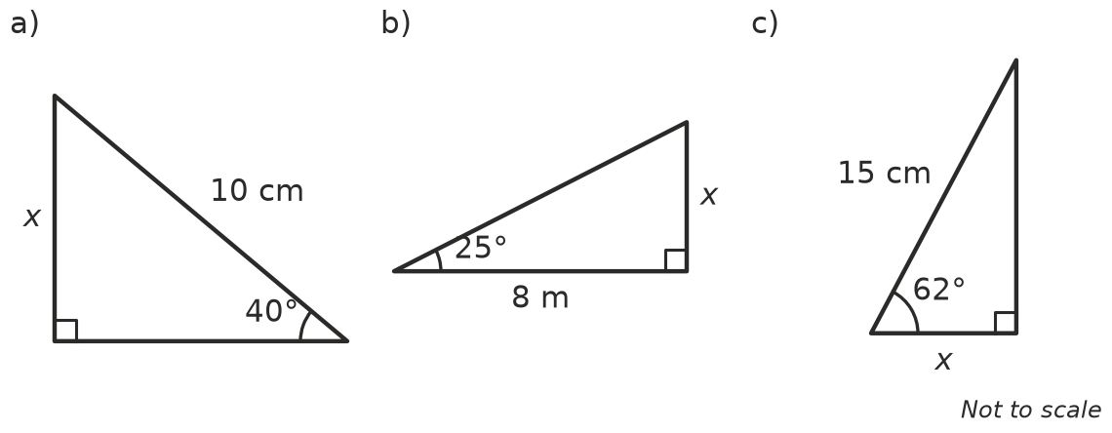
  - Sides ______________ Ratio
  - Sides ______________ Ratio
  - Sides ______________ Ratio
- Complete the working to find x in Question 1a.
- $sin{40}^{∘}=\frac{x}{10}$
- x = 10 ×
- x = ______________ cm (to 1 decimal place)

 Fluency
- Find x in each triangle. Round to 1 decimal place.
- 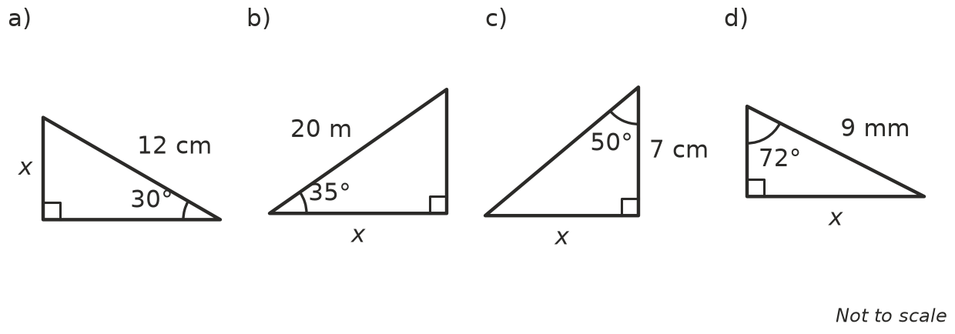
  - x =
  - x =
  - x =
  - x =
- Solve each equation for x. Round to 1 decimal place.
  - x = 15 × $sin{22}^{∘}$
  - $cos{48}^{∘}=\frac{x}{6}$
  - $tan{15}^{∘}=\frac{x}{30}$

 Reasoning
- A right-angled triangle has a hypotenuse of 14 cm and an angle of 33°. Ravi wants the side opposite the 33° angle. He writes x = 14 × $tan{33}^{∘}$ ≈ 9.1 cm.
  - What mistake did Ravi make?
  - Find the correct value of x.
- In Question 3a, the hypotenuse is 12 cm. Explain why x must be less than 12 cm, and check that your answer is.

 Problem solving
- A 6 m ladder leans against a wall. It makes an angle of 70° with the ground. How far up the wall does it reach?
- A kite string is 40 m long and makes an angle of 55° with the flat ground. How high is the kite above the ground? (Ignore the height of the person holding it.)
- A tree casts a shadow 12 m long on flat ground. The line from the end of the shadow to the top of the tree makes an angle of 38° with the ground. How tall is the tree?
- A playground slide is 4.5 m long and makes an angle of 32° with the ground. How far along the ground does the slide reach?
- A diagonal of a rectangle is 15 cm long. It makes an angle of 28° with the longer side.
  - Find the length of the rectangle.
  - Find the width of the rectangle.

