8.02 Trigonometric ratios
Year 9 Maths · Worksheet · Level 3 · Challenge
Name: ____________________ Date: ______________
This worksheet takes the trigonometric ratios further: exact ratios with square roots, finding one ratio from another, the exact values for 30°, 45° and 60°, and why the ratios behave as they do. Tip: when you are given one ratio, draw a triangle with those side lengths and use Pythagoras’ theorem to find the third side.

 Understanding
- In triangle ABC the right angle is at C, and CD is drawn at right angles to AB.
- 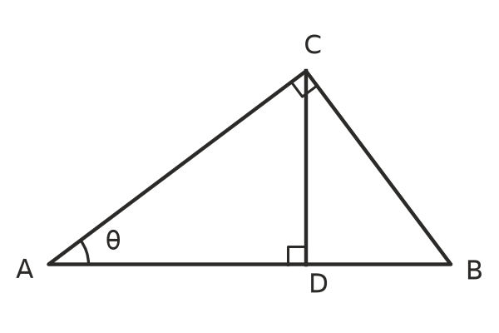
  - Use triangle ABC to write $sinθ$. ______________
  - Use triangle ACD to write $sinθ$ in a different way. ______________
  - Explain why angle BCD is also equal to θ.

  - Use triangle BCD to write $tanθ$. ______________
- Find the missing side in each triangle exactly. Then write $sinθ$, $cosθ$ and $tanθ$ exactly.
- 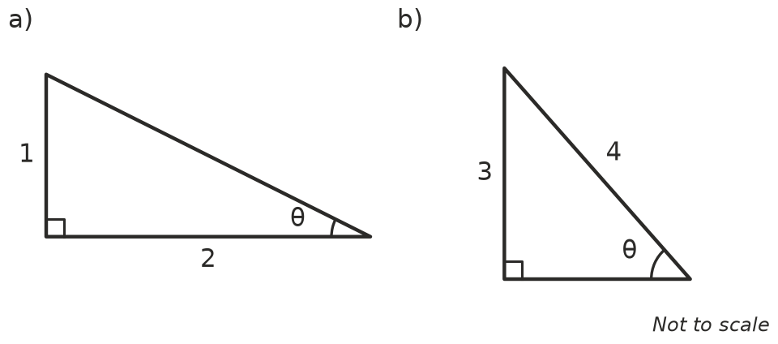
  - Missing side ______________ $sinθ$ = ______________ $cosθ$ = ______________ $tanθ$ = ______________
  - Missing side ______________ $sinθ$ = ______________ $cosθ$ = ______________ $tanθ$ = ______________

 Fluency
- θ is an acute angle in a right-angled triangle. Find the other two ratios as fractions.
  - $sinθ=\frac{8}{17}$ ______________
  - $tanθ$ = 2.4 ______________
  - $cosθ$ = 0.6 ______________
- Use a calculator in degree mode. Round to 4 decimal places where needed.
  - 5 × $sin{40}^{∘}$ = ______________
  - $(sin{30}^{∘})^{2}+(cos{30}^{∘})^{2}$ = ______________
  - $sin{70}^{∘}$ ÷ $cos{70}^{∘}$ = ______________ and $tan{70}^{∘}$ = ______________
- These two triangles are half of a square and half of an equilateral triangle.
- 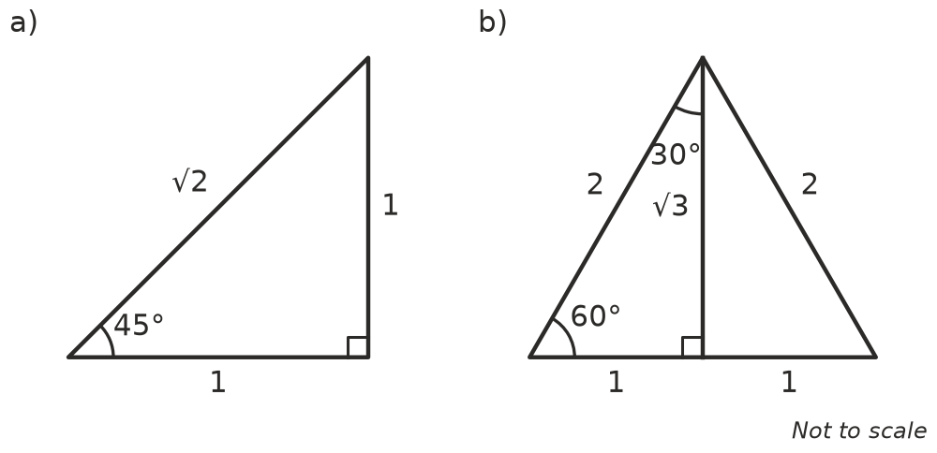
- Use them to complete the table of exact values. Leave square roots in your answers.
θ | 30° | 45° | 60°
$sinθ$
$cosθ$
$tanθ$

 Reasoning
- These questions show two facts that are true for every angle.
  - For the triangle in Question 2a, show that $(sinθ)^{2}+(cosθ)^{2}$ = 1.

  - Use Pythagoras’ theorem, $O^{2}+A^{2}=H^{2}$, to explain why $(sinθ)^{2}+(cosθ)^{2}$ = 1 for every angle θ.

  - Show that $\frac{sinθ}{cosθ}=tanθ$. Hint: divide $\frac{O}{H}$ by $\frac{A}{H}$.

- Imagine a right-angled triangle with a hypotenuse that stays 10 cm long while θ gets bigger, from close to 0° up to close to 90°. Explain what happens to the adjacent side, and so to $cosθ$.

- Without a calculator, put these in order from smallest to largest. Explain your reasoning.
- $sin{50}^{∘}$, $tan{50}^{∘}$, $sin{20}^{∘}$, $cos{20}^{∘}$
- Order: ______________

- Write True or False for each statement. Give a reason.
  - $sin{30}^{∘}+sin{30}^{∘}=sin{60}^{∘}$ ______________
  - $sin{40}^{∘}=cos{50}^{∘}$ ______________
  - $tanθ$ can be bigger than 100. ______________

 Problem solving
- A road sign warns that a hill has a slope of “1 in 8”: the road rises 1 m for every 8 m across. θ is the angle the road makes with the horizontal.
  - Write $tanθ$. ______________
  - Write $sinθ$ exactly, then to 4 decimal places. ______________
- A right-angled triangle has a hypotenuse of 30 cm and $tanθ=\frac{3}{4}$. Find the lengths of its two shorter sides. Hint: the sides are in the ratio 3 : 4 : 5.

- A rectangle is 12 cm long and 5 cm wide. θ is the angle between a diagonal and a long side, and α is the angle between the same diagonal and a short side.
  - Write $sinθ$, $cosθ$ and $tanθ$. ______________
  - Write $tanα$, and explain how it is related to $tanθ$. ______________
- For one angle θ, $sinθ=cosθ$. Find θ and explain how you know.

