8.02 Trigonometric ratios
Year 9 Maths · A5 question sheet · Level 2 · Core
This worksheet practises the three trigonometric ratios, $sinθ=\frac{O}{H}$, $cosθ=\frac{A}{H}$ and $tanθ=\frac{O}{A}$. Tip: the opposite and adjacent sides depend on which angle you are using, so label the sides again every time the angle changes.

 Understanding
- In triangle ABC, the right angle is at C. Copy and complete the table to name the sides for each angle.
- 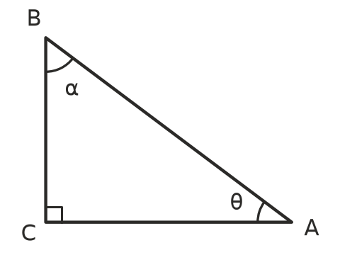
Angle | Hypotenuse | Opposite
θ (at A)
α (at B)

- Write $sinθ$, $cosθ$ and $tanθ$ for each triangle as fractions in simplest form.
- 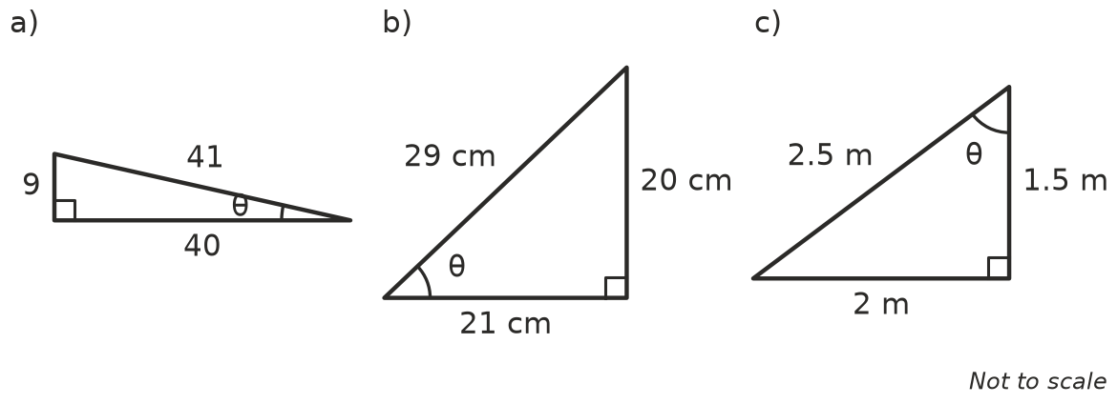
  - $sinθ$ = ______________ $cosθ$ = ______________ $tanθ$ =
  - $sinθ$ = ______________ $cosθ$ = ______________ $tanθ$ =
  - $sinθ$ = ______________ $cosθ$ = ______________ $tanθ$ =

 Fluency
- Use a calculator in degree mode. Round each answer to 4 decimal places.
  - $sin{37}^{∘}$ =
  - $cos{64}^{∘}$ =
  - $tan{18}^{∘}$ =
  - $tan{75}^{∘}$ =
  - $cos5^{∘}$ =
  - $sin{89}^{∘}$ =
- Look at this triangle.
- 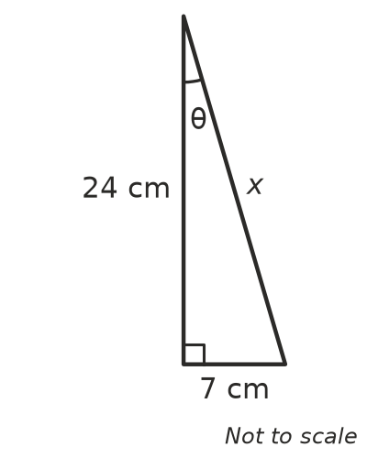
  - Use Pythagoras’ theorem to find x.
  - Write $sinθ$, $cosθ$ and $tanθ$ as fractions.
- For an angle θ in a right-angled triangle, $tanθ=\frac{5}{12}$.
  - Sketch a right-angled triangle that fits, and label the opposite and adjacent sides.
  - Find the length of the hypotenuse.
  - Write $sinθ$ and $cosθ$ as fractions.

 Reasoning
- Compare $sin{25}^{∘}$ and $cos{65}^{∘}$.
  - Use a calculator to find $sin{25}^{∘}$ and $cos{65}^{∘}$ to 4 decimal places.
  - Explain why they are equal. Hint: draw a right-angled triangle with angles of 25° and 65°.
- Ella says her calculator gave $sinθ$ = 1.2 for an angle in her right-angled triangle. Explain why she must have made a mistake.
- A triangle has sides 6 cm, 8 cm and 10 cm. A bigger triangle has sides 15 cm, 20 cm and 25 cm. In both triangles, θ is the angle opposite the shortest side.
  - Find $sinθ$ in each triangle.
  - Explain why the answers are the same.
- Without a calculator, decide which is bigger: $tan{30}^{∘}$ or $tan{60}^{∘}$. Explain using the sides of a triangle.

 Problem solving
- A roof is 6.0 m wide and rises 1.6 m in the middle. θ is the angle the roof makes with the horizontal.
- 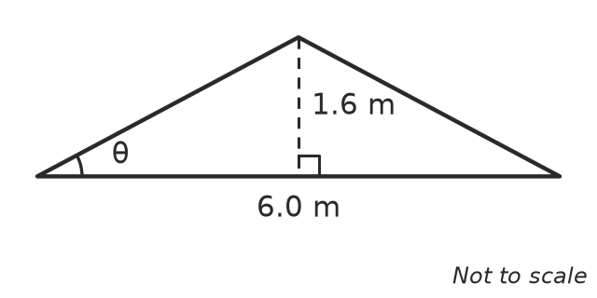
  - Find the length of one sloping side of the roof.
  - Write $sinθ$, $cosθ$ and $tanθ$ as fractions in simplest form.
- A straight line joins the origin O(0, 0) to the point P(5, 12). θ is the angle between OP and the positive x-axis.
  - Find the length of OP.
  - Write $sinθ$, $cosθ$ and $tanθ$.
- Use a calculator to copy and complete the table. Round to 2 decimal places.
θ | 0° | 15° | 30° | 45° | 60° | 75° | 90°
$sinθ$
$cosθ$

- Describe two patterns in your table for Question 12.

