8.02 Trigonometric ratios
Year 9 Maths · A5 question sheet · Level 1 · Warm-up
This worksheet practises naming the sides of a right-angled triangle and writing the three trigonometric ratios. Tip: remember SOH CAH TOA: $sinθ=\frac{O}{H}$, $cosθ=\frac{A}{H}$, $tanθ=\frac{O}{A}$. Always label H first (opposite the right angle), then O (across from θ), then A.

 Understanding
- For each triangle, name the hypotenuse, the side opposite θ and the side adjacent to θ. Use the letters at the ends of each side.
- 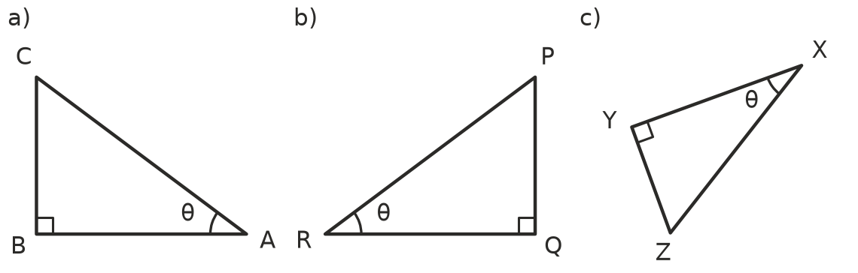
  - Hypotenuse ______________ Opposite ______________ Adjacent
  - Hypotenuse ______________ Opposite ______________ Adjacent
  - Hypotenuse ______________ Opposite ______________ Adjacent
- Complete each ratio using the words opposite, adjacent and hypotenuse.
  - $sinθ$ = ______________ ÷
  - $cosθ$ = ______________ ÷
  - $tanθ$ = ______________ ÷
- Look at this triangle.
- 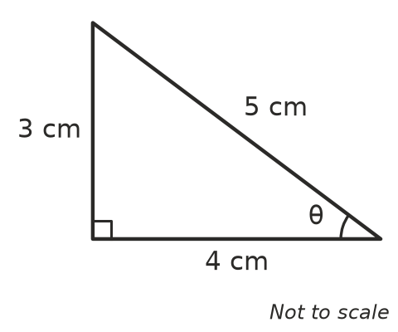
  - Write the length of the hypotenuse.
  - Write the length of the side opposite θ.
  - Write the length of the side adjacent to θ.
  - Write $sinθ$, $cosθ$ and $tanθ$ as fractions.

 Fluency
- Write $sinθ$, $cosθ$ and $tanθ$ for each triangle as fractions in simplest form.
- 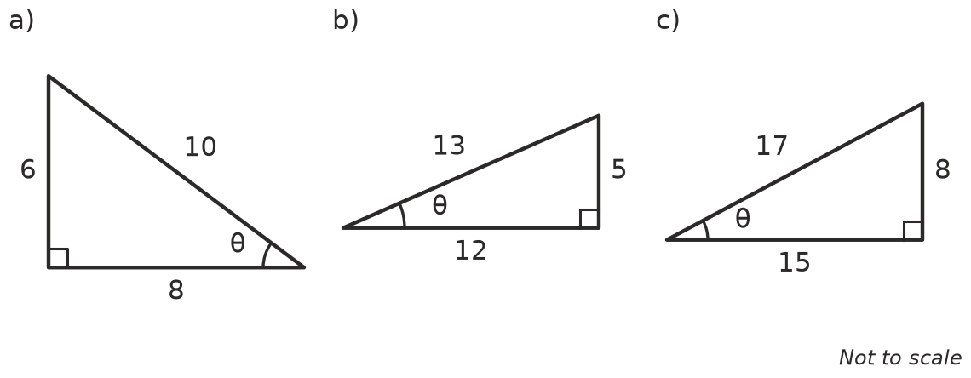
  - $sinθ$ = ______________ $cosθ$ = ______________ $tanθ$ =
  - $sinθ$ = ______________ $cosθ$ = ______________ $tanθ$ =
  - $sinθ$ = ______________ $cosθ$ = ______________ $tanθ$ =
- Use a calculator to find each value. Check that your calculator is in degree mode. Round to 4 decimal places where needed.
  - $sin{30}^{∘}$ =
  - $cos{60}^{∘}$ =
  - $tan{45}^{∘}$ =
  - $sin{52}^{∘}$ =
  - $cos{18}^{∘}$ =
  - $tan{70}^{∘}$ =

 Reasoning
- This triangle has two marked angles, θ and α.
- 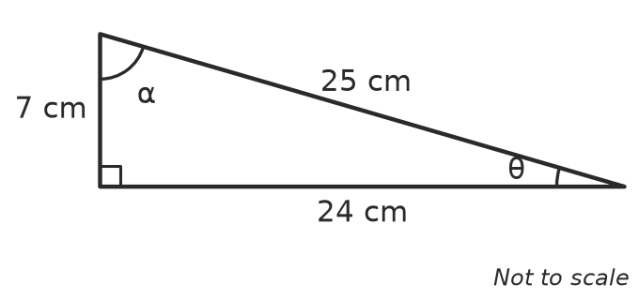
  - Which ratio of θ is equal to $\frac{7}{25}$?
  - Write $tanθ$.
  - Write $tanα$.
  - What do you notice about your answers to b and c? Explain why it happens.
- Explain why $sinθ$ can never be bigger than 1. Hint: think about which side of the triangle is the longest.
- A right-angled triangle has two shorter sides of 5 cm each, so it has two 45° angles. Use the triangle to explain why $tan{45}^{∘}$ = 1.

 Problem solving
- A garden path slopes up 1 m for every 8 m it goes along the ground. Sketch the right-angled triangle, mark the angle θ that the path makes with the ground, and write $tanθ$ as a fraction.
- Look at this triangle.
- 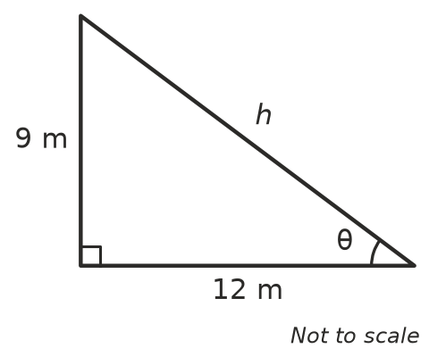
  - Use Pythagoras’ theorem to find h.
  - Write $sinθ$, $cosθ$ and $tanθ$ as fractions in simplest form.

