8.01 Pythagoras' theorem
Year 9 Maths · Worksheet · Level 3 · Challenge
Name: ____________________ Date: ______________
This worksheet takes Pythagoras’ theorem further: exact answers with square roots, triangles joined together, algebra and boxes in three dimensions. Tip: in a problem with two triangles, find the side they share first.

 Understanding
- Find each missing length exactly. Simplify if the answer is a whole number.
  - The shorter sides are $\sqrt{5}$ cm and 2 cm. Find the hypotenuse. ______________
  - The hypotenuse is 7 m and one shorter side is $\sqrt{13}$ m. Find the other shorter side. ______________
  - The shorter sides are 2 cm and 3 cm. Find the hypotenuse. ______________

 Fluency
- Find the length of each unknown side. Round your answers to 1 decimal place. Watch the units in part c: give your answer in metres.
- 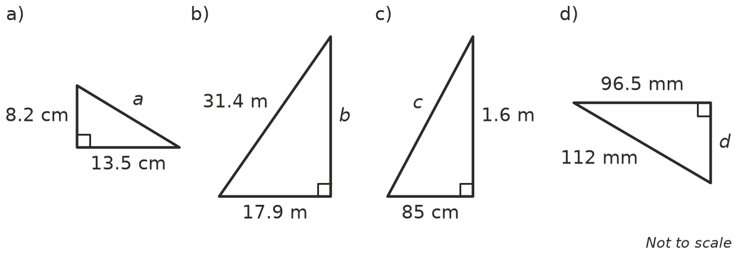
  - a = ______________
  - b = ______________
  - c = ______________
  - d = ______________
- Find y, then x.
- 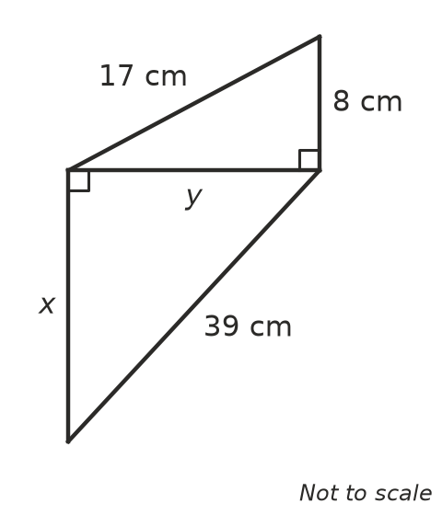
  - y = ______________
  - x = ______________
- A rectangular window is 1.8 m wide and 75 cm high. Find the length of its diagonal in centimetres.

 Reasoning
- Decide whether each set of side lengths makes a right-angled triangle. Show your check.
  - 2.8, 4.5, 5.3 ______________
  - 11, 60, 61 ______________
  - 12, 35, 36 ______________
  - A triangle has sides 7, k and 25, where 25 is the longest side. Find the value of k that makes it right-angled. ______________
- The sides of a right-angled triangle are x cm, (x + 7) cm and (x + 8) cm.
  - Which side is the hypotenuse? ______________
  - Show that Pythagoras’ theorem simplifies to $x^{2}−2x−15=0$.

  - Solve the equation to find x, and write the three side lengths. ______________
- Use $c^{2}=a^{2}+b^{2}$ to explain why the hypotenuse is always the longest side of a right-angled triangle.

 Problem solving
- A storage box is 120 cm long, 40 cm wide and 30 cm high.
- 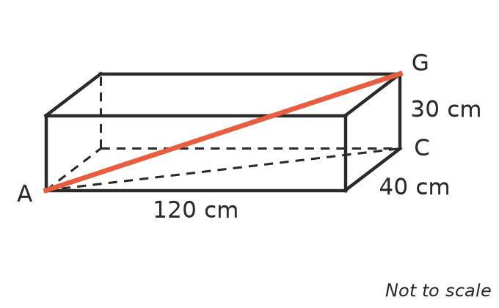
  - Find the length of the diagonal AC across the floor of the box, to 1 decimal place. ______________
  - Find the length of the red diagonal AG from one bottom corner to the opposite top corner. ______________
  - Will a straight umbrella 1.25 m long fit inside the box? Explain. ______________
- An equilateral triangle has sides of 8 cm. Find its height and its area, each to 1 decimal place.

- Find the distance between the points P(−3, 4) and Q(5, −2).

- A flagpole 10 m tall is held up by a straight wire. The wire is fixed 2 m below the top of the pole and pegged to the flat ground 4.5 m from the base of the pole. How long is the wire, to 1 decimal place?

- A 5 m ladder leans against a wall with its foot 1.4 m from the wall.
  - How high up the wall does it reach? ______________
  - The top of the ladder slides 0.8 m down the wall. How far does the foot of the ladder move out from the wall? ______________

- A rhombus has diagonals of 10 cm and 24 cm. The diagonals of a rhombus cross at right angles and cut each other in half. Find the perimeter of the rhombus.

