8.01 Pythagoras' theorem
Year 9 Maths · Worksheet · Level 1 · Warm-up
Name: ____________________ Date: ______________
This worksheet revises Pythagoras’ theorem from Year 8, ready for trigonometry. Tip: the hypotenuse is the side opposite the right angle. It is always the longest side, so find it first in every triangle.

 Understanding
- Name the hypotenuse of each triangle. Use the two letters at its ends.
- 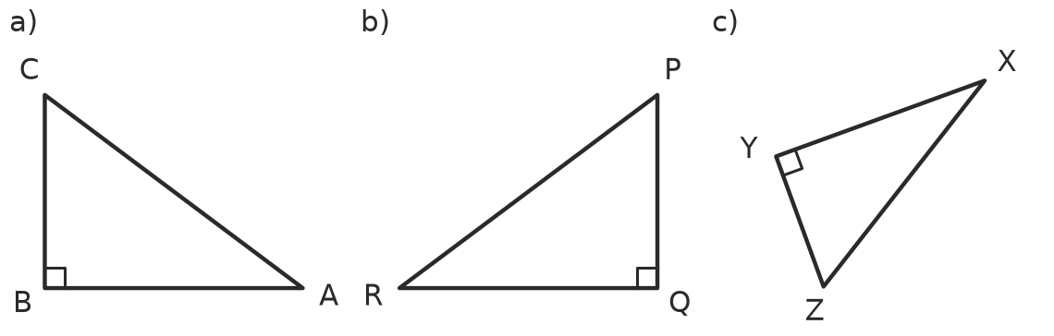
  - ______________
  - ______________
  - ______________
- In a right-angled triangle the two shorter sides are a and b, and the hypotenuse is c. Complete Pythagoras’ theorem.
- $c^{2}$ = ______________

 Fluency
- Find the length of the hypotenuse in each triangle. Each answer is a whole number.
- 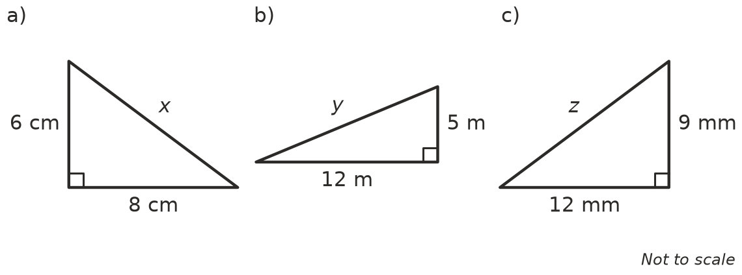
  - x = ______________
  - y = ______________
  - z = ______________
- Find the length of the hypotenuse in each triangle. Round your answers to 1 decimal place.
- 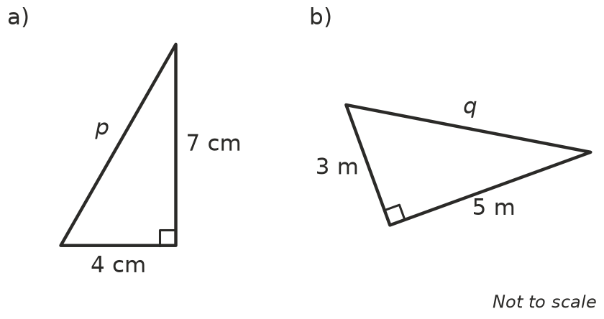
  - p = ______________
  - q = ______________
- Find the length of the shorter side in each triangle. Hint: subtract, $a^{2}=c^{2}−b^{2}$.
- 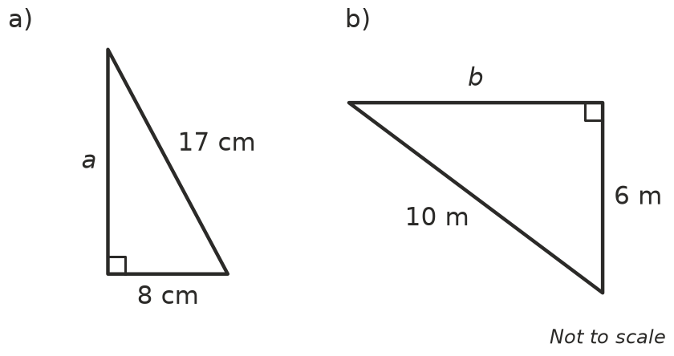
  - a = ______________
  - b = ______________
- A right-angled triangle has a hypotenuse of 9 cm and one shorter side of 5 cm. Find the other shorter side. Round to 1 decimal place.

 Reasoning
- Use Pythagoras’ theorem to decide whether each triangle is right-angled. Show your check, then write Yes or No.
  - sides 7 cm, 24 cm and 25 cm ______________
  - sides 6 cm, 7 cm and 9 cm ______________
  - sides 9 m, 12 m and 15 m ______________
- Mia wants the shorter side x of a right-angled triangle with a hypotenuse of 13 cm and another side of 5 cm. Her working is: $x^{2}={13}^{2}+5^{2}$ = 194, so x ≈ 13.9 cm.
  - How can you tell her answer is wrong without using a calculator?

  - Find the correct value of x. ______________

 Problem solving
- A 5 m ladder leans against a wall. Its foot is 1.4 m from the bottom of the wall. How high up the wall does the ladder reach?

- A rectangular paddock is 40 m long and 30 m wide. Ella walks straight across the paddock from one corner to the opposite corner.
  - How far does she walk? ______________
  - How much shorter is this than walking along two sides of the paddock? ______________
- A wheelchair ramp covers 3.6 m along the ground and rises 1.5 m. How long is the sloping surface of the ramp?

