8.01 Pythagoras' theorem
Year 9 Maths · A5 question sheet · Level 2 · Core
This worksheet revises Pythagoras’ theorem, $c^{2}=a^{2}+b^{2}$, ready for trigonometry. Tip: find the hypotenuse first. If you want the hypotenuse, add the squares; if you want a shorter side, subtract. Round only at the very end.

 Understanding
- For each triangle, write an equation using Pythagoras’ theorem, then solve it. Each answer is exact.
- 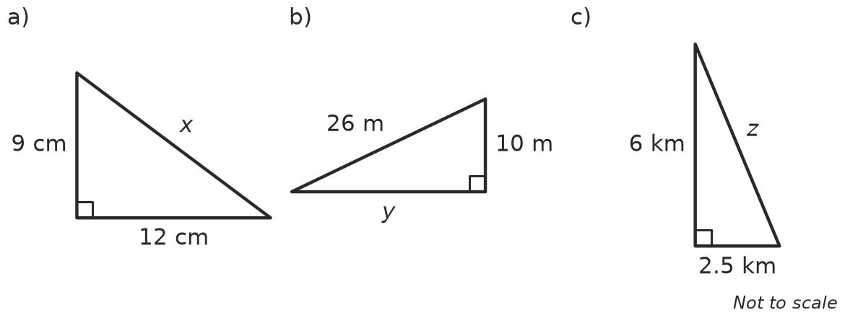
  - Equation: ______________ x =
  - Equation: ______________ y =
  - Equation: ______________ z =

 Fluency
- Find each missing length exactly. Leave your answer as a square root.
  - The shorter sides are 4 cm and 6 cm. Find the hypotenuse.
  - The hypotenuse is 9 m and one shorter side is 4 m. Find the other shorter side.
  - Both shorter sides are 5 mm. Find the hypotenuse.
- Find the length of each unknown side. Round your answers to 1 decimal place.
- 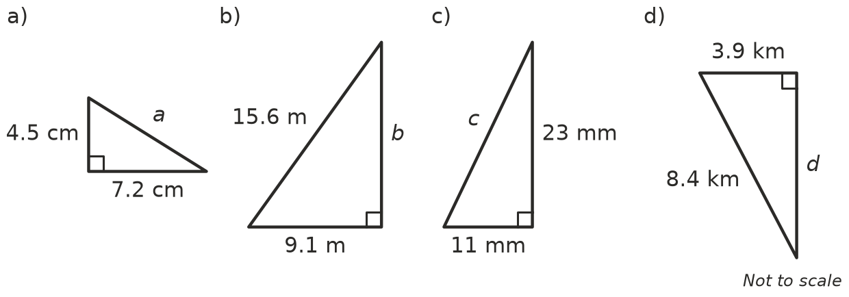
  - a =
  - b =
  - c =
  - d =
- A right-angled triangle has shorter sides of 45 cm and 1.08 m. Find the length of the hypotenuse in metres.

 Reasoning
- Decide whether each set of side lengths makes a right-angled triangle. Show your check, then write Yes or No.
  - 20, 21, 29
  - 9, 10, 14
  - 1.5, 2, 2.5
  - 8, 15, 16
- A Pythagorean triple is three whole numbers that fit $c^{2}=a^{2}+b^{2}$, like 3, 4, 5. Find the missing number in each triple.
  - 9, 40,
  - ______________, 60, 61
- Sam is finding the shorter side of a right-angled triangle with a hypotenuse of 20 cm and another side of 12 cm. He gets 23.3 cm.
  - Explain how you know Sam’s answer is wrong without doing any working.
  - Find the correct length.

 Problem solving
- A farm gate is 1.2 m high and 2.5 m wide. A wooden brace runs diagonally from one corner to the opposite corner. How long is the brace, to 1 decimal place?
- An isosceles triangle has two sides of 13 cm and a base of 10 cm.
- 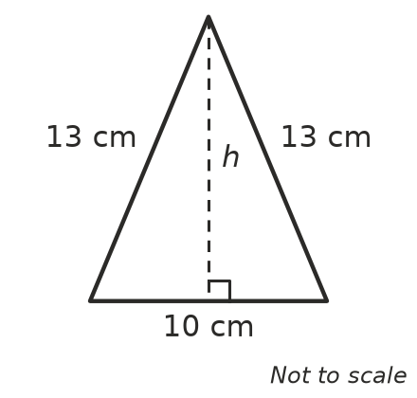
  - Find its height, h.
  - Find its area.
- A fishing boat sails 24 km east from a harbour, then 10 km north. How far is the boat from the harbour now?
- Find w, then x.
- 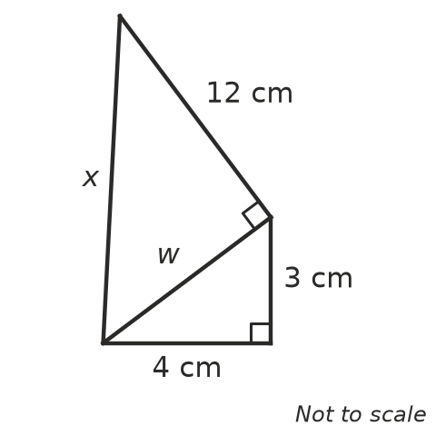
  - w =
  - x =
- Find the distance between the points A(1, 2) and B(7, 10). Hint: sketch the points and draw a right-angled triangle.
- A 6.5 m ladder leans against a wall and just reaches a window ledge 6 m above the ground. How far is the foot of the ladder from the wall?

