Statistics: Practice test 3
Year 9 Maths · Test · Test 3
Name: ____________________ Date: ______________
Time: 45 minutes
Total: 40 marks
Show your working in the boxes. Then write each final answer on the answer sheet on the last page.

 Section A: No calculator
- Classify each variable as categorical (nominal or ordinal) or numerical (discrete or continuous).
  - The postcode of each student’s home. (1 mark)

  - The length of each snake at a reptile park. (1 mark)

  - The number of text messages each student sent yesterday. (1 mark)

- Name the most suitable display for each situation and give a reason.
  - Comparing the heights of the students in two Year 9 classes of about 25 students each. (1 mark)

  - Showing what fraction of a school’s budget is spent on each area (staff, buildings, books and so on). (1 mark)

- A local radio station asks listeners to phone in and say whether they support a new fast-food outlet in their town.
  - What type of sample is this? (1 mark)

  - Explain why the results might be biased. (1 mark)

- A tennis club put this graph in its newsletter with the heading “Membership is skyrocketing!”
- 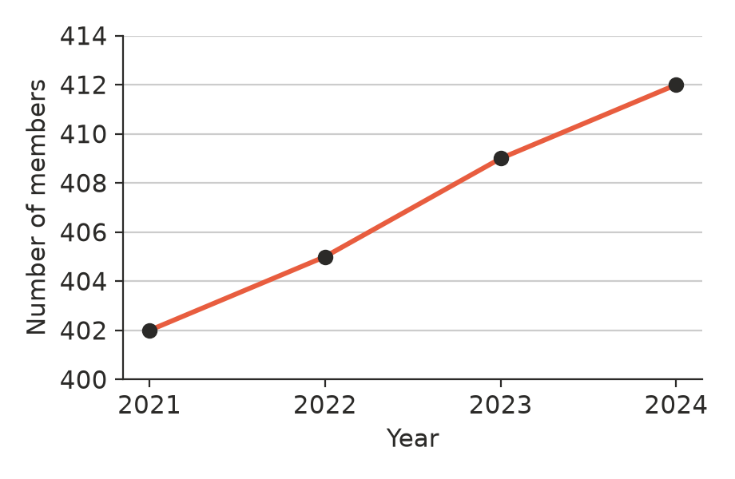
  - Explain why the graph is misleading. (1 mark)

  - How many members did the club gain from 2021 to 2024? (1 mark)

- The back-to-back stem-and-leaf plot shows the ages of the people at a church’s morning service and evening service one Sunday.
Morning (leaf) | Stem | Evening (leaf)
8 | 0
2 | 1 | 4 5 6 7 9
 | 2 | 1 2 4 5 8
8 5 | 3 | 3 6
5 4 1 | 4 | 1
8 2 | 5 | 5
9 7 3 | 6
5 2 | 7
1 | 8

- Key: 5 | 3 | 6 means 35 years at the morning service and 36 years at the evening service
  - Find the median age at each service. (2 marks)

  - Find the range of ages at each service. (1 mark)

  - Describe the shape of the evening service data. (1 mark)

  - Compare the ages of the people at the two services. Use the centre and the spread. (2 marks)

- The histogram shows the heights of 50 sunflowers grown by a Year 9 class.
- 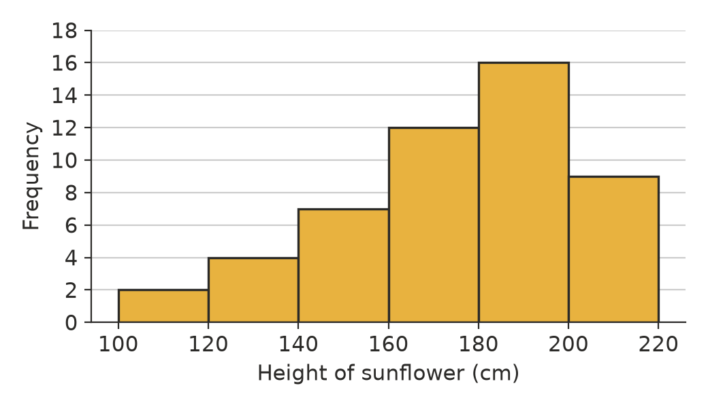
  - What percentage of the sunflowers were 180 cm or taller? (1 mark)

  - Write down the modal class. (1 mark)

  - Describe the shape of the distribution. (1 mark)

- These are the daily maximum temperatures, in °C, at a beach for 16 days in summer. Complete the frequency table. (2 marks)
- 24.5, 27.1, 22.8, 31.4, 29.0, 26.3, 25.7, 33.2, 28.6, 23.9, 30.5, 27.8, 26.0, 21.4, 29.9, 28.2
Temperature (°C) | Frequency
20 ≤ T < 24
24 ≤ T < 28
28 ≤ T < 32
32 ≤ T < 36
Total

- These are Hayley’s times, in seconds, for six 100 m races.
- 13.2, 13.5, 13.1, 13.4, 16.8, 13.3
  - Which time is an outlier? Suggest a reason for it. (1 mark)

  - Which measure of centre, the mean or the median, better describes Hayley’s typical time? Explain. (1 mark)

- The six values below are in order from smallest to largest. Their mean is equal to their median. Find the value of $x$. (2 marks)
- 3, 6, 8, $x$, 14, 15

- A toothpaste advertisement says, “4 out of 5 dentists recommend Sparkle toothpaste.” Write two questions you would ask about how this data was collected. (2 marks)

- A real estate agent sold these five houses in a small town last month.
- $600 000, $640 000, $650 000, $700 000, $3 410 000
- Her advertisement says, “The average house we sell goes for $1.2 million!”
  - Find the median price. (1 mark)

  - The agent used the mean. Explain why she chose the mean rather than the median. (1 mark)

 Section B: Calculator allowed
- Use the histogram in Question 6.
  - Use the midpoint of each class to estimate the mean height of the sunflowers. Show your working. (2 marks)

  - The modal class is higher than the estimated mean. Use the shape of the data to explain why. (1 mark)

- A netball coach compares the goals scored by two goal shooters in their last 10 games.
- Jade: 12, 15, 14, 18, 13, 16, 15, 14, 17, 16
- Ruby: 22, 8, 19, 25, 6, 21, 10, 24, 9, 20
  - Find the mean for each shooter. (1 mark)

  - Find the median for each shooter. (1 mark)

  - Find the range for each shooter. (1 mark)

  - The coach needs a reliable shooter for the grand final. Who should she choose? Explain. (1 mark)

- A farm dam holds about 3600 fish. A random sample of 25 fish has a mean mass of 1.32 kg.
  - Estimate the total mass of fish in the dam. (1 mark)

  - Suppose the sample had been caught with a lure made for large fish. Would the estimate be too high or too low? Explain. (1 mark)

- The table shows the scores on a quiz. One frequency, $k$, is missing. The estimated mean, found using the midpoints of the classes, is 14. Find the value of $k$. Show your working. (3 marks)
Score | Frequency
0 ≤ s < 10 | 6
10 ≤ s < 20 | $k$
20 ≤ s < 30 | 4

 Answer sheet
Name: ____________________
Write your final answer for each question in the table.
Question | Answer | Marks | Question | Answer | Marks
1a |  | /1 | 7 | (in the table) | /2
1b |  | /1 | 8a |  | /1
1c |  | /1 | 8b |  | /1
2a |  | /1 | 9 |  | /2
2b |  | /1 | 10 |  | /2
3a |  | /1 | 11a |  | /1
3b |  | /1 | 11b |  | /1
4a |  | /1 | 12a |  | /2
4b |  | /1 | 12b |  | /1
5a |  | /2 | 13a |  | /1
5b |  | /1 | 13b |  | /1
5c |  | /1 | 13c |  | /1
5d |  | /2 | 13d |  | /1
6a |  | /1 | 14a |  | /1
6b |  | /1 | 14b |  | /1
6c |  | /1 | 15 |  | /3
 |  |  |  | Total | /40

