Statistics: Practice test 2
Year 9 Maths · Test · Test 2
Name: ____________________ Date: ______________
Time: 45 minutes
Total: 40 marks
Show your working in the boxes. Then write each final answer on the answer sheet on the last page.

 Section A: No calculator
- Types of data.
  - Classify the breed of each dog at a dog show as categorical (nominal or ordinal) or numerical (discrete or continuous). (1 mark)

  - Classify the number of people in each car at a drive-in movie in the same way. (1 mark)

  - Write an example of a numerical, continuous variable that you could collect at a school camp. (1 mark)

- Mia asked 30 students to name their favourite sport. She drew a histogram of the results.
  - Explain why a histogram is not a suitable display for this data. (1 mark)

  - Name a more suitable display. (1 mark)

- A school wants to estimate how long its students spend on homework each night. Which of these samples is best? Explain your choice. (2 marks)
  - The 25 students in the Year 12 study group.
  - 10 students chosen at random from each year group.
  - The first 40 students to reply to an email.

- Students voted for a new school jumper colour. The graph shows the results.
- 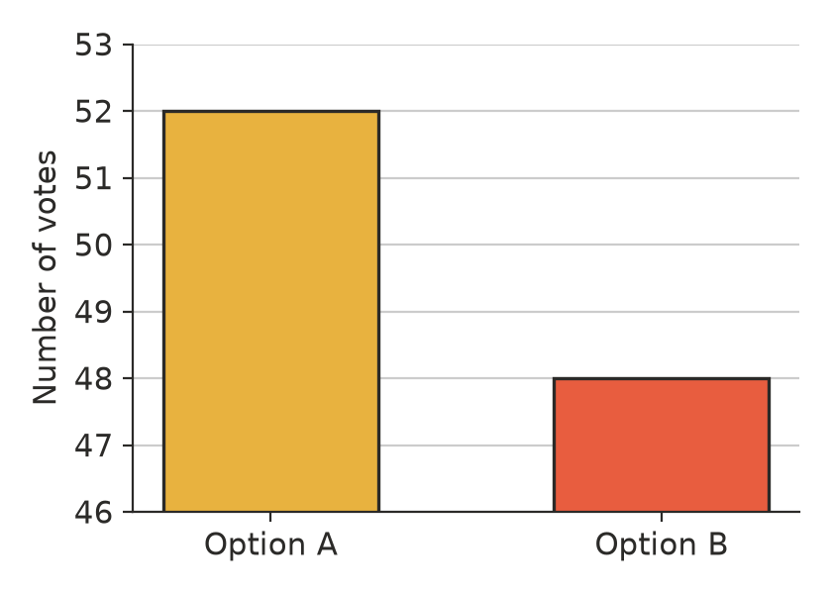
  - Sam says, “Option A got three times as many votes as Option B.” Explain why Sam is wrong. (1 mark)

  - How many more votes did Option A get than Option B? (1 mark)

- The back-to-back stem-and-leaf plot shows the scores out of 50 on a science quiz for two Year 9 classes.
9A (leaf) | Stem | 9B (leaf)
8 | 1 | 2 4 7 9
8 5 | 2 | 1 2 2 3 5 6 8
9 7 6 6 4 3 1 | 3 | 1 5
7 4 2 1 | 4 | 9

- Key: 5 | 2 | 1 means 25 for 9A and 21 for 9B
  - Find the median score for each class. (2 marks)

  - Which score in 9B is an outlier? (1 mark)

  - Describe the shape of the 9B scores. (1 mark)

  - Which class did better on the quiz? Compare the centre and the spread of the two classes. (2 marks)

- A farmer weighed the watermelons she picked one morning. The histogram shows her results.
- 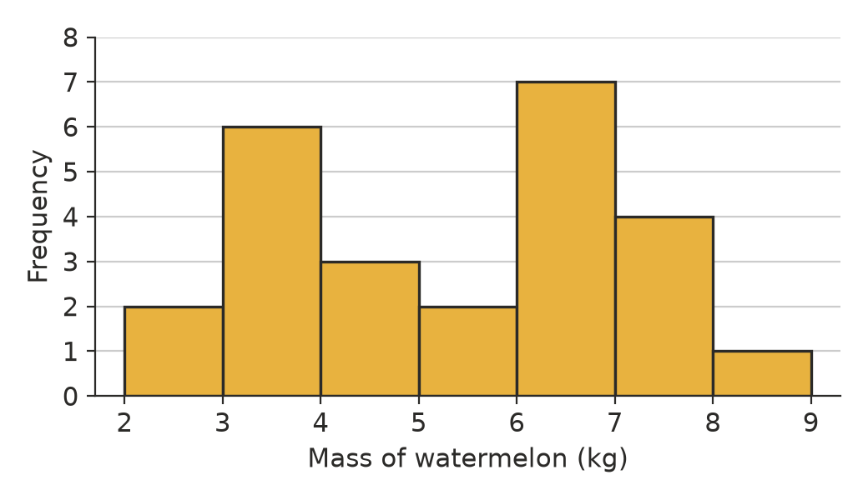
  - How many watermelons did she weigh? (1 mark)

  - Describe the shape of the distribution. (1 mark)

  - Suggest a reason why the data might have this shape. (1 mark)

- These are the ages of the 18 young people at a youth group camp. Complete the frequency table. (2 marks)
- 12, 15, 13, 17, 14, 16, 19, 13, 12, 18, 15, 14, 16, 13, 17, 20, 15, 14
Age (years) | Frequency
12–13
14–15
16–17
18–19
20–21
Total

- Seven friends get this much pocket money each week.
- $10, $12, $15, $15, $18, $20, $25
- The friend who gets $25 starts getting an extra $40 each week from her grandparents. Without calculating, explain what happens to the mean and to the median of the data. (2 marks)

- The six values below are in order from smallest to largest. Two digits are missing. The median is 25 and the mean is 26. Find the two missing digits. (2 marks)
- 14, 18, 2□, 27, 3□, 41

- A TV news program ran an online poll: “Should daylight saving be scrapped?” Of the 4800 viewers who voted, 72% said yes. The program reported that “most Australians want daylight saving scrapped”.
  - Give one reason why the poll may not represent all Australians. (1 mark)

  - The program said 4800 votes is a huge sample, so the result must be accurate. Explain why a large sample does not fix the problem. (1 mark)

- A report says: “A random sample of 200 Year 9 students from schools across WA found that the median time spent on homework is 45 minutes a night.”
  - What is the population in this report? (1 mark)

  - Is it reasonable to use this sample to estimate the median for all Year 9 students in WA? Explain. (1 mark)

 Section B: Calculator allowed
- The table shows the distances that 40 students travel to school.
Distance (km) | Frequency
0 ≤ d < 5 | 12
5 ≤ d < 10 | 9
10 ≤ d < 15 | 8
15 ≤ d < 20 | 6
20 ≤ d < 25 | 5

  - Use the midpoint of each class to estimate the mean distance. Show your working. (2 marks)

  - Explain why your answer to part a) is only an estimate. (1 mark)

- A fruit shop compares random samples of 8 apples from two orchards. The masses, in grams, are:
- Orchard X: 142, 155, 148, 160, 151, 139, 157, 148
- Orchard Y: 130, 175, 162, 128, 169, 140, 181, 135
  - Find the mean mass for each orchard. (1 mark)

  - Find the median mass for each orchard. (1 mark)

  - Find the range for each orchard. (1 mark)

  - A café wants apples that are all close to the same size. Which orchard should it buy from? Explain. (1 mark)

- A town has 2500 households. A random sample of 40 households owns a total of 98 dogs.
  - Estimate the number of dogs in the town. (1 mark)

  - Suppose all 40 households in the sample had been on farms. Would the estimate be likely to be too high or too low? Explain. (1 mark)

- The mean of six numbers is 15. Two more numbers are added, and the mean of all eight numbers is 17. The two new numbers differ by 4. Find the two new numbers. Show your working. (3 marks)

 Answer sheet
Name: ____________________
Write your final answer for each question in the table.
Question | Answer | Marks | Question | Answer | Marks
1a |  | /1 | 8 |  | /2
1b |  | /1 | 9 |  | /2
1c |  | /1 | 10a |  | /1
2a |  | /1 | 10b |  | /1
2b |  | /1 | 11a |  | /1
3 |  | /2 | 11b |  | /1
4a |  | /1 | 12a |  | /2
4b |  | /1 | 12b |  | /1
5a |  | /2 | 13a |  | /1
5b |  | /1 | 13b |  | /1
5c |  | /1 | 13c |  | /1
5d |  | /2 | 13d |  | /1
6a |  | /1 | 14a |  | /1
6b |  | /1 | 14b |  | /1
6c |  | /1 | 15 |  | /3
7 | (in the table) | /2
 |  |  |  | Total | /40

