Statistics: Practice test 1
Year 9 Maths · Test · Test 1
Name: ____________________ Date: ______________
Time: 45 minutes
Total: 40 marks
Show your working in the boxes. Then write each final answer on the answer sheet on the last page.

 Section A: No calculator
- Classify each variable as categorical (nominal or ordinal) or numerical (discrete or continuous).
  - The number of goals kicked by each player in a footy match. (1 mark)

  - The time each runner takes to finish the school cross-country. (1 mark)

  - The shirt size (S, M, L or XL) of each camper at a church camp. (1 mark)

- Choose the best display for each data set from this list: pie chart, line graph, stem-and-leaf plot, histogram. Give a reason for each choice.
  - The temperature at a beach, recorded every hour from 6 am to 6 pm. (1 mark)

  - The heights of all 160 students in Year 9. (1 mark)

- A town council wants to know whether its residents want a new skate park. It surveys 50 people at the old skate ramp on a Saturday afternoon.
  - Explain why this sample is likely to be biased. (1 mark)

  - Describe a better way to choose the sample. (1 mark)

- The canteen manager made this graph to show that pie sales have “skyrocketed”.
- 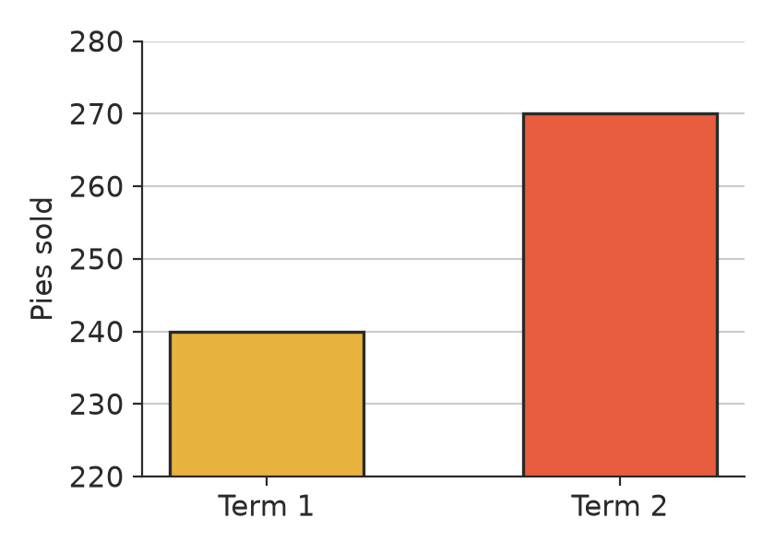
  - Explain why the graph is misleading. (1 mark)

  - By what percentage did pie sales actually increase from Term 1 to Term 2? (1 mark)

- Fifteen students recorded how many push-ups they could do in one minute, before and after a six-week fitness program.
Before (leaf) | Stem | After (leaf)
9 7 4 | 1
8 6 6 5 3 2 | 2 | 1 5 8
7 4 2 1 | 3 | 0 2 3 5 6 6 8
4 0 | 4 | 1 2 5 7
 | 5 | 2

- Key: 4 | 2 | 1 means 24 push-ups before and 21 push-ups after
  - Find the median number of push-ups before and after the program. (2 marks)

  - Find the range before and after the program. (1 mark)

  - Did the program improve the students’ fitness? Use the centre and the spread of the data to support your answer. (2 marks)

- These are the lengths, in centimetres, of 20 bream caught on a family fishing trip.
- 22, 27, 31, 24, 29, 33, 28, 26, 35, 30, 21, 27, 32, 29, 38, 26, 28, 34, 30, 25
Length (cm) | Frequency
20 ≤ L < 25
25 ≤ L < 30
30 ≤ L < 35
35 ≤ L < 40
Total

  - Complete the frequency table. (2 marks)

  - Write down the modal class. (1 mark)

- The histogram shows how long 40 shoppers spent at a farmers market.
- 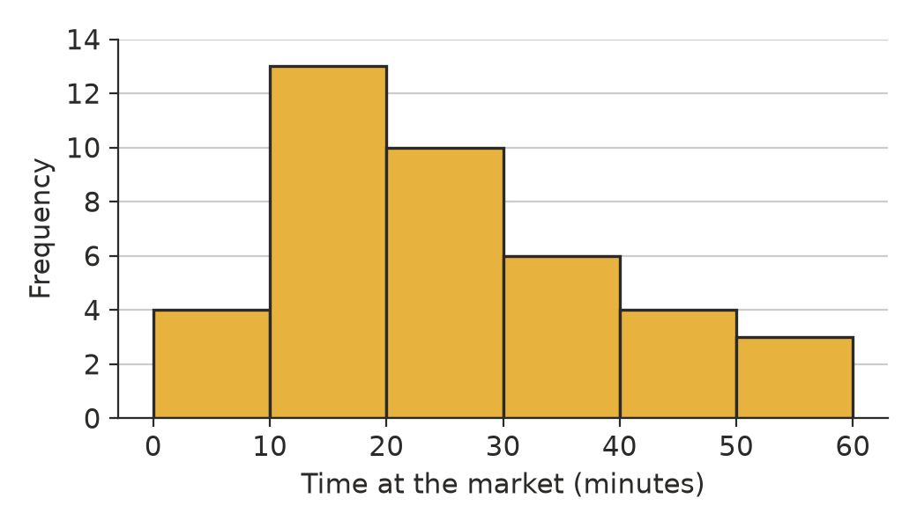
  - How many shoppers spent 30 minutes or more at the market? (1 mark)

  - Write down the modal class. (1 mark)

  - Describe the shape of the distribution. (1 mark)

- These are the scores out of 20 on a class quiz. One student arrived late and only answered a few questions.
- 15, 16, 14, 17, 15, 18, 16, 15, 3
  - Which score is an outlier? (1 mark)

  - Which measure of centre is affected more by the outlier, the mean or the median? Explain. (1 mark)

- Five whole numbers have a mean of 9, a median of 7, a mode of 6 and a range of 9. Find the five numbers. (2 marks)

- A news website reports: “9 out of 10 Aussies love our new energy drink!” The survey was run by the drink company, which asked 20 people at the drink’s launch party. Give two reasons why this claim may not be reliable. (2 marks)

- The canteen recorded the flavour of each of the 50 ice blocks it sold on Monday.
  - Which measure of centre can be used for this data: the mean, the median or the mode? (1 mark)

  - Explain why the other two measures cannot be used. (1 mark)

 Section B: Calculator allowed
- Use the histogram in Question 7.
  - Use the midpoint of each class to estimate the mean time the shoppers spent at the market. Show your working. (2 marks)

  - What percentage of the shoppers spent less than 20 minutes at the market? (1 mark)

- A cricket selector compares the runs scored by two batters in their last 8 innings.
- Batter A: 34, 0, 52, 41, 28, 105, 37, 31
- Batter B: 45, 38, 41, 50, 36, 44, 39, 47
  - Find the mean for each batter. (1 mark)

  - Find the median for each batter. (1 mark)

  - Find the range for each batter. (1 mark)

  - The selector wants a batter who scores well in most innings. Which batter should she choose? Use your answers to explain. (1 mark)

- A farmer has 2400 sheep. She shears a random sample of 60 sheep and finds that the mean fleece mass is 4.6 kg.
  - Estimate the total mass of wool from the whole flock. (1 mark)

  - Suppose she had sheared the 60 biggest sheep instead. How would this affect her estimate? (1 mark)

- The mean score of 12 students on a test is 68. One more student sits the test, and the mean score of all 13 students becomes 70.
  - Find the score of the extra student. Show your working. (2 marks)

  - The lowest score of the 13 students, 41, is then found to be a mistake and is removed. Find the new mean, correct to one decimal place. (1 mark)

 Answer sheet
Name: ____________________
Write your final answer for each question in the table.
Question | Answer | Marks | Question | Answer | Marks
1a |  | /1 | 8a |  | /1
1b |  | /1 | 8b |  | /1
1c |  | /1 | 9 |  | /2
2a |  | /1 | 10 |  | /2
2b |  | /1 | 11a |  | /1
3a |  | /1 | 11b |  | /1
3b |  | /1 | 12a |  | /2
4a |  | /1 | 12b |  | /1
4b |  | /1 | 13a |  | /1
5a |  | /2 | 13b |  | /1
5b |  | /1 | 13c |  | /1
5c |  | /2 | 13d |  | /1
6a | (in the table) | /2 | 14a |  | /1
6b |  | /1 | 14b |  | /1
7a |  | /1 | 15a |  | /2
7b |  | /1 | 15b |  | /1
7c |  | /1
 |  |  |  | Total | /40

