11.06 Compare data sets
Year 9 Maths · A5 question sheet · Level 2 · Core
This worksheet practises comparing two groups using their centre (mean, median), spread (range, IQR) and shape, and writing a clear conclusion in context. Tip: a difference between two medians is strong evidence only if it is large compared with the spread of the data; if the two groups overlap a lot, be careful about your conclusion.

 Understanding
- The dot plots show the scores of the students in 9R and 9T on a spelling quiz.
- 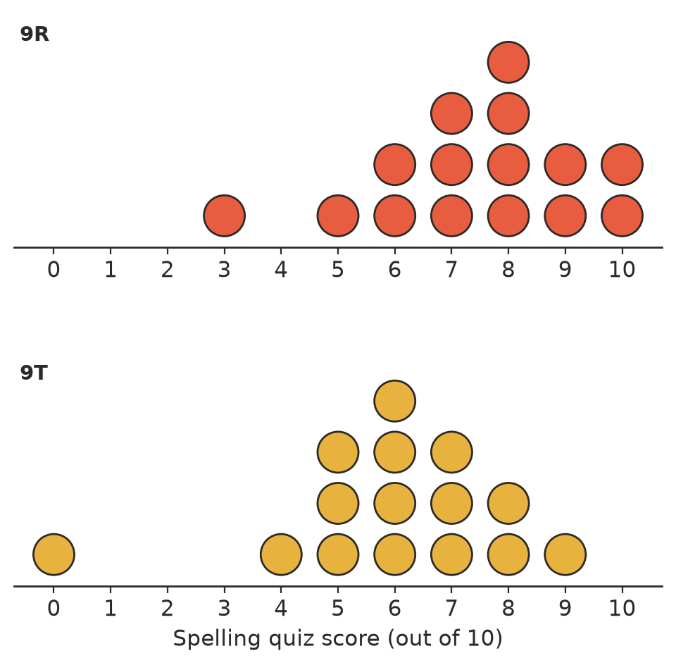
  - Find the median of each class.
  - Find the range and the IQR of each class.
  - The scores add up to 111 for 9R and 89 for 9T. Find each class’s mean, correct to 1 decimal place.
  - Which value is an outlier? Find that class’s range and mean without it.
- The table shows the lifetimes (in hours) of samples of two brands of battery.
Brand | Mean | Median | Range | IQR
Brand X | 42 | 41 | 15 | 4
Brand Y | 45 | 47 | 30 | 12

  - Which brand generally lasts longer? Use two statistics.
  - Which brand is more consistent? Use two statistics.

 Fluency
- The times (in minutes) for 12 Year 7 and 12 Year 9 students to complete a cross-country course were:
Group | Times (minutes)
Year 7 | 18, 23, 28, 16, 22, 33, 21, 22, 19, 25, 26, 20
Year 9 | 15, 13, 14, 18, 24, 29, 17, 22, 16, 20, 17, 19

  - Copy and complete the table.
 | Mean | Median | Range | Q1 | Q3
Year 7
Year 9

  - Which group was faster? Which was more consistent?
- The plot shows the heights (in cm) of 11 plants of each of two bean varieties, six weeks after planting.
Leaf (Variety A) | Stem | Leaf (Variety B)
 | 2 | 4 9
8 5 2 | 3 | 3 6
9 7 6 4 3 1 | 4 | 0 2 5
8 2 | 5 | 1 5
 | 6 | 1 7

- Key: 4 | 0 = 40 cm
  - Find the median and the IQR of each variety.
  - The heights add up to 485 cm for A and 483 cm for B. Find each mean, correct to 1 decimal place.
  - Compare the shapes of the two distributions.

 Reasoning
- Write a short paragraph comparing the quiz scores of 9R and 9T in Question 1. Mention centre, spread and shape, with numbers.
- In Question 1, explain why the IQR is a better measure than the range for comparing the spread of the two classes.
- Class A’s median test mark is 64% and Class B’s is 62%. Both classes have an IQR of about 20%, and the marks overlap a lot. Lucy says, “Class A is definitely better at maths.” Is the evidence strong? Explain.

 Problem solving
- A farmer wants bean plants that are all about the same height, so they can be harvested by machine. Which variety in Question 4 should she plant? Explain using statistics.
- Use Question 2. Which brand of battery would you choose for:
  - a smoke alarm, where you want to know when the battery will run out?
  - a torch for a camping trip, where you just want the longest life?
- Set P is 12, 15, 18, 20, 25. Set Q is 10, 14, 16, 21, 30 and x. The two sets have the same median. Find x.
- The 24 students in Question 3 were the students who volunteered from one school. Can we use the results to say that Year 9 students in Australia run faster than Year 7 students? Explain.
- Write two data sets of 5 whole numbers each, with the same median but different IQRs.

