11.06 Compare data sets
Year 9 Maths · A5 question sheet · Level 1 · Warm-up
To compare two data sets, look at their centre (mean or median: which group is generally higher?) and their spread (range: which group is more consistent?). A smaller spread means the values are closer together, so the group is more consistent. Tip: a good comparison uses numbers from the data and says what they mean in the context.

 Understanding
- The dot plots show the number of goals two netball shooters scored in 10 games each.
- 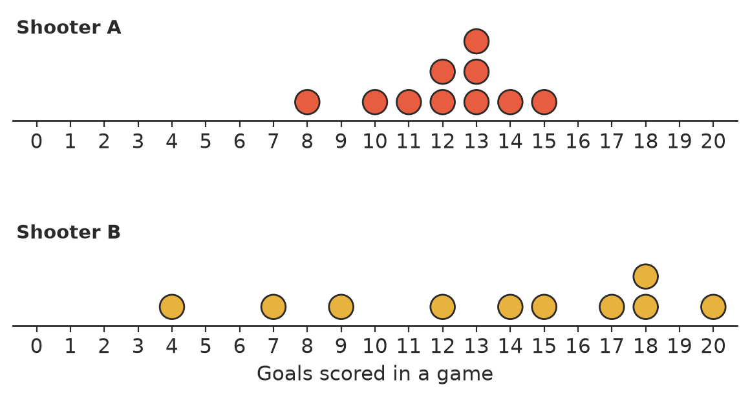
  - Find the median for each shooter.
  - Find the range for each shooter.
  - Which shooter generally scored more goals?
  - Which shooter was more consistent?
- The table shows statistics for the runs scored by two cricketers this season.
 | Mean | Median | Range
Mia | 32 | 30 | 18
Zoe | 35 | 28 | 64

  - Which player has the higher mean?
  - Which player is more consistent? How do you know?
  - Zoe’s range is very large. What does this tell you about her scores?
- The maximum temperatures (°C) in two towns for the same week were:
Town | Temperatures (°C)
Town A | 22, 24, 25, 25, 26, 27, 26
Town B | 18, 21, 24, 27, 30, 29, 26

  - Find the mean, median and range for each town.
 | Mean | Median
Town A
Town B

  - Both towns have the same mean. How are their temperatures different?

 Fluency
- Two groups of students did a puzzle. One group listened to music and the other worked in silence. Their times (in seconds) were:
Group | Times (seconds)
Music | 48, 60, 40, 55, 45, 52
Silence | 44, 35, 47, 41, 38, 47

  - Find the mean, median and range for each group.
 | Mean | Median
Music
Silence

  - Which group was faster in general?
  - Which group’s times were more consistent?
- Complete each sentence about Question 4 using higher, lower, larger or smaller.
  - The median time for the silence group was ______________ than for the music group.
  - The range for the music group was ______________ than for the silence group.

 Reasoning
- Explain why it is not enough to compare only the means of two groups. Use Question 3 as an example.
- One group’s data has an outlier. Should you compare the groups using the mean or the median? Explain.

 Problem solving
- A coach needs a shooter for the grand final, where a steady, reliable game is most important. Which shooter from Question 1 should she choose? Give a reason using the statistics.
- Group A’s values are 6, 8, 9 and 13. Group B’s values are 5, 10, 11 and x. Both groups have the same mean. Find x.
- Write two sentences comparing the two shooters in Question 1: one about the centre and one about the spread. Use numbers.
- Two machines fill bags of rice. Both machines have a mean of 1000 g. Machine A’s bags range from 990 g to 1010 g. Machine B’s bags range from 950 g to 1050 g. Which machine is better? Explain.

