11.05 Shape of data
Year 9 Maths · A5 question sheet · Level 3 · Challenge
This worksheet looks closely at how the shape of a distribution and its outliers affect the mean, median, range and IQR, and asks you to work backwards and to build data sets with a given shape. Tip: in positively skewed data the mean is usually greater than the median; in negatively skewed data it is usually less; in symmetrical data they are about the same.

 Understanding
- The histogram shows how long 40 students spent on social media yesterday. The dashed lines P and Q mark the median and the estimated mean, but not in that order.
- 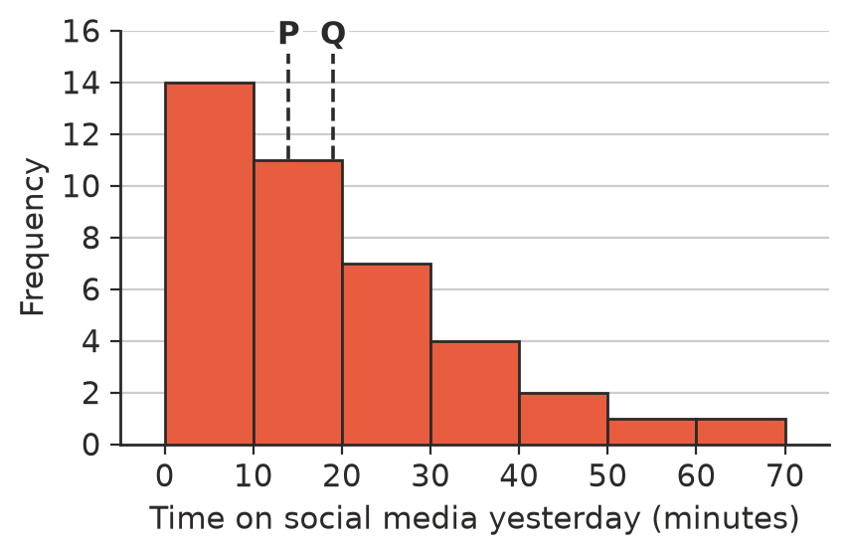
  - Describe the shape of the data.
  - Which line marks the median and which marks the mean? Explain without calculating.
  - Estimate the mean using class centres, and check your answer to part b).
- For each data set, decide whether the mean is greater than, less than or about equal to the median, without calculating. Give a reason.
  - The number of children in each family in a town
  - The marks on a test that almost everyone found easy
  - The heights of all the Year 9 girls in a large school

 Fluency
- The mean of 12 values is 15. One of the values, 15, is replaced by a new value x, and the mean rises to 17. Find x.
- The five values 12, 14, 15, 17 and x have a mean that is 4 more than their median. Find x, and say whether x is an outlier.
- A small company pays its seven workers $55 000, $58 000, $60 000, $62 000, $65 000, $70 000 and $72 000 a year, and the owner pays herself $400 000.
  - Find the mean and median of all eight salaries.
  - The owner says, “The average salary here is over $100 000.” The workers say, “Most of us earn less than $66 000.” Who is right? Explain.
  - Which measure better describes a typical salary at the company?
- Ten values have a mean of 50 and a median of 48. A new value of 150 is added.
  - Find the new mean, correct to 1 decimal place.
  - Can you find the new median exactly? What can you say about it?

 Reasoning
- “If the mean and median of a data set are equal, the data must be symmetrical.” Show that this is false by giving a counterexample with five values.
- A scientist measures the growth of 20 plants. One plant grew far more than the others. Give one good reason to keep this outlier in the data and one situation where it would be right to remove it.
- Sam looks at Question 1 and says, “The mean is 19 minutes, so half the students spent more than 19 minutes on social media.” Explain why Sam’s reasoning is wrong.
- Two Year 9 classes measured their reaction times. Each class’s results were symmetrical with one peak, but when the two classes were combined, the results were bimodal. What does this tell you about the two classes?

 Problem solving
- Write a data set of 8 whole numbers that is bimodal and has a mean and a median both equal to 20.
- Write a data set of 7 whole numbers with a median of 30, a mean of 25 and a range of 40. Describe its shape.
- A set of 9 values is positively skewed, with mean 30 and median 24. The largest value, 84, was a recording error and should have been 48. Find the new mean. Explain whether the median changes, and whether the data is still positively skewed.

