11.05 Shape of data
Year 9 Maths · A5 question sheet · Level 2 · Core
This worksheet practises describing the shape of a distribution (symmetrical, positively or negatively skewed, unimodal or bimodal), spotting clusters, gaps and outliers, and seeing how outliers and skew affect the mean, median, range and IQR. Tip: in skewed data the mean is pulled towards the tail, so the median is usually the better measure of a typical value.

 Understanding
- Look at the four histograms.
- 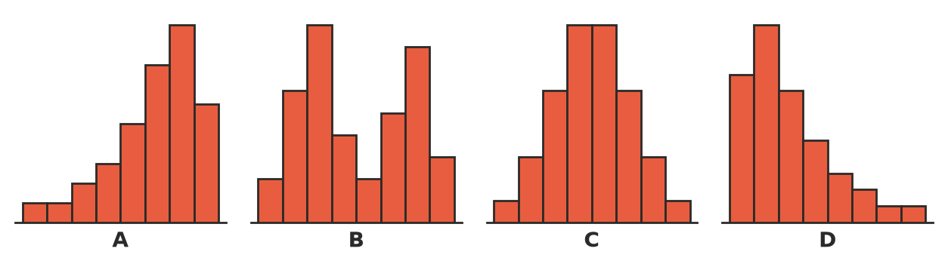
  - Describe the shape of each histogram.
  - Match each histogram with the data set it most likely shows.

    - The heights of 50 adult women

    - The marks on a very easy test

    - The ages of everyone at a children’s playground, including parents

    - The number of hours of TV each student watched last week
- The dot plot shows how long 23 workers take to travel to work.
- 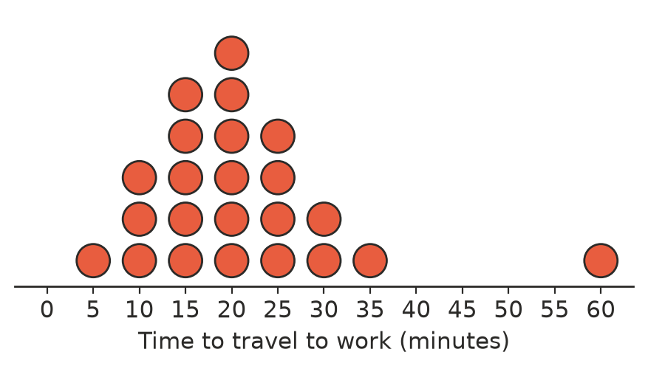
  - Describe the shape of the data, and name any outlier.
  - The times add up to 485 minutes. Find the mean and the median, correct to 1 decimal place.
  - Find the mean without the outlier.

 Fluency
- The prices of the eight houses sold in a street last year (in thousands of dollars) were:
- 520, 545, 560, 580, 600, 615, 640, 2400
  - Find the mean, median, range and IQR.
  - Find the mean, median, range and IQR without the $2.4 million house.
  - Which measures changed a lot, and which hardly changed?
- For the data 2, 3, 3, 4, 4, 4, 5, 9, 12:
  - Find the mean (to 1 decimal place) and the median.
  - Use your answers to describe the shape of the data.
- The stem-and-leaf plot shows the ages of the 21 people in the pool at a swim school one afternoon.
Stem | Leaf
0 | 5 6 7 7 8 9 9
1 | 0 1 2
2 | 8
3 | 1 4 5 6 8 9
4 | 0 2 3 5

- Key: 3 | 1 = 31 years
  - Describe the shape of the data, including any clusters.
  - The ages add up to 495. Find the mean (to 1 decimal place) and the median.
  - Do the mean and median describe a typical person in the pool? Explain.

 Reasoning
- News reports about house prices usually give the median price, not the mean. Use Question 3 to explain why.
- Explain why one outlier changes the range a lot but hardly changes the IQR.
- A bimodal shape often means that two different groups have been mixed together. Explain how this happened in Question 5.

 Problem solving
- The mean of 10 values is 24. One value, 78, is an outlier and is removed. Find the mean of the other 9 values.
- Write a set of 7 whole numbers that is positively skewed, has a median of 10 and contains one outlier.
- A teacher adds 5 bonus marks to every student’s test mark. Explain what happens to the mean, the median, the range and the shape of the marks.
- A report says “the average Australian worker earns $1800 a week”. Most workers earn less than this. Explain how this can be true, and which measure of centre the report probably used.
- Would you expect each data set to be symmetrical, positively skewed, negatively skewed or bimodal? Give a reason.
  - The number of goals scored by each player in a netball league over a season
  - The times of runners finishing a fun run that includes both serious athletes and walkers
  - The lifetimes of a brand of light globe that is well made (most last close to 1000 hours)

