11.05 Shape of data
Year 9 Maths · A5 question sheet · Level 1 · Warm-up
The shape of a data set tells you how the values are spread out. Data is symmetrical if both sides look about the same. It is positively skewed if the tail stretches out to the right (towards the bigger values), and negatively skewed if the tail stretches out to the left. Data with two peaks is bimodal. Tip: the skew is named after the side with the long tail, not the side with the peak.

 Understanding
- Look at the four dot plots.
- 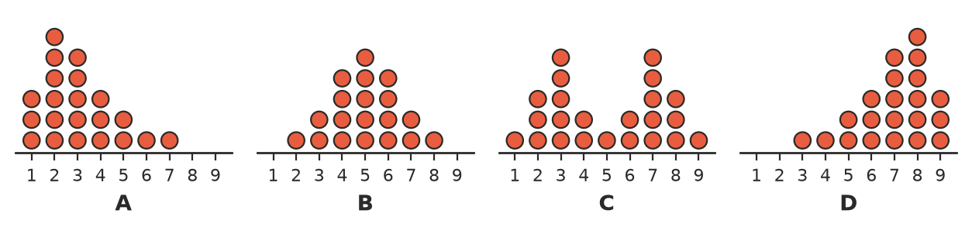
- Write the letter of the plot that is:
  - symmetrical
  - positively skewed
  - negatively skewed
  - bimodal
- The dot plot shows how long 17 students waited for the bus one morning.
- 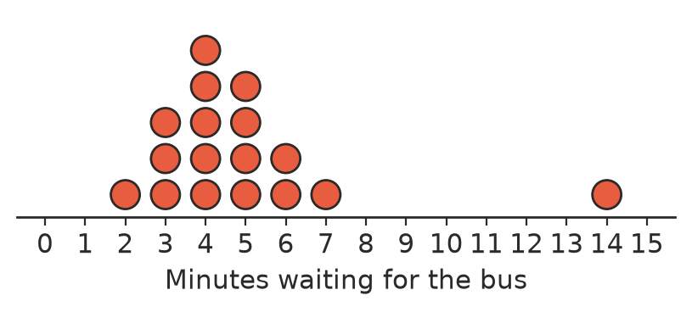
  - Which value is an outlier (a value far away from the rest)?
  - Most of the data is in a cluster (a group of values close together). Between which values is the cluster?
  - Where is there a gap (a stretch with no values)?
  - Ignoring the outlier, is the shape symmetrical, positively skewed or negatively skewed?
- Copy and fill in the gaps with the words left, right, peaks or outlier.
  - A positively skewed data set has a long tail on the ______________ side.
  - A negatively skewed data set has a long tail on the ______________ side.
  - A bimodal data set has two ______________ .
  - A value that is much bigger or much smaller than the rest of the data is an ______________ .

 Fluency
- The ages of the people at a Year 7 birthday party were:
- 11, 12, 12, 13, 14, 14, 15, 45
  - Which age is an outlier? Suggest who this person might be.
  - Find the mean and the median of all eight ages.
  - Find the mean and the median without the outlier.
  - Which measure changed more when the outlier was removed: the mean or the median?
- The stem-and-leaf plot shows the marks (out of 100) of 22 students on an easy test.
Stem | Leaf
4 | 5
5 | 2 8
6 | 1 4 7
7 | 0 3 5 6 9
8 | 1 2 4 5 6 7 8
9 | 0 1 3 4

- Key: 7 | 3 = 73
  - Turn the page so the stems are at the bottom. Where is the peak, and where is the tail?
  - Describe the shape of the data.
- The histogram shows the price some students paid for their mobile phone.
- 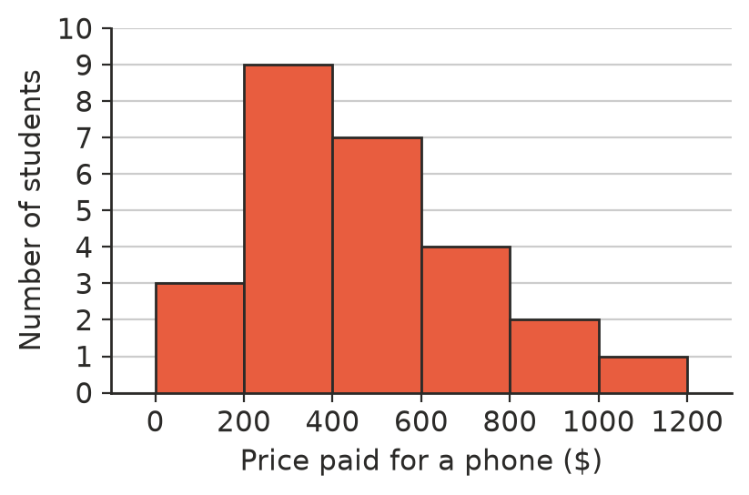
  - Describe the shape of the data.
  - Which class is the modal class?

 Reasoning
- In Question 4, which measure of centre, the mean or the median, gives a better idea of a typical age at the party? Explain.
- Would you expect each data set to be symmetrical, positively skewed or negatively skewed? Give a reason.
  - The heights of adult men in Australia
  - The number of cars owned by each family in a town (most have 1 or 2)
  - The age at which people retire

 Problem solving
- Add one value to the data set 3, 4, 5, 5, 6 so that it stays symmetrical.
- In Question 2, the 14-minute wait is removed. Which of the mean, median and range changes the most? Explain.
- The mean of a data set is much bigger than its median. Is the data more likely to be positively or negatively skewed? Explain.

