11.04 Grouped histograms
Year 9 Maths · A5 question sheet · Level 3 · Challenge
This worksheet practises grouped frequency tables and histograms with decimals, working backwards from an estimated mean, comparing groups of different sizes with percentages, and thinking about how the choice of classes changes the picture. Tip: the true mean of grouped data must lie between the mean you get using every lower class limit and the mean you get using every upper class limit.

 Understanding
- The histogram shows the distance 60 members of a cycling club rode last week.
- 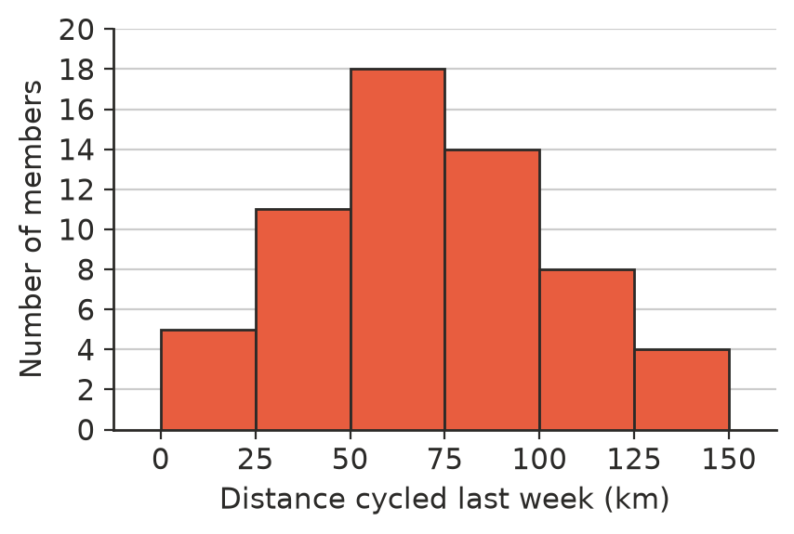
  - Copy and complete the table.
Distance (km) | Frequency | Cumulative frequency | Class centre
0–<25
25–<50
50–<75
75–<100
100–<125
125–<150
Total

  - Estimate the mean distance, correct to 1 decimal place.
  - Which class contains the median?
  - What percentage of members rode 100 km or more?
  - Assuming the distances in the 75–<100 class are spread evenly, estimate how many members rode 90 km or more.

 Fluency
- The times (in seconds) 24 students took to solve a puzzle are listed below.
- 24.1, 33.8, 41.3, 30.6, 25.3, 29.9, 44.0, 38.7, 24.9, 34.4, 29.1, 31.2, 26.0, 16.2, 26.7, 27.8, 22.8, 32.5, 21.4, 18.9, 36.1, 28.4, 23.5, 27.2
  - Copy and complete the table.
Time (s) | 15–<20 | 20–<25 | 25–<30 | 30–<35 | 35–<40 | 40–<45
Frequency

  - Draw a histogram of the data.
- 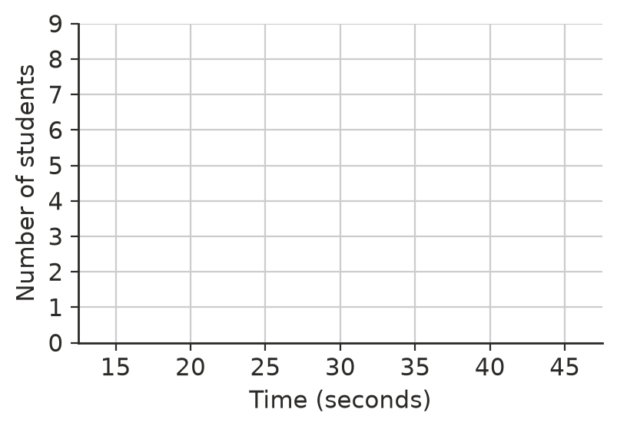
  - Estimate the mean time.
  - The times add up to 694.8 s. Find the actual mean, and the difference between the estimate and the actual mean.
- The table shows the times 35 people waited at a bus stop. The estimated mean is 25 minutes. Find a and b.
Wait (minutes) | 0–<10 | 10–<20 | 20–<30 | 30–<40 | 40–<50
Frequency | 3 | a | 12 | b | 2

- For the cycling data in Question 1, find the mean you would get if every member rode the lower limit of their class, and the mean if every member rode the upper limit. What does this tell you about the true mean?

 Reasoning
- A survey asked 120 Year 9 students and 80 Year 12 students how much they slept last night.
Sleep (hours) | 5–<6 | 6–<7 | 7–<8 | 8–<9 | 9–<10
Year 9 | 6 | 18 | 42 | 36 | 18
Year 12 | 8 | 20 | 30 | 16 | 6

  - Explain why drawing the two histograms with the same frequency axis could be misleading.
  - Find the percentage of each year group in each class.
  - Estimate the mean sleep for each year group, correct to 2 decimal places.
  - Write a conclusion comparing the two year groups.
- Both histograms show the same 40 values.
- 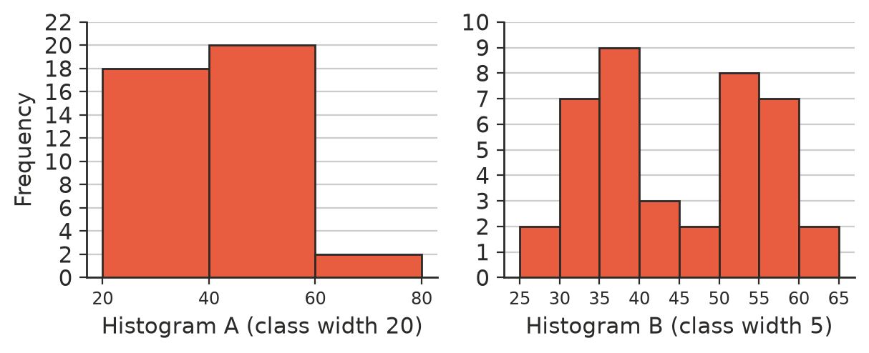
  - Describe what each histogram suggests about the data.
  - Which histogram is more useful, and why? What could go wrong if the class width is made very small, such as 1?
- Explain why the vertical axis of a histogram should always start at 0.

 Problem solving
- A teacher regroups the puzzle times from Question 2 into just two classes: 15–<30 and 30–<45.
  - Find the frequency of each class and the new estimated mean, correct to 2 decimal places.
  - Compare the new estimate with your answers to Question 2. What does this suggest about using very wide classes?
- Use the table in Question 5. Estimate the mean sleep for all 200 students, correct to 2 decimal places.
- Ten more cyclists join the club in Question 1. They all rode between 25 and 50 km last week. Find the new estimated mean, correct to 1 decimal place. Does the class containing the median change?
- A histogram has classes 0–<10, 10–<20 and 20–<30, with frequencies 4, 10 and 6. Ellie says the median must be 15. Explain why she cannot be sure, and say what you can say about the median.
- Design a grouped frequency table with 4 classes of width 10, starting at 0, for 20 values, so that the estimated mean is exactly 20 and the modal class is 10–<20.
Class | 0–<10 | 10–<20 | 20–<30 | 30–<40
Frequency

