11.04 Grouped histograms
Year 9 Maths · A5 question sheet · Level 2 · Core
This worksheet practises grouping data into class intervals, drawing and reading histograms, finding the modal class and the class that contains the median, and estimating the mean using class centres. Tip: estimated mean = (sum of class centre × frequency) ÷ (total frequency).

 Understanding
- The histogram shows how long some Year 9 students spent on homework last night.
- 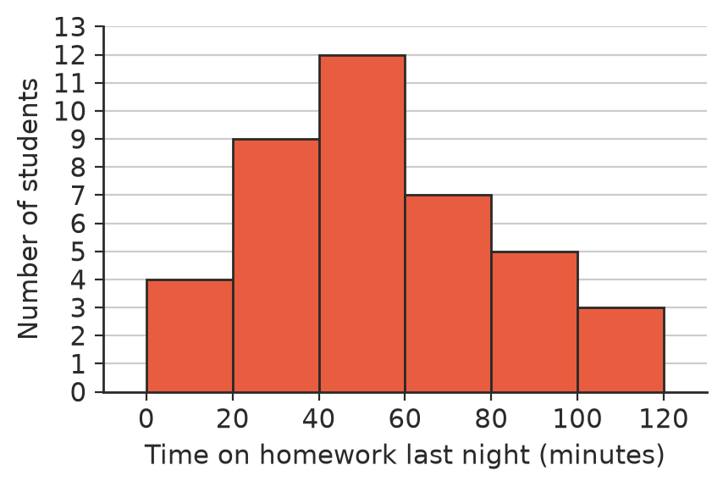
  - How many students were surveyed?
  - What is the modal class?
  - How many students spent 60 minutes or more on homework?
  - What percentage of students spent less than 40 minutes?
  - Which class contains the median?
  - Estimate the mean time.

 Fluency
- The masses (in grams) of 30 apples from an orchard are listed below.
- 152, 163, 138, 147, 144, 154, 155, 171, 145, 151, 157, 167, 137, 148, 142, 178, 128, 174, 152, 164, 124, 158, 131, 135, 149, 146, 161, 133, 143, 141
  - Copy and complete the table.
Mass (g) | Frequency | Class centre
120–<130
130–<140
140–<150
150–<160
160–<170
170–<180
Total

  - Estimate the mean mass.
  - The masses add up to 4488 g. Find the actual mean, and compare it with your estimate.
  - What percentage of the apples weigh 160 g or more?
- Draw a histogram of the apple data from Question 2.
- 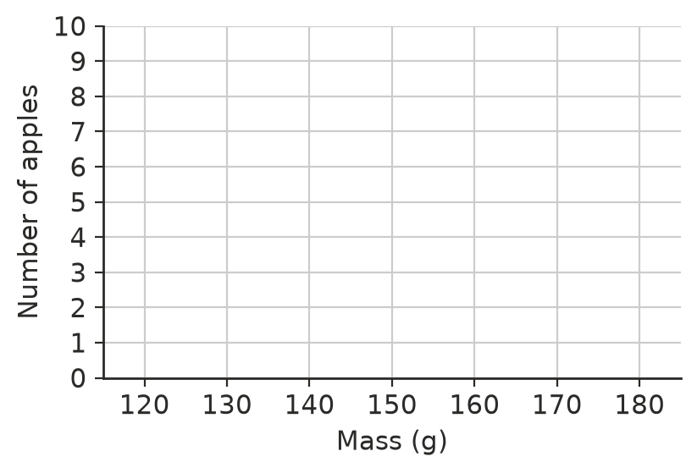
- The histograms show the ages of 50 people at a classical music concert and 50 people at a rock concert.
- 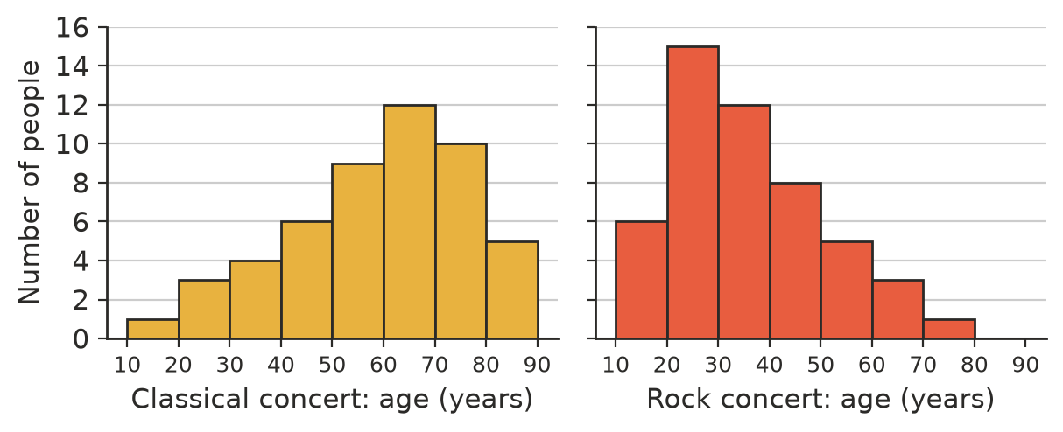
  - Write the modal class for each concert.
  - Which class contains the median age for each concert?
  - Estimate the mean age at each concert.
  - Write a sentence comparing the ages of the people at the two concerts.

 Reasoning
- Lily says a 60-minute homework time belongs in the 40–<60 class in Question 1. Is she right? Explain.
- In Question 2, the estimated mean and the actual mean are close but not the same. Explain why.
- Grouping data makes it easier to see the shape of a large data set, but something is lost. What is lost? Give an example from Question 1.
- Can you tell from the histogram in Question 1 exactly how many students spent more than 50 minutes on homework? Explain.

 Problem solving
- The table shows the number of minutes 15 + k people waited at a doctor’s surgery. The estimated mean is 17 minutes. Find k.
Wait (minutes) | 0–<10 | 10–<20 | 20–<30 | 30–<40
Frequency | 5 | 8 | k | 2

- Ten more people from the classical concert in Question 4 are surveyed, and all of them are aged 20–<30. Would the estimated mean age go up or down? Would the modal class change? Explain.
- A teacher grouped 28 test marks out of 100 into the classes 0–<50 and 50–<100. Explain why this is not a useful histogram, and suggest better classes.

