11.04 Grouped histograms
Year 9 Maths · A5 question sheet · Level 1 · Warm-up
When there is a lot of numerical data, we sort it into class intervals such as 150–<160, which means “150 up to but not including 160”. A histogram shows grouped data: the columns touch, because the classes join on to each other. The class centre is halfway between the ends of the class. Tip: the class with the highest column is the modal class.

 Understanding
- The histogram shows the heights of the students in a Year 9 class.
- 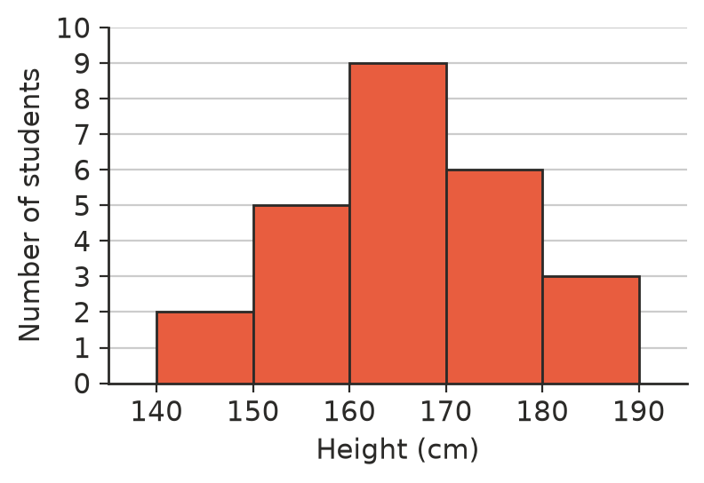
  - How many students are in the class?
  - Which class is the modal class?
  - How many students are 170 cm or taller?
  - How many students are shorter than 160 cm?
  - What percentage of the class is 170 cm or taller?
- These are the times (in minutes) 20 students take to walk to school.
- 3, 7, 12, 8, 15, 22, 4, 9, 11, 14, 13, 18, 10, 2, 13, 27, 8, 16, 12, 5
  - Copy and complete the frequency table.
Time (minutes) | Tally
0–<5
5–<10
10–<15
15–<20
20–<25
25–<30
Total

  - Which is the modal class?
  - How many students take 15 minutes or more?
- Write the class centre of each class.
  - 0–<10
  - 20–<30
  - 150–<160
  - 5–<10

 Fluency
- The table shows the masses of 25 dogs at a dog show.
Mass (kg) | 0–<10 | 10–<20 | 20–<30 | 30–<40 | 40–<50
Number of dogs | 3 | 7 | 9 | 4 | 2

- Draw a histogram of the data on a copy of the grid in your book.
- 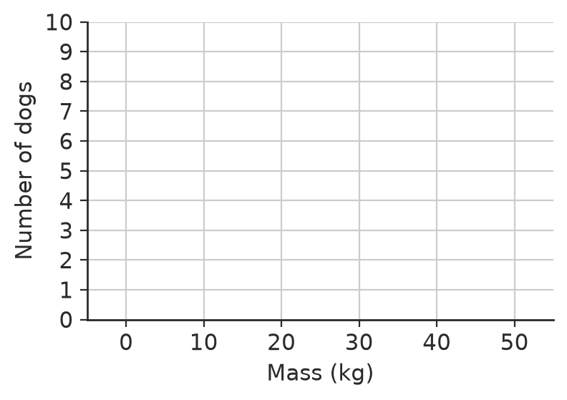
- We can estimate the mean of grouped data by pretending every value is at its class centre. Copy and complete the table for the dogs in Question 4, then estimate the mean mass.
Mass (kg) | Class centre | Frequency
0–<10 | 5 | 3
10–<20 |  | 7
20–<30 |  | 9
30–<40 |  | 4
40–<50 |  | 2
Total |  | 25

- Estimated mean = ______________ ÷ 25 =
- Look at the histogram in Question 1. There are 25 students, so the median is the 13th height. Which class contains the median?

 Reasoning
- Explain why we can only estimate the mean from a grouped frequency table.
- Give two differences between a histogram and a column graph.

 Problem solving
- A grouped frequency table shows the ages of 40 people at a family party. The frequencies of four classes are 6, 11, 9 and 5. The fifth class is missing. What is its frequency?
- In Question 2, Josh says, “The longest walk was 30 minutes.” Explain why the table cannot tell you this, but the list of data can.
- The marks of 30 students on a test go from 12 to 47. Suggest suitable class intervals for a frequency table, and explain your choice.

