11.02 Data displays
Year 9 Maths · Worksheet · Level 2 · Core
Name: ____________________ Date: ______________
This worksheet practises frequency tables (with cumulative frequency), dot plots, column graphs and sector graphs, choosing a display that suits the data, and spotting graphs that mislead. Tip: the cumulative frequency is a running total, so you can use it to find which value is in the middle.

 Understanding
- Twenty-five students were asked how many books they read last term.
Books read (x) | Frequency (f) | Cumulative frequency | f × x
0 | 3
1 | 5
2 | 7
3 | 4
4 | 4
5 | 2
Total

  - Complete the table.
  - What is the mode? ______________
  - Use the cumulative frequency to find the median. ______________
  - Find the mean. ______________
- The dot plot shows the number of pairs of shoes owned by some Year 9 students.
- 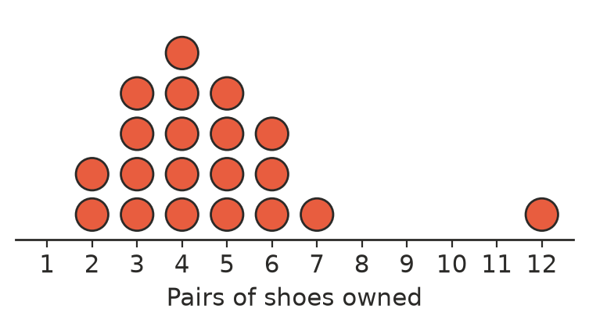
  - How many students are shown? ______________
  - Find the mode and the median. ______________
  - Find the mean. ______________
  - Which value is an outlier? ______________
  - Which measure, the mean or the median, better describes a typical student here? Explain. ______________
- Sixty people were asked their favourite takeaway food.
Food | Frequency | Percentage | Angle of sector
Pizza | 18
Burgers | 15
Sushi | 9
Thai | 12
Fish and chips | 6
Total | 60

  - Complete the table.
  - Explain how you found the angle for pizza. ______________
- The sector graph shows how the 480 students at a school travel to school.
- 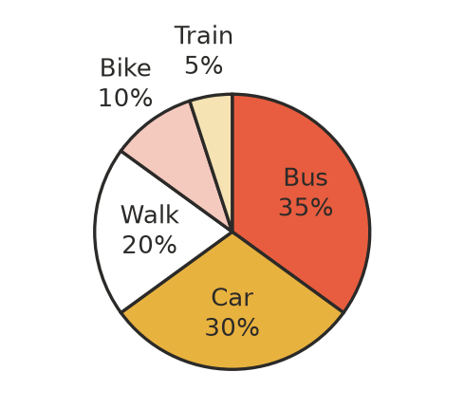
  - How many students catch the bus? ______________
  - How many more students come by car than walk? ______________
  - What is the angle of the sector for walking? ______________

 Fluency
- Choose the best display for each data set, and give a reason: column graph, sector graph, dot plot, stem-and-leaf plot or line graph.
  - The number of goals scored in each of 20 netball games ______________
  - The percentage of a family’s budget spent on rent, food, transport and other things ______________
  - The value of a car each year for 10 years ______________
  - The heights (in cm) of 30 Year 9 students, keeping every value ______________
- A bus was late on 16 school days. These are the numbers of minutes it was late.
- 0, 2, 1, 0, 3, 5, 2, 1, 0, 2, 4, 2, 1, 9, 2, 3
  - Draw a dot plot of the data.
- 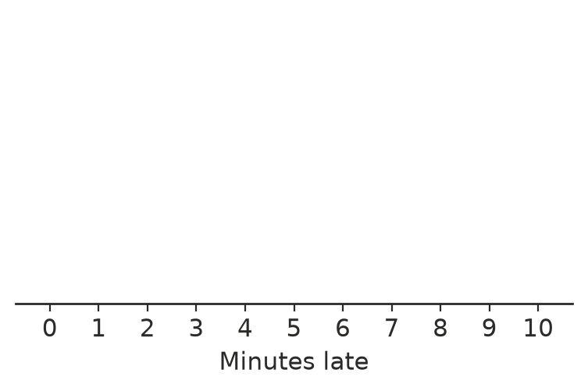
  - Find the median. ______________
  - Find the mean, correct to 1 decimal place. ______________
- The table shows the number of people in each of 30 cars that drove past the school.
People in the car | 1 | 2 | 3 | 4 | 5
Number of cars | 14 | 9 | 4 | 2 | 1

- Find the mean number of people per car. ______________

 Reasoning
- A football club put this graph in its newsletter.
- 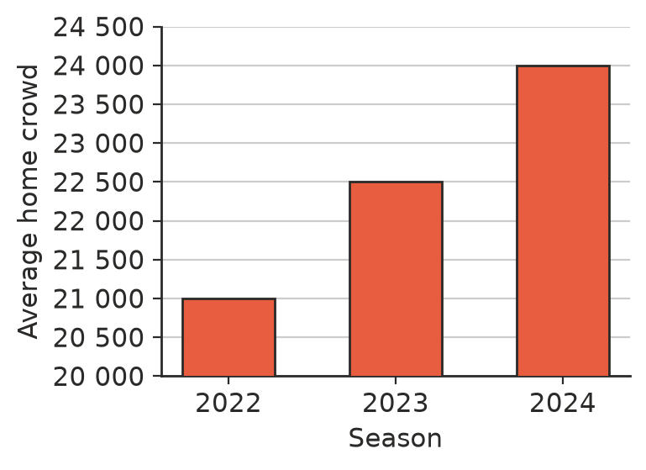
  - By what percentage did the average crowd grow from 2022 to 2024? Give your answer to 1 decimal place. ______________
  - The 2024 column looks how many times as tall as the 2022 column? ______________
  - Why might the club have drawn the graph this way? How should it be drawn? ______________
- A milk company’s sales doubled. Its advert shows a milk bottle for this year that is twice as tall and twice as wide as the bottle for last year. Explain why the advert is misleading.

- Students were asked, “Which sports do you play? Tick all that apply.” The results were: football 45%, swimming 40%, basketball 30%, tennis 15%. Explain why these results cannot be shown on a sector graph.

 Problem solving
- The table shows the number of bikes owned by some families. The number of families with 1 bike is missing. The mean is exactly 2 bikes. Find the missing frequency.
Bikes | 0 | 1 | 2 | 3 | 4
Families | 3 | ? | 8 | 5 | 2

- In a sector graph, a sector with an angle of 135° stands for 48 people. How many people are shown in the whole sector graph?

- A school surveyed how its Year 7 and Year 9 students get to school.
 | Walk | Bus | Car | Total
Year 7 | 30 | 54 | 36 | 120
Year 9 | 28 | 32 | 20 | 80

  - Jack says, “More Year 7s than Year 9s walk, so walking is more popular in Year 7.” Find the percentage of each year group that walks. ______________
  - Is Jack right? Explain why percentages are better than counts for comparing these groups.

