11.02 Data displays
Year 9 Maths · Worksheet · Level 1 · Warm-up
Name: ____________________ Date: ______________
This worksheet practises reading and drawing frequency tables, dot plots, column graphs and sector graphs (pie charts), and choosing the right display. Tip: always read the labels and the scale on the axis before you read a graph.

 Understanding
- Twenty households were asked how many pets they have. Here are the answers.
- 0, 1, 2, 1, 0, 3, 1, 2, 2, 1, 0, 1, 4, 2, 1, 0, 1, 2, 3, 1
  - Complete the frequency table.
Number of pets | Frequency
0
1
2
3
4
Total

  - What is the mode? ______________
  - How many households have 2 or more pets? ______________
  - How many pets do the 20 households have altogether? ______________
- The dot plot shows how many times some students bought lunch at the canteen last week.
- 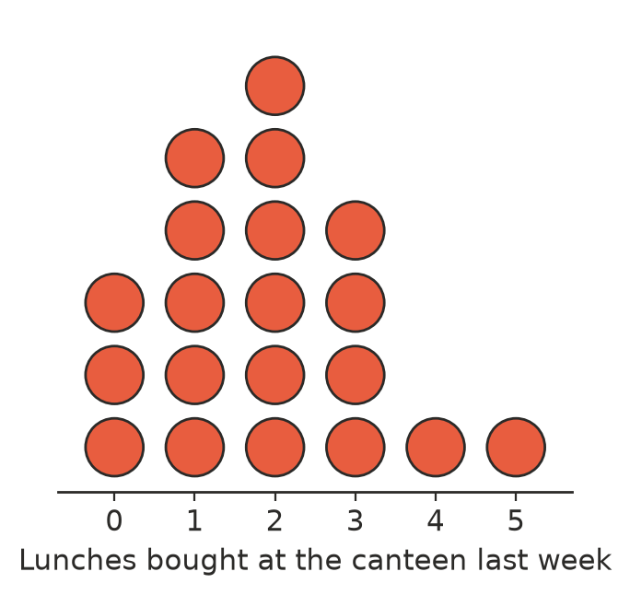
  - How many students are shown? ______________
  - What is the mode? ______________
  - How many students bought lunch 3 or more times? ______________
  - How many lunches did these students buy altogether? ______________
- The column graph shows the favourite sport of the students in a Year 9 class.
- 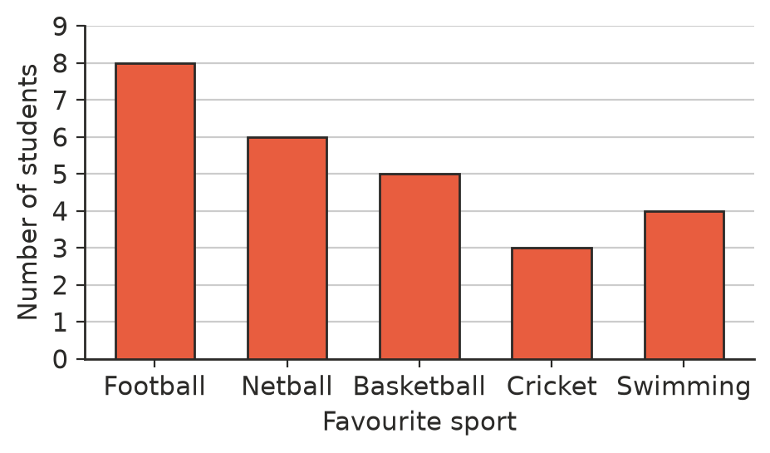
  - Which sport is the most popular? ______________
  - How many students are in the class? ______________
  - How many more students chose football than cricket? ______________
- The sector graph shows the favourite sport of 72 students. How many students chose each sport?
- 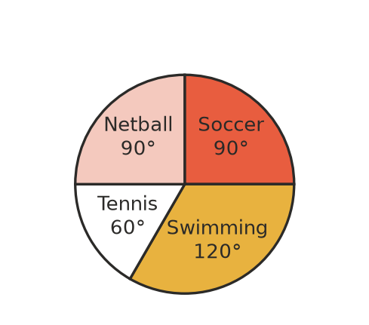
  - Soccer ______________
  - Swimming ______________
  - Tennis ______________
  - Netball ______________

 Fluency
- Forty students were asked how they get to school. To draw a sector graph, each student is shown by 360° ÷ 40 = 9°. Complete the table.
Transport | Number of students | Angle of sector
Walk | 10
Bus | 14
Car | 12
Bike | 4
Total | 40

- The table shows the number of goals a hockey team scored in each of 15 games.
Goals scored | Number of games | Goals × number of games
0 | 2
1 | 4
2 | 5
3 | 3
4 | 1
Total | 15

  - Complete the last column. ______________
  - How many goals did the team score in the 15 games? ______________
  - Find the mean number of goals per game. ______________
- These are the numbers of people in 15 cars that arrived at a school one morning.
- 1, 2, 2, 3, 1, 4, 2, 2, 5, 1, 2, 3, 2, 1, 3
  - Draw a dot plot of the data on the number line.
- 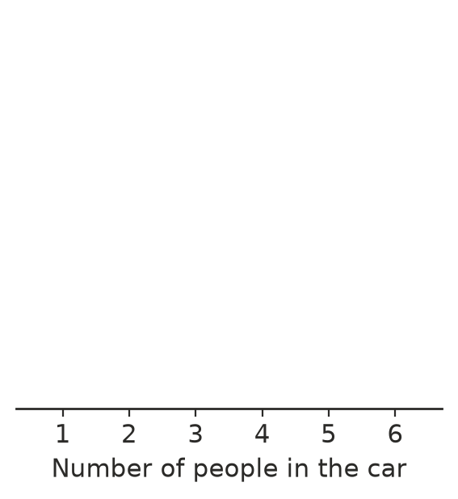
  - What is the mode? ______________

 Reasoning
- Choose the best display for each set of data: column graph, dot plot or line graph.
  - The favourite pizza topping of 30 students ______________
  - The number of siblings of each student in a class ______________
  - The temperature outside the school every hour from 9 am to 3 pm ______________
- The graph shows the number of iced coffees two cafes sold on Saturday.
- 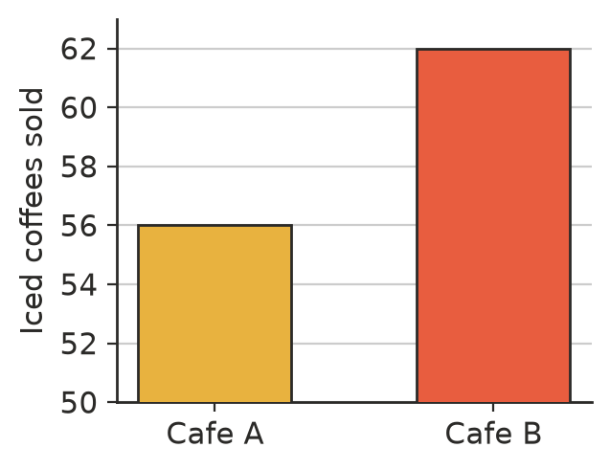
  - How many iced coffees did each cafe sell? ______________
  - Cafe B’s column looks about how many times as tall as Cafe A’s? ______________
  - Explain why the graph is misleading.

- Explain why a sector graph is not a good way to show the heights of 25 students.

 Problem solving
- Thirty students were asked their favourite colour. Red was chosen by 7 students, green by 9 and white by 6. The rest chose blue. How many students chose blue? ______________
- In a sector graph of the favourite drinks of 30 students, the sector for water has an angle of 60°. How many students chose water?

