11.02 Data displays
Year 9 Maths · A5 question sheet · Level 3 · Challenge
This worksheet practises frequency tables, dot plots and sector graphs, working backwards from a mean or a sector angle, choosing displays, and judging how a graph can be drawn to support a point of view. Tip: when a graph looks dramatic, check where the axis starts and whether the gaps on each axis are equal.

 Understanding
- A water polo team recorded the number of goals it scored in each of 34 games.
Goals (x) | Frequency (f) | Cumulative frequency | f × x
0 | 4
1 | 7
2 | 6
3 | 6
4 | 5
5 | 4
6 | 2
Total

  - Copy and complete the table.
  - Find the median.
  - Find the mean, correct to 2 decimal places.
  - In how many games did the team score fewer than 3 goals?
- Seventy-two people were asked their favourite season: summer 26, autumn 14, winter 12, spring 20.
  - Find the angle of each sector for a sector graph.
  - Find the percentage for each season, correct to 1 decimal place.
- The dot plot shows the number of tries a rugby team scored in each of 18 games.
- 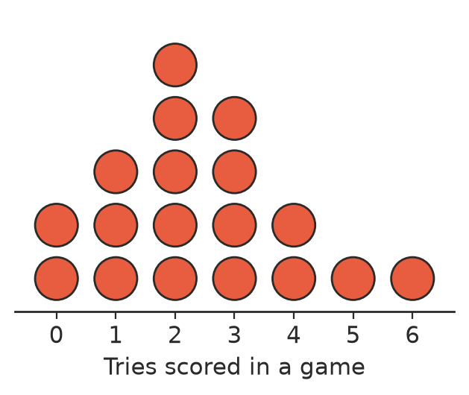
  - Find the mean, correct to 2 decimal places, and the median.
  - The team plays two more games and scores the same number of tries in each. Its mean for all 20 games is now 2.6. How many tries did it score in each of the two games?

 Fluency
- The table shows the scores (1 to 5) given to a new canteen menu by 30 students. Two frequencies are missing. The mean score is 3. Find a and b.
Score | 1 | 2 | 3 | 4 | 5
Frequency | 4 | a | 10 | b | 2

- Work backwards from a sector graph.
  - In a sector graph of the favourite subjects of 90 students, the sector for Maths has an angle of 84°. How many students chose Maths?
  - In another sector graph, 15% of people chose “other”. What is the angle of that sector?
- Choose a suitable display for each data set and give a reason.
  - The ages of 500 people at a concert
  - The reaction times of 15 Year 9 students and 15 adults, so the two groups can be compared and every value kept
  - The number of visitors to a national park in each month of one year
  - The type of each of the 40 trees in a park (gum, wattle, pine, oak)

 Reasoning
- A council received 412 complaints about its bin collection in 2023 and 386 in 2024. Here are two graphs of the same data.
- 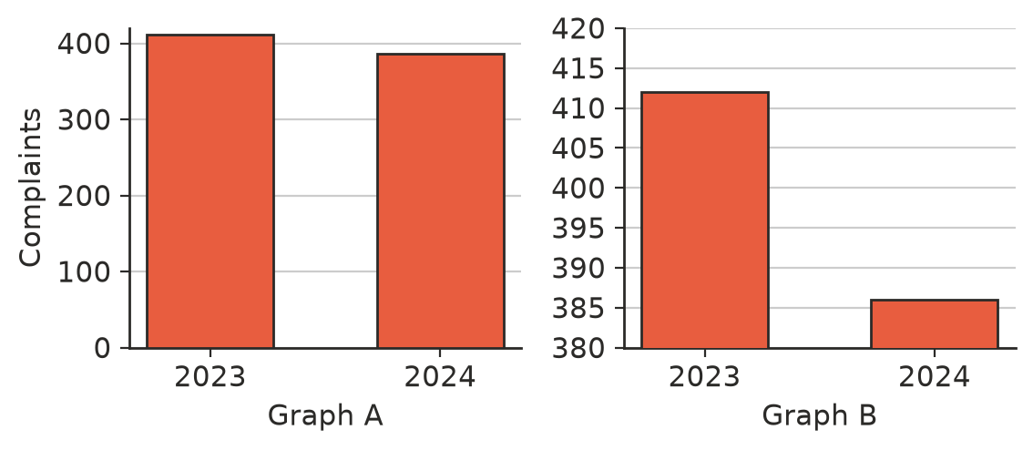
  - Find the percentage decrease in complaints, correct to 1 decimal place.
  - Which graph would the council use in its newsletter? Which graph would a residents’ group that is unhappy with the bin service use? Explain.
  - Which graph gives a fairer picture? Explain.
- A real estate agent shows this graph of house prices in a town.
- 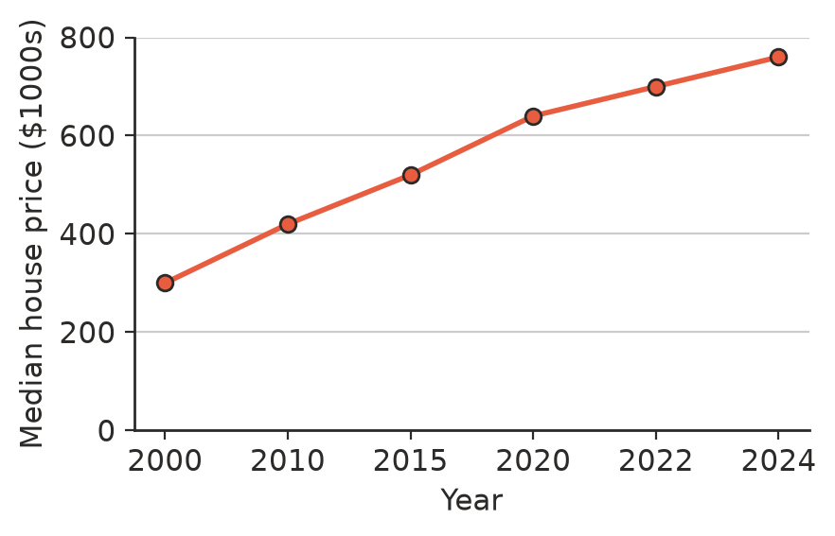
- Explain what is misleading about the graph, and how it changes the impression of how fast prices rose in recent years.
- A company’s sales of potato chips rose from 2 million bags to 3 million bags. Its advert shows a picture of a chip bag for each year, with the new bag 1.5 times as tall and 1.5 times as wide as the old one. By how many times does the new bag’s area look bigger? Explain why this is misleading.
- For the table in Question 1, Sam found the mean like this: (0 + 1 + 2 + 3 + 4 + 5 + 6) ÷ 7 = 3. Explain Sam’s mistake.

 Problem solving
- Make up a frequency table for 10 values that has a mean of 3, a median of 2 and a mode of 1.
Value
Frequency

- Two schools each drew a sector graph of how their students get to school. School A has 800 students and its “walk” sector is 90°. School B has 400 students and its “walk” sector is 135°.
  - Which school has more students who walk?
  - Which school has a greater proportion of students who walk?
  - Explain why two sector graphs of the same size can be misleading when the totals are different.
- The table shows the number of siblings of some students. The median is 1. Find the largest possible value of k. Explain.
Siblings | 0 | 1 | 2 | 3
Frequency | 5 | 8 | k | 3

