Scale and similarity: Practice test 3
Year 9 Maths · Test · Test 3
Name: ____________________ Date: ______________
Time: 45 minutes
Total: 40 marks
Show your working in the boxes. Then write each final answer on the answer sheet on the last page. Diagrams marked “Not to scale” are not drawn accurately, so work out lengths instead of measuring.

 Section A: No calculator
- In △PQR, ∠Q = 90° and ∠P = 48°. In △XYZ, ∠Y = 90° and ∠X = 42°.
  - Find the third angle of each triangle, and explain why the triangles are similar. (1 mark)

  - Complete the similarity statement: △PQR ∼ △ ______________ (put the letters in matching order). (1 mark)

- The two right-angled triangles are similar.
- 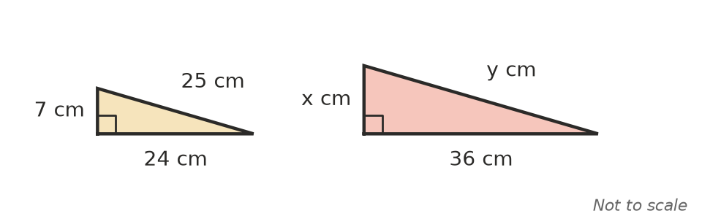
  - Find the scale factor from the small triangle to the large triangle. (1 mark)

  - Find x. (1 mark)

  - Find y. (1 mark)

- At church camp, a guy rope AE runs from a peg at A to the top of a tent pole DE. A vertical stick BC, 0.9 m tall, touches the rope at C.
- 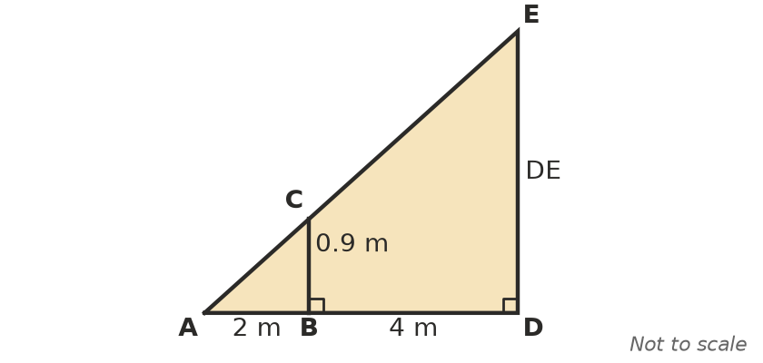
  - Explain why △ABC is similar to △ADE. (1 mark)

  - Find the height of the tent pole DE. (2 marks)

- A student 1.6 m tall casts a shadow 2.4 m long. At the same time, a mobile phone tower casts a shadow 45 m long. How tall is the tower? (2 marks)

- Three students each drew a different-sized right-angled triangle with a 40° angle. They each measured the side opposite the 40° angle and the hypotenuse, and worked out opposite ÷ hypotenuse. Their answers were 0.64, 0.64 and 0.65.
  - Explain why their answers are (almost) the same. (1 mark)

  - Another right-angled triangle has a 40° angle and a hypotenuse of 50 cm. Use the ratio 0.64 to estimate the side opposite the 40° angle. (1 mark)

- Triangle ABC has been enlarged to triangle A′B′C′.
- 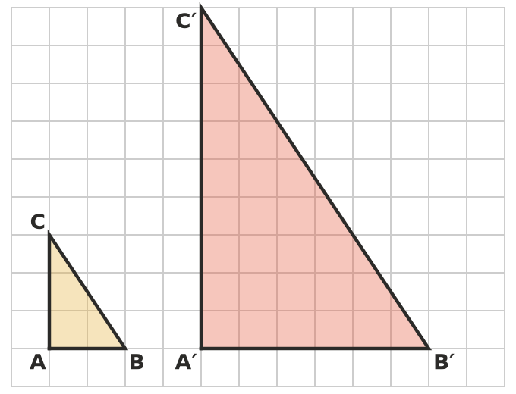
  - Find the scale factor of the enlargement. (1 mark)

  - Find the area of each triangle in square units. (1 mark)

  - How many times larger is the area of A′B′C′? Explain how this number is linked to the scale factor. (1 mark)

- Is a triangle with sides 3 cm, 4 cm and 5 cm similar to a triangle with sides 4.5 cm, 6 cm and 7.5 cm? Give a reason. (1 mark)

- A scale drawing of a garden uses the scale 1 cm : 2 m.
  - Write this scale as a ratio in the form 1 : n. (1 mark)

  - A garden bed is 7.5 cm long on the drawing. Find its real length. (1 mark)

- Here is an algorithm for describing a change of size.
- Step 1: Divide an image length by the matching original length to get the scale factor k.
- Step 2: If k > 1, output “enlargement”. If k < 1, output “reduction”.
  - An original length is 12 cm and the matching image length is 9 cm. Use the algorithm. What does it output, and what is k? (1 mark)

  - One case is missing from Step 2. What is it, and what should the algorithm output? (1 mark)

- This question is about scale and area.
  - A rectangle with an area of 45 cm² is reduced by a scale factor of $\frac{1}{3}$. Find the area of the reduced rectangle. (1 mark)

  - Two similar hexagons have areas of 32 cm² and 50 cm². A side of the smaller hexagon is 8 cm. Find the matching side of the larger hexagon. (2 marks)

- This question is about scale and volume.
  - A cube with a volume of 3 cm³ is enlarged by a scale factor of 4. Find the volume of the enlarged cube. (1 mark)

  - Two spheres have volumes of 27 cm³ and 1000 cm³. The smaller sphere has a radius of 6 cm. Find the radius of the larger sphere. (2 marks)

- A pizza shop sells a 20 cm pizza for $10 and a 40 cm pizza for $30. The pizzas are the same thickness. Sam says, “The big pizza is worse value: it costs 3 times as much but it is only twice as big.” Explain why Sam is wrong. (2 marks)

 Section B: Calculator allowed
- A model ship is built to a scale of 1 : 250.
  - The model is 74 cm long. Find the length of the real ship in metres. (1 mark)

  - The real ship is 32 m wide. Find the width of the model in centimetres. (1 mark)

  - The deck of the model has an area of 0.12 m². Find the area of the real deck in square metres. (2 marks)

- A spotlight on the ground shines towards a wall that is 10 m away. A person 1.8 m tall stands 2.5 m from the spotlight, and their shadow appears on the wall.
- 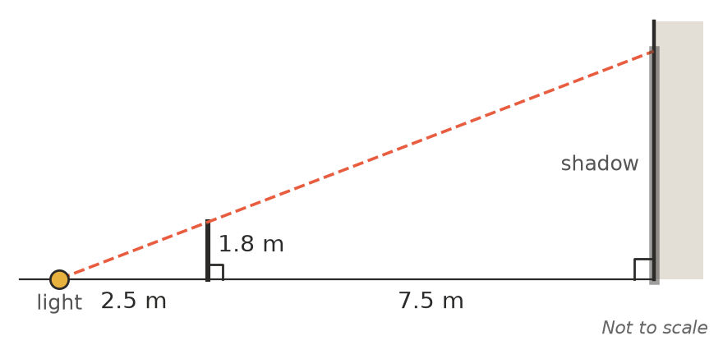
  - Use similar triangles to find the height of the shadow on the wall. (2 marks)

  - The person walks towards the wall. Does the shadow get taller or shorter? Explain. (1 mark)

- A 2 L ice-cream tub is 16 cm tall. A similar tub holds 0.5 L.
  - Find the height of the 0.5 L tub, correct to 1 decimal place. (2 marks)

  - The 0.5 L tub costs $3.50 and the 2 L tub costs $11.90. Which tub is better value? Show your working. (1 mark)

- Two similar trophies have masses of 0.4 kg and 3.2 kg. The small trophy is 15 cm tall and its base has an area of 24 cm². Find the height of the large trophy and the area of its base. (2 marks)

 Answer sheet
Name: ____________________
Write your final answer for each question in the table.
Question | Answer | Marks | Question | Answer | Marks
1a |  | /1 | 9a |  | /1
1b |  | /1 | 9b |  | /1
2a |  | /1 | 10a |  | /1
2b |  | /1 | 10b |  | /2
2c |  | /1 | 11a |  | /1
3a |  | /1 | 11b |  | /2
3b |  | /2 | 12 |  | /2
4 |  | /2 | 13a |  | /1
5a |  | /1 | 13b |  | /1
5b |  | /1 | 13c |  | /2
6a |  | /1 | 14a |  | /2
6b |  | /1 | 14b |  | /1
6c |  | /1 | 15a |  | /2
7 |  | /1 | 15b |  | /1
8a |  | /1 | 16 |  | /2
8b |  | /1
 |  |  |  | Total | /40

