Scale and similarity: Practice test 2
Year 9 Maths · Test · Test 2
Name: ____________________ Date: ______________
Time: 45 minutes
Total: 40 marks
Show your working in the boxes. Then write each final answer on the answer sheet on the last page. Diagrams marked “Not to scale” are not drawn accurately, so work out lengths instead of measuring.

 Section A: No calculator
- Each triangle below has a right angle. The size of one of its acute angles is given.
- Triangle A: 25° Triangle B: 65° Triangle C: 30°
  - Which two triangles are similar? (1 mark)

  - Explain your answer. (1 mark)

- The two right-angled triangles are similar.
- 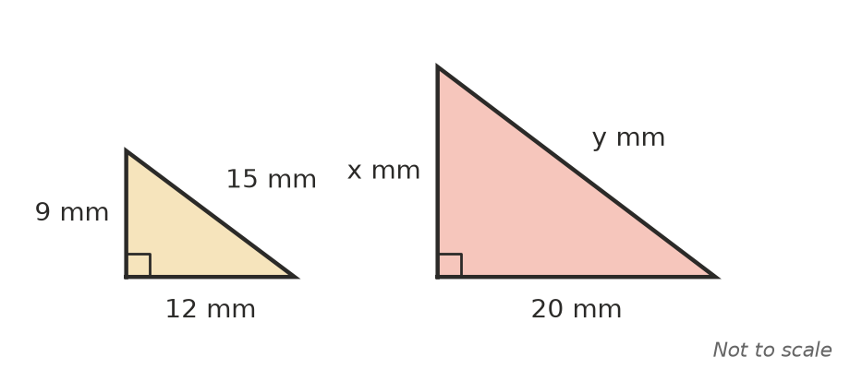
  - Find the scale factor from the small triangle to the large triangle. (1 mark)

  - Find x. (1 mark)

  - Find y. (1 mark)

- The sloping side AE of a playground slide is held up by a vertical support BC, 1.2 m tall, and a vertical ladder DE.
- 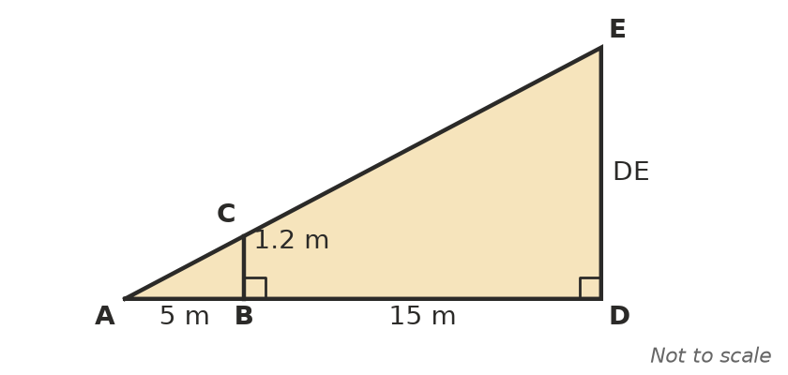
  - Explain why △ABC is similar to △ADE. (1 mark)

  - Find the height DE. (2 marks)

- Late in the afternoon, a fence post 1.5 m tall casts a shadow 2 m long. At the same time, a grain silo casts a shadow 18 m long. How tall is the silo? (2 marks)

- A right-angled triangle has an angle θ. The side opposite θ is 7 cm, the side adjacent to θ is 24 cm and the hypotenuse is 25 cm.
  - A larger right-angled triangle also has an angle θ, and the side opposite θ is 21 cm. Find the side adjacent to θ. (1 mark)

  - Explain why the ratio opposite ÷ adjacent is the same for both triangles. (1 mark)

- A poster for a church fundraiser is 60 cm wide and 84 cm long. It is reduced to make a flyer 15 cm wide.
  - Find the scale factor. (1 mark)

  - Find the length of the flyer. (1 mark)

  - Is this an enlargement or a reduction? What happens to the angles of the poster? (1 mark)

- Is a rectangle 8 cm by 12 cm similar to a rectangle 10 cm by 15 cm? Give a reason. (1 mark)

- A house plan is drawn to a scale of 1 : 100.
  - On the plan, a bedroom is 3.2 cm by 4 cm. Find its real size in metres. (1 mark)

  - A kitchen bench is 2.5 m long. How long is it on the plan? (1 mark)

- Here is an algorithm for drawing a triangle A′B′C′ similar to △ABC with a scale factor of 2.
- Step 1: Draw a line A′B′ that is 2 × AB long.
- Step 2: At A′, copy the angle at A.
- Step 3: At B′, copy the angle at B.
- Step 4: Mark C′ where the two arms meet.
  - Explain why triangle A′B′C′ must be similar to △ABC. (1 mark)

  - Ella changes Step 1 to “Draw a line A′B′ that is 3 × AB long” and keeps the other steps. What will the scale factor of her triangle be? (1 mark)

- This question is about scale and area.
  - A pentagon with an area of 20 cm² is enlarged by a scale factor of 1.5. Find the area of the enlarged pentagon. (1 mark)

  - Two similar parallelograms have areas of 12 cm² and 75 cm². A side of the larger parallelogram is 15 cm. Find the matching side of the smaller one. (2 marks)

- This question is about scale and volume.
  - A storage box holds 5 L. A similar box is 3 times as long, wide and high. How much does the larger box hold? (1 mark)

  - Two similar rectangular prisms have volumes of 64 cm³ and 216 cm³. The smaller prism is 8 cm long. How long is the larger prism? (2 marks)

- Tom builds a model by halving every length of a full-size wooden toy box. He says, “My model will need half as much paint.” Explain why Tom is wrong, and give the correct fraction. (2 marks)

 Section B: Calculator allowed
- A road map has a scale of 1 : 200 000.
  - Two towns are 7.3 cm apart on the map. Find the real distance in kilometres. (1 mark)

  - A farm covers 2.5 cm² on the map. Find the real area of the farm in square kilometres. (2 marks)

  - A ute drives between the two towns in part a) at an average speed of 80 km/h. How long does the trip take, to the nearest minute? (1 mark)

- Ahmed lies on the ground and looks past the top of a post 1.2 m tall so that it lines up with the top of a cliff. The post is 3 m from his eye, and the base of the cliff is a further 81 m beyond the post.
- 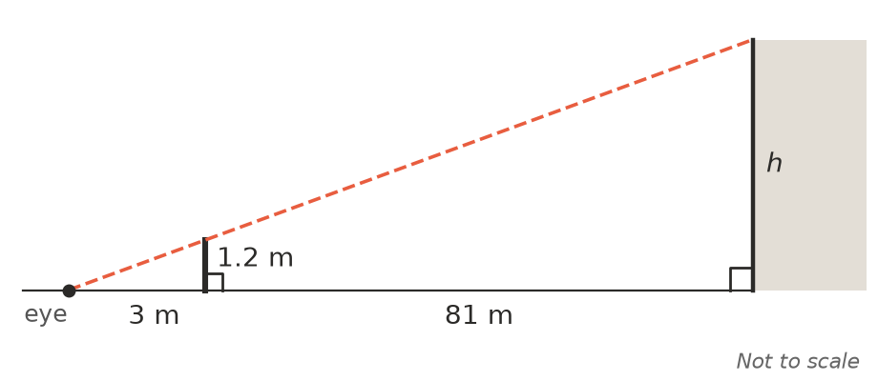
  - Use similar triangles to find the height h of the cliff. (2 marks)

  - Ahmed finds out that the post is really 1.25 m tall, not 1.2 m. By how much does this change his answer for the height of the cliff? (1 mark)

- A 600 mL drink bottle is 20 cm tall. A similar bottle holds 1.5 L.
  - Find the height of the 1.5 L bottle, correct to 1 decimal place. (2 marks)

  - The label on the 600 mL bottle has an area of 90 cm². Find the area of the label on the 1.5 L bottle, correct to 1 decimal place. (1 mark)

- A garden shop sells a small concrete gnome and a large concrete gnome that is similar to it and 3 times as tall. The small gnome has a mass of 2.4 kg. The large gnome has a surface area of 1.8 m². Find the mass of the large gnome and the surface area of the small gnome. (2 marks)

 Answer sheet
Name: ____________________
Write your final answer for each question in the table.
Question | Answer | Marks | Question | Answer | Marks
1a |  | /1 | 9a |  | /1
1b |  | /1 | 9b |  | /1
2a |  | /1 | 10a |  | /1
2b |  | /1 | 10b |  | /2
2c |  | /1 | 11a |  | /1
3a |  | /1 | 11b |  | /2
3b |  | /2 | 12 |  | /2
4 |  | /2 | 13a |  | /1
5a |  | /1 | 13b |  | /2
5b |  | /1 | 13c |  | /1
6a |  | /1 | 14a |  | /2
6b |  | /1 | 14b |  | /1
6c |  | /1 | 15a |  | /2
7 |  | /1 | 15b |  | /1
8a |  | /1 | 16 |  | /2
8b |  | /1
 |  |  |  | Total | /40

