Scale and similarity: Practice test 1
Year 9 Maths · Test · Test 1
Name: ____________________ Date: ______________
Time: 45 minutes
Total: 40 marks
Show your working in the boxes. Then write each final answer on the answer sheet on the last page. Diagrams marked “Not to scale” are not drawn accurately, so work out lengths instead of measuring.

 Section A: No calculator
- In △DEF, ∠E = 90° and ∠D = 40°. In △KLM, ∠L = 90° and ∠K = 50°.
  - Explain why the two triangles are similar. (1 mark)

  - Complete the similarity statement: △DEF ∼ △ ______________ (put the letters in matching order). (1 mark)

- The two right-angled triangles are similar.
- 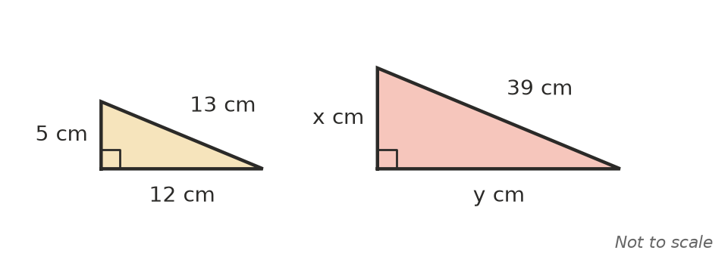
  - Find the scale factor from the small triangle to the large triangle. (1 mark)

  - Find x. (1 mark)

  - Find y. (1 mark)

- A sloping roof AE is held up by a vertical strut BC that is 2 m tall and a vertical wall DE.
- 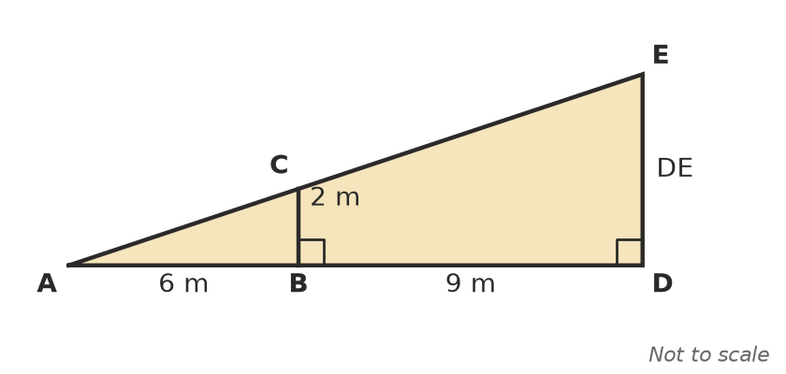
  - Explain why △ABC is similar to △ADE. (1 mark)

  - Find the height DE. (2 marks)

- At morning recess, a 2 m fence post casts a shadow 1.5 m long. At the same time, the school flagpole casts a shadow 6 m long. How tall is the flagpole? (2 marks)

- A right-angled triangle has an angle θ. The side adjacent to θ is 8 cm and the hypotenuse is 10 cm.
  - A larger right-angled triangle also has an angle θ, and its adjacent side is 20 cm. Find the length of its hypotenuse. (1 mark)

  - Lily says, “In a bigger triangle with angle θ, the ratio adjacent ÷ hypotenuse will be bigger.” Explain why Lily is wrong. (1 mark)

- A club logo is a rectangle 4 cm wide and 6 cm long. It is enlarged for a banner so that its width becomes 14 cm.
  - Find the scale factor of the enlargement. (1 mark)

  - Find the length of the enlarged logo. (1 mark)

  - Find the perimeter of the enlarged logo, and write the size of each of its angles. (1 mark)

- Is a rectangle 3 cm by 5 cm similar to a rectangle 6 cm by 10 cm? Give a reason. (1 mark)

- A road map has a scale of 1 : 25 000.
  - Two towns are 8 cm apart on the map. Find the real distance between them in kilometres. (1 mark)

  - A creek is 3.5 km long. How long is it on the map, in centimetres? (1 mark)

- Ben uses this algorithm to decide whether two right-angled triangles are similar.
- Step 1: Check that both triangles have a right angle.
- Step 2: Pick one acute angle in each triangle.
- Step 3: If the two angles are equal, output “similar”. Otherwise output “not similar”.
  - Ben’s first triangle has an acute angle of 28°. He picks an acute angle of 62° in the second triangle, and the algorithm outputs “not similar”. Is that correct? Explain. (1 mark)

  - Suggest a change to Step 3 that fixes the problem. (1 mark)

- This question is about scale and area.
  - A triangle with an area of 5 cm² is enlarged by a scale factor of 4. Find the area of the enlarged triangle. (1 mark)

  - Two similar rectangles have areas of 18 cm² and 50 cm². A side of the smaller rectangle is 6 cm. Find the matching side of the larger rectangle. (2 marks)

- This question is about scale and volume.
  - A prism with a volume of 10 cm³ is enlarged by a scale factor of 3. Find the volume of the enlarged prism. (1 mark)

  - Two similar cones have volumes of 8 cm³ and 125 cm³. The smaller cone has a radius of 4 cm. Find the radius of the larger cone. (2 marks)

- Jack enlarges a photo by a scale factor of 3. He says, “The area of the new photo is 3 times the area of the old one.” Explain why Jack is wrong, and give the correct number. (2 marks)

 Section B: Calculator allowed
- A model train is built to a scale of 1 : 87.
  - A model carriage is 23 cm long. Find the length of the real carriage in metres. (1 mark)

  - The real carriage is 4.35 m tall. Find the height of the model in centimetres. (1 mark)

  - The outside of the model carriage has a surface area of 600 cm². Find the surface area of the real carriage in square metres. (2 marks)

- Grace puts a mirror flat on the ground and steps back until she can see the top of a building in it. Her eyes are 1.6 m above the ground. She is 2.4 m from the mirror, and the mirror is 27 m from the building. The two triangles are similar.
- 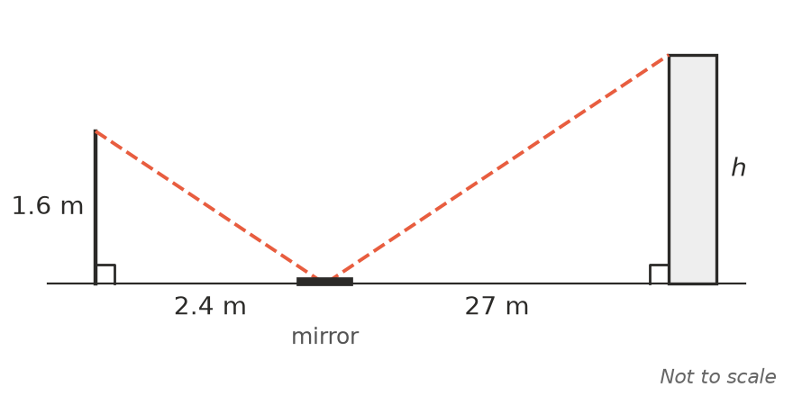
  - Find the height h of the building. (2 marks)

  - Give one reason why the real height might be different from your answer. (1 mark)

- A chocolate shop sells a mini Easter egg and a giant Easter egg. The eggs are similar, and the giant egg is 4 times as tall. The mini egg has a mass of 35 g.
  - Find the mass of the giant egg in kilograms. (2 marks)

  - The mini egg costs $1.20 and the giant egg costs $45. Which egg is better value? Show your working. (1 mark)

- Two similar jugs are 12 cm and 18 cm tall. The small jug holds 400 mL and its label has an area of 50 cm². Find the capacity of the large jug and the area of its label. (2 marks)

 Answer sheet
Name: ____________________
Write your final answer for each question in the table.
Question | Answer | Marks | Question | Answer | Marks
1a |  | /1 | 9a |  | /1
1b |  | /1 | 9b |  | /1
2a |  | /1 | 10a |  | /1
2b |  | /1 | 10b |  | /2
2c |  | /1 | 11a |  | /1
3a |  | /1 | 11b |  | /2
3b |  | /2 | 12 |  | /2
4 |  | /2 | 13a |  | /1
5a |  | /1 | 13b |  | /1
5b |  | /1 | 13c |  | /2
6a |  | /1 | 14a |  | /2
6b |  | /1 | 14b |  | /1
6c |  | /1 | 15a |  | /2
7 |  | /1 | 15b |  | /1
8a |  | /1 | 16 |  | /2
8b |  | /1
 |  |  |  | Total | /40

