7.04 Scale and volume
Year 9 Maths · Worksheet · Level 2 · Core
Name: ____________________ Date: ______________
This worksheet practises using $k$, $k^{2}$ and $k^{3}$ together: lengths, surface areas, and volumes, capacities and masses of similar solids. Tip: to go back from a volume scale factor to a length scale factor, take the cube root. Volumes 64 times as big means lengths 4 times as long.

 Understanding
- A rectangular prism has length $l$, width $w$ and height $h$. It is enlarged with scale factor $k$. Use the new dimensions to explain why the volume is multiplied by $k^{3}$.

- Complete the table.
Length scale factor ($k$) | Area scale factor ($k^{2}$) | Volume scale factor ($k^{3}$)
3
0.5
 | 16
 |  | 8
1.5

- Two drink cans are similar cylinders.
- 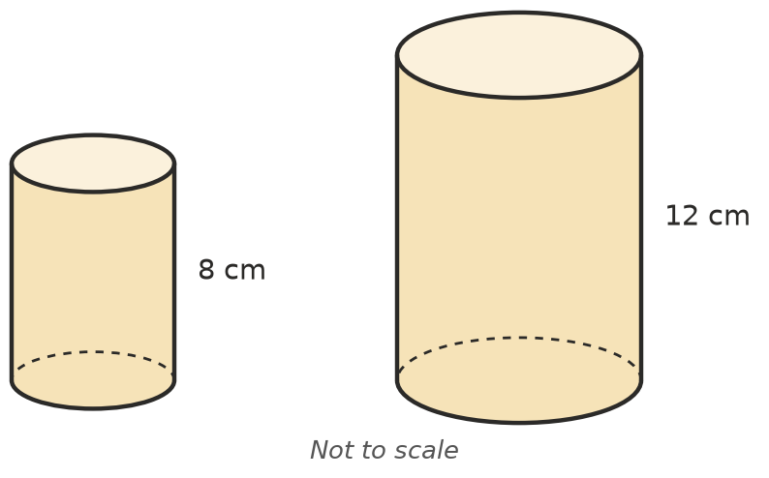
  - Find the length scale factor from the small can to the large can. ______________
  - The small can holds 240 mL. How much does the large can hold? ______________
  - The label on the small can has an area of 150 cm². Find the area of the label on the large can. ______________

 Fluency
- A solid is enlarged or reduced. Find the new volume.
  - 12 cm³, $k$ = 4 ______________ b) 500 cm³, $k$ = 0.2 ______________ c) 6 m³, $k$ = 1.5 ______________
- Two similar containers have volumes of 16 L and 54 L.
  - Find the volume scale factor from the small container to the large one. ______________
  - Find the length scale factor. ______________
  - The small container is 60 cm tall. How tall is the large container? ______________
- Two similar prisms have surface areas of 50 cm² and 200 cm².
  - Find the length scale factor. ______________
  - The small prism has a volume of 30 cm³. Find the volume of the large prism. ______________
- A model of a house is built at a scale of 1 : 50. The inside of the model has a volume of 1200 cm³. Find the volume inside the real house in m³. (1 m³ = 1 000 000 cm³)

 Reasoning
- A jam company makes two similar glass jars. The large jar is twice as tall as the small jar.
  - How many times as much glass is needed to make the large jar? (The glass is the same thickness.) ______________
  - How many times as much jam does the large jar hold? ______________
  - Use your answers to explain why large jars of jam are often cheaper per gram. ______________

- A sculptor makes a statue of a person that is exactly 3 times life size, in every direction, using the same material.
  - How many times as heavy is the statue as a life-size version would be? ______________
  - How many times as big is the area of the cross-section of each leg? ______________
  - Use your answers to explain why the statue’s legs might crack even though the life-size version stands safely.

 Problem solving
- A 250 mL juice bottle is 12 cm tall. A similar 2 L bottle is made. How tall is it? (1 L = 1000 mL)

- An aquarium is designed with a model built at a scale of 1 : 20. The model holds 4 L of water. How many litres will the real aquarium hold?

- Two solid chocolate Easter eggs are similar. The small egg is 6 cm tall and has a mass of 40 g. The large egg is 9 cm tall.
  - Find the mass of the large egg. ______________
  - The small egg costs $3. What would a fair price for the large egg be, if the price depends only on the amount of chocolate? ______________
- A jug 10 cm tall is enlarged to make a similar jug that holds exactly twice as much.
  - Find the length scale factor, correct to 3 decimal places. ______________
  - How tall is the new jug, to the nearest millimetre? ______________

