7.04 Scale and volume
Year 9 Maths · A5 question sheet · Level 3 · Challenge
This worksheet practises moving between length, area and volume scale factors, working backwards with cube roots and algebra, and solving problems about cones, models and real objects. Tip: turn any ratio into the length scale factor $k$ first. From $k$ you can get the area factor $k^{2}$ and the volume factor $k^{3}$.

 Understanding
- Explain why, for two similar solid objects made of the same material, the ratio of their masses equals the ratio of their volumes, $k^{3}$.
- Two similar solids have surface areas in the ratio 9 : 25.
  - Find the ratio of their lengths. ______________ b) Find the ratio of their volumes.
- Two similar solids have volumes in the ratio 8 : 27. The smaller one has a surface area of 120 cm². Find the surface area of the larger one.

 Fluency
- Two similar cones have volumes of 128 cm³ and 250 cm³. The large cone is 3 cm taller than the small cone.
  - Find the length scale factor from the small cone to the large cone.
  - Find the height of each cone.
- A model car is built at a scale of 1 : 25.
  - It takes 15 mL of paint to paint the model. How many litres would it take to paint the real car with paint of the same thickness?
  - The real car’s fuel tank holds 50 L. How many millilitres would the model’s tank hold?
- A solid cone is 12 cm tall and has a volume of 400 cm³. It is cut halfway up, parallel to its base. The top piece is a small cone.
- 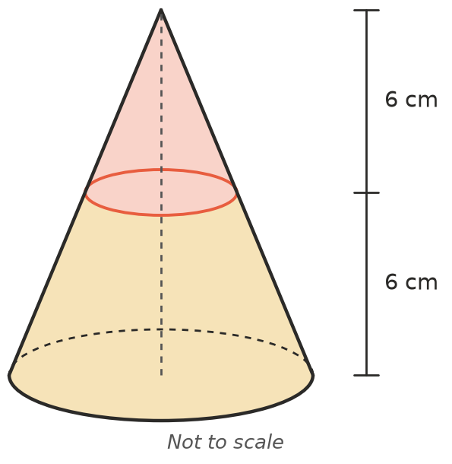
  - Explain why the small cone is similar to the original cone, and give the scale factor.
  - Find the volume of the small cone.
  - Find the volume of the bottom piece.
- A cone-shaped glass (point at the bottom) holds 240 mL when full.
  - It is filled with water to half its height. How much water is in it?
  - To what fraction of its height should it be filled to hold exactly 120 mL? Give a percentage to 1 decimal place.

 Reasoning
- Every length of a solid is increased by 10%. By what percentage does
  - its surface area increase? ______________ b) its volume increase?
- Two cylinders have volumes in the ratio 1 : 8. Josh says the large cylinder must be twice as tall as the small one. Explain why he might be wrong, using an example.
- Ice cubes cool a drink by taking in heat through their surface.
  - Find the surface area and volume of a 2 cm ice cube and a 6 cm ice cube.
  - Find surface area ÷ volume for each cube.
  - Explain why a cup of small ice cubes cools a drink faster than one big block with the same volume of ice.

 Problem solving
- A model of a statue is 30 cm tall and has a mass of 2.4 kg. The real statue is 4.5 m tall and is made of the same material. Find the mass of the real statue in tonnes. (1 t = 1000 kg)
- The Moon and the Earth are both close to spheres. The Moon’s diameter is about 0.27 times the Earth’s diameter.
  - Find the volume scale factor from the Earth to the Moon, correct to 3 significant figures.
  - About how many Moons would it take to fill the same volume as the Earth?

