7.04 Scale and volume
Year 9 Maths · A5 question sheet · Level 1 · Warm-up
This worksheet practises what happens to volume when a solid is enlarged or reduced. Tip: if every length is multiplied by $k$, the volume is multiplied by $k^{3}$ and the surface area by $k^{2}$. A box with every edge twice as long holds 8 times as much.

 Understanding
- Three cubes are built from 1 cm cubes.
- 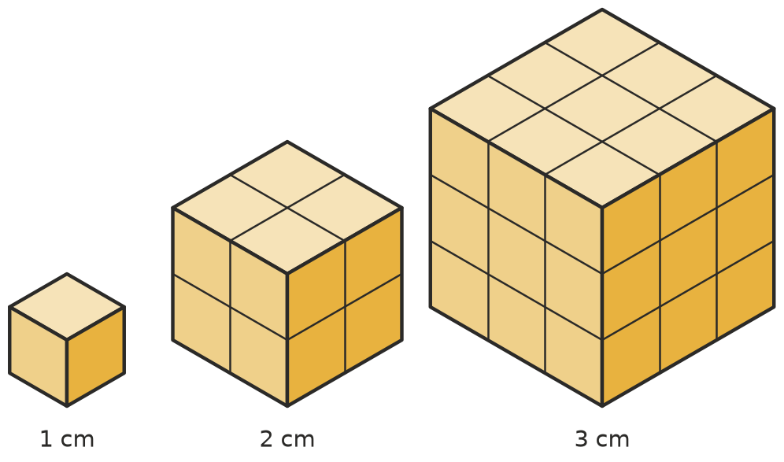
- Copy and complete the table.
Edge length (cm) | Scale factor from the 1 cm cube | Volume (cm³) | How many times the volume of the 1 cm cube
1 | 1 | 1 | 1
2
3

- Complete each sentence.
  - If every length is doubled, the area of each face is multiplied by ______________ and the volume is multiplied by
  - If every length is multiplied by $k$, the volume is multiplied by
- Copy and complete the table.
Scale factor for lengths ($k$) | 2 | 3 | 4 | 10 | $\frac{1}{2}$
Scale factor for volume ($k^{3}$)

 Fluency
- A box is 2 cm by 3 cm by 4 cm. It is enlarged with a scale factor of 2.
  - Find the dimensions of the new box.
  - Find the volume of each box. ______________ and
  - How many times bigger is the new volume?
- A solid is enlarged or reduced. Find the new volume.
  - volume 5 cm³, scale factor 3 ______________ b) volume 10 m³, scale factor 2
  - volume 64 cm³, scale factor $\frac{1}{2}$ ______________ d) volume 2 cm³, scale factor 10
- The two boxes are similar.
- 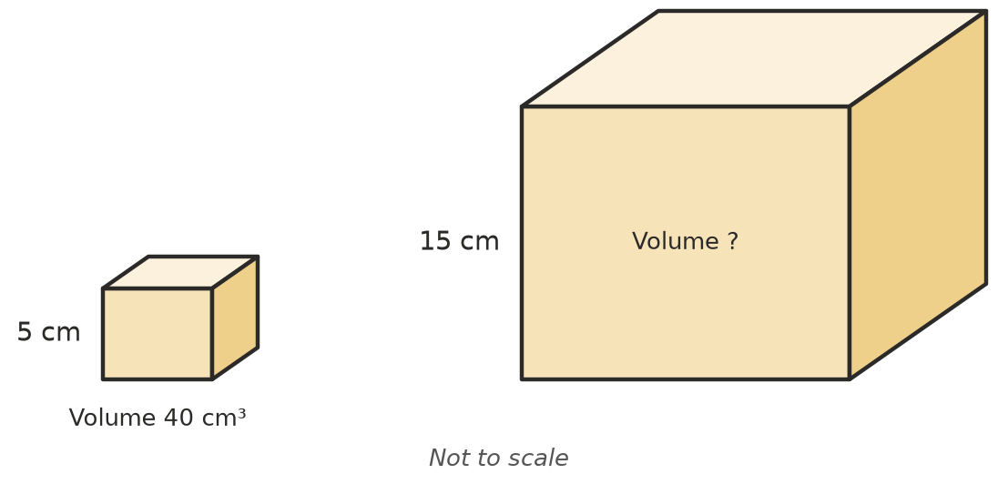
  - Find the length scale factor. ______________ b) Find the volume scale factor.
  - Find the volume of the large box.
- Find the length scale factor $k$ when the volume is multiplied by:
  - 27 ______________ b) 125 ______________ c) 1000 ______________ d) $\frac{1}{8}$

 Reasoning
- A shop sells two cube-shaped storage boxes. The big box has edges twice as long as the small box. Lucy thinks the big box holds twice as much. Explain why she is wrong, and how much more it really holds.

 Problem solving
- A model of a water tank is built at a scale of 1 : 10. The model holds 2 L. How much does the real tank hold?
- A cube of ice with 3 cm edges has a mass of 25 g. Find the mass of a cube of ice with 6 cm edges.
- It takes 10 mL of paint to cover all the faces of a small wooden cube. A second cube has edges twice as long.
  - How much paint will the second cube need? (Hint: paint covers area.)
  - How many times as much wood is in the second cube?

