7.03 Scale and area
Year 9 Maths · Worksheet · Level 2 · Core
Name: ____________________ Date: ______________
This worksheet practises using the area scale factor $k^{2}$ to find areas of similar shapes, working backwards from areas to lengths, and finding real areas from plans and maps. Tip: to go from an area scale factor back to a length scale factor, take the square root. Areas 9 times as big means lengths 3 times as long.

 Understanding
- A rectangle has length $l$ and width $w$. It is enlarged with scale factor $k$. Write the new length, width and area, and use them to explain why the area is multiplied by $k^{2}$.

- Complete the table.
Length scale factor ($k$) | 4 | 0.5 |  | $\frac{2}{3}$
Area scale factor ($k^{2}$) |  |  | 2.25 |  | 0.36

- Shape B is an enlargement of shape A, drawn on a grid of 1 cm squares.
- 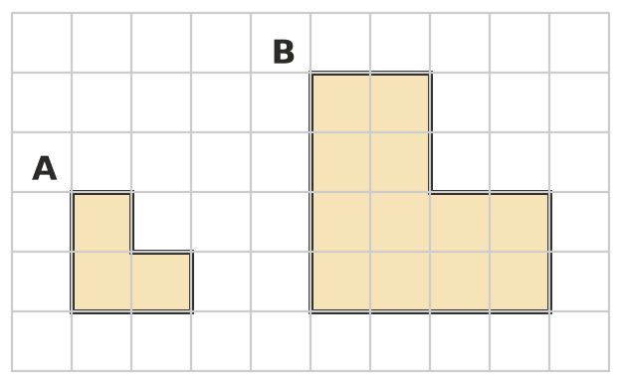
  - Find the length scale factor from A to B. ______________
  - Find the area of each shape. ______________ and ______________
  - Show that the area scale factor equals the square of the length scale factor. ______________

 Fluency
- The two trapeziums are similar.
- 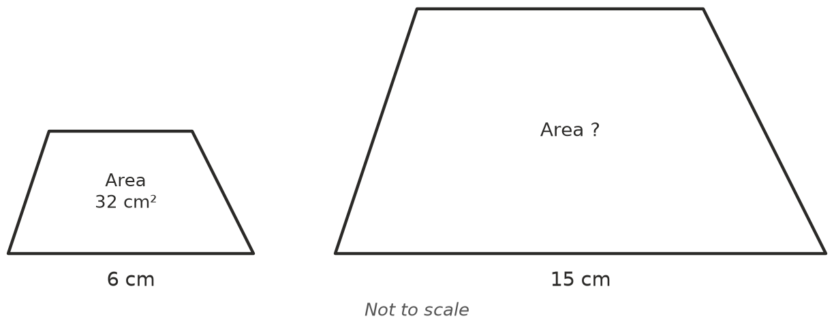
  - Find the length scale factor and the area scale factor. ______________
  - Find the area of the large trapezium. ______________
- Two similar triangles have areas of 18 cm² and 50 cm².
  - Find the area scale factor from the small triangle to the large one, as a fraction. ______________
  - Find the length scale factor. ______________
  - A side of the small triangle is 6 cm. Find the matching side of the large triangle. ______________
- A shape is enlarged or reduced. Find the length scale factor $k$.
  - area 12 cm² becomes 108 cm² ______________ b) area 50 cm² becomes 8 cm² ______________
  - area 20 m² becomes 45 m² ______________ d) area 4 cm² becomes 1 cm² ______________
- A plan has a scale of 1 : 200. A rectangular classroom is 4 cm by 3.5 cm on the plan.
  - Find the real length and width of the classroom, then its real area. ______________
  - Find the area on the plan, then multiply it by ${200}^{2}$. Change your answer from cm² to m² (1 m² = 10 000 cm²) and check that it matches part a). ______________

 Reasoning
- A square is enlarged so that its perimeter is 3 times as long. What happens to its area? Explain.

- Mia enlarges a rectangle and its area goes from 20 cm² to 80 cm². She says every length was multiplied by 4. Is she right? Explain.

- A pizza shop sells a 30 cm pizza for $18 and a 20 cm pizza for $10. The pizzas are similar (round and the same thickness).
  - How many times as much pizza is in the 30 cm pizza? ______________
  - Which is better value: one 30 cm pizza, or two 20 cm pizzas? Explain. ______________

 Problem solving
- A painter makes a small sign and then a large sign of exactly the same design. Every length on the large sign is 5 times as long. The small sign used 40 mL of paint. How much paint will the large sign need, in litres?

- On a map with a scale of 1 : 50 000, a national park has an area of 12 cm².
  - How many kilometres does 1 cm on the map represent? ______________
  - What real area does 1 cm² on the map represent? ______________
  - Find the real area of the park in km². ______________
- A farm plan has a scale of 1 : 2000. A paddock has an area of 45 cm² on the plan. Find the real area of the paddock in square metres and in hectares. (1 ha = 10 000 m²)

