7.03 Scale and area
Year 9 Maths · A5 question sheet · Level 3 · Challenge
This worksheet practises the area scale factor $k^{2}$ in harder problems: working backwards from areas, percentage changes, nested and crossed triangles, and areas on maps and plans. Tip: write down both scale factors before you start. Lengths use $k$ and areas use $k^{2}$; mixing them up is the most common mistake.

 Understanding
- A triangle has base $b$ and height $h$. It is enlarged with scale factor $k$. Prove that its area is multiplied by $k^{2}$.
- A shape is enlarged so that its area exactly doubles.
  - Find the length scale factor, exactly and correct to 3 decimal places.
  - An A3 sheet of paper has twice the area of an A4 sheet, and the two sheets are similar. The short side of A4 is 210 mm. Use part a) to find the short side of A3, to the nearest millimetre.
- Two similar shapes have areas of 45 cm² and 80 cm². A side of the small shape is $x$ cm, and the matching side of the large shape is ($x$ + 3) cm.
  - Find the length scale factor.
  - Find $x$.

 Fluency
- In △ABC, DE is parallel to BC. AD = 4 cm, DB = 6 cm and the area of △ADE is 12 cm².
- 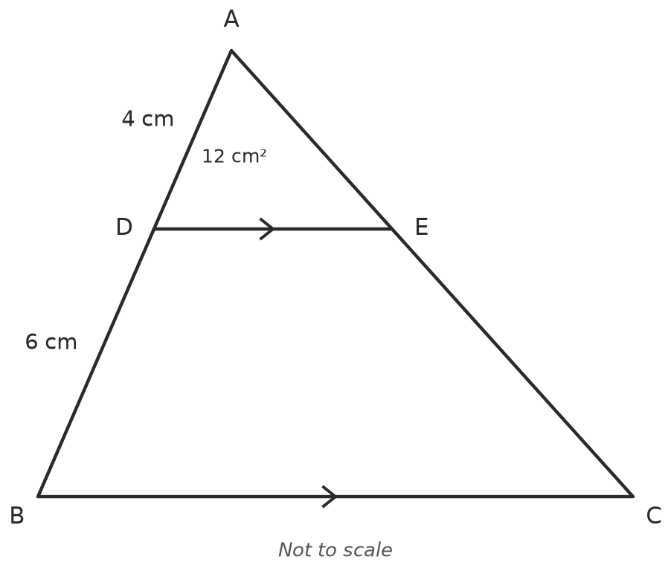
  - Explain why △ADE is similar to △ABC.
  - Find the length scale factor from △ADE to △ABC.
  - Find the area of △ABC. ______________ d) Find the area of the trapezium DBCE.
- On a map with a scale of 1 : 25 000, a lake has an area of 6.4 cm². Find the real area of the lake in m², in hectares and in km². (1 ha = 10 000 m², 1 km² = 1 000 000 m²)
- A sports field has a real area of 1.2 ha. On a plan, its area is 30 cm². Find the scale of the plan as a ratio 1 : $n$.
- On a plan with a scale of 1 : 50, a kitchen floor has an area of 48 cm².
  - Find the real area of the floor in m².
  - Tiles are sold in boxes that cover 1.44 m² and cost $62 each. How many boxes are needed, and what is the cost?

 Reasoning
- Liam wants to enlarge a photo so that its area is 50% bigger. What percentage should he set the photocopier to? Give your answer to the nearest whole per cent.
- Every length of a shape is increased by 20%. By what percentage does its area increase? Explain.
- A 25 cm pizza costs $14 and a 35 cm pizza costs $24. The pizzas are similar. Use the area scale factor to decide which pizza is better value. Show your working.

 Problem solving
- AB is parallel to DC, and AC and BD cross at O. AB = 6 cm, DC = 15 cm and the area of △OAB is 8 cm².
- 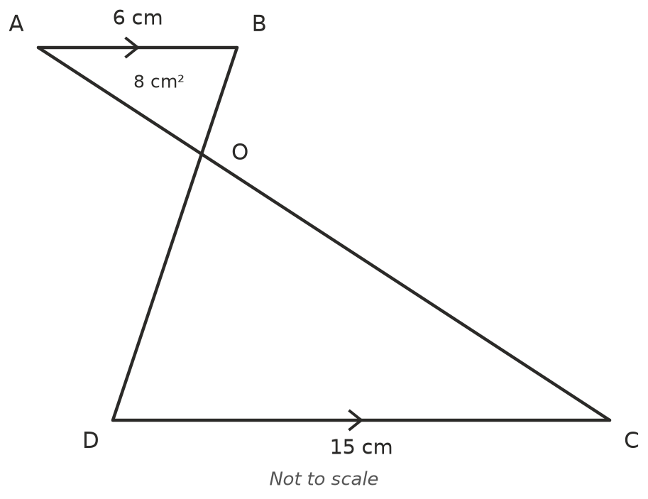
  - Explain why △OAB is similar to △OCD.
  - Find the area of △OCD.
- Zoe says: “If a shape’s area is multiplied by 9, its perimeter must be multiplied by 3.” Show with two rectangles that this is not always true, and explain when it is true.

