7.03 Scale and area
Year 9 Maths · A5 question sheet · Level 1 · Warm-up
This worksheet practises what happens to area when a shape is enlarged or reduced. Tip: if every length is multiplied by a scale factor $k$, the area is multiplied by $k^{2}$. Doubling the lengths makes the area 4 times as big, not 2 times.

 Understanding
- Squares A, B and C are drawn on a grid of 1 cm squares.
- 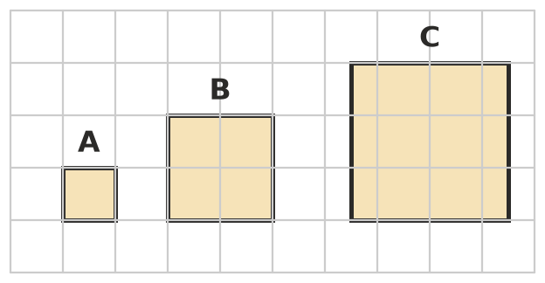
- Copy and complete the table.
Square | Side length (cm) | Scale factor from A | Area (cm²) | How many times the area of A
A | 1 | 1 | 1 | 1
B
C

- Look at your table in Question 1. Complete: if the lengths are multiplied by $k$, the area is multiplied by
- A rectangle 3 cm long and 2 cm wide is enlarged with a scale factor of 2.
  - Find the length and width of the new rectangle.
  - Find the area of each rectangle. ______________ and
  - How many times bigger is the new area?

 Fluency
- Copy and complete the table.
Scale factor for lengths ($k$) | 2 | 3 | 5 | 10 | $\frac{1}{2}$
Scale factor for area ($k^{2}$)

- A shape is enlarged or reduced. Find the new area.
  - area 5 cm², scale factor 2 ______________ b) area 12 m², scale factor 4
  - area 36 cm², scale factor $\frac{1}{2}$ ______________ d) area 8 cm², scale factor 3
- The two triangles are similar.
- 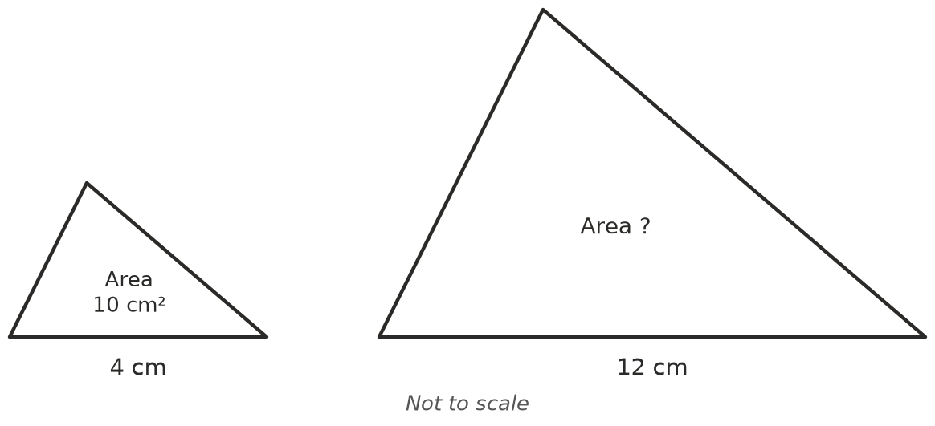
  - Find the scale factor from the small triangle to the large triangle.
  - Find the area scale factor. ______________ c) Find the area of the large triangle.
- Find the scale factor for lengths, $k$, when the area is multiplied by:
  - 16 ______________ b) 49 ______________ c) 100 ______________ d) $\frac{1}{9}$

 Reasoning
- Sam says: “If I double the side length of a square, its area doubles too.” Use a square with sides of 3 cm to show that Sam is wrong.
- A house plan has a scale of 1 : 100. A bedroom is 4 cm by 3 cm on the plan.
  - Find the area of the bedroom on the plan, in cm².
  - Find the real length and width of the bedroom, in metres.
  - Find the real area of the bedroom, in m².

 Problem solving
- A square cake 20 cm wide needs 200 g of icing to cover the top. A square cake 30 cm wide gets icing of the same thickness.
  - Find the scale factor for lengths. ______________ b) Find the scale factor for area.
  - How much icing does the top of the bigger cake need?
- A garden bed needs 3 bags of mulch. A new garden bed is the same shape, but every length is twice as long. How many bags of mulch does the new bed need?

