7.02 Scale factors
Year 9 Maths · Worksheet · Level 2 · Core
Name: ____________________ Date: ______________
This worksheet practises finding and using scale factors, enlarging shapes from a centre of enlargement, and using scales written as ratios on plans, models and maps. Tip: always divide image by original. Going from a big shape to a small one gives a scale factor less than 1, not a bigger number.

 Understanding
- Complete each sentence.
  - The scale factor from a shape to its image is found by dividing ______________ by ______________
  - An enlargement with scale factor $k$ makes every length ______________ times as long.
  - If 0 < $k$ < 1, the image is ______________ than the original.
- Trapeziums A, B and C are similar. Use the grid to find each scale factor.
- 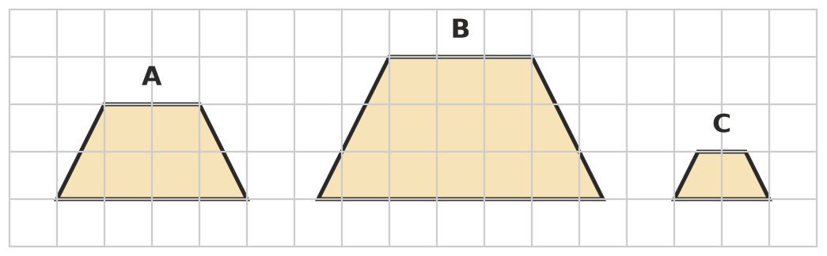
  - from A to B ______________ b) from B to C ______________ c) from C to A ______________
- A shape is enlarged with a scale factor of 2.5. For each feature, write Same, or describe how it changes.
Feature | Same, or how it changes
the size of each angle
the length of each side
the perimeter
the ratio of two sides, such as length ÷ width
parallel sides

 Fluency
- The two quadrilaterals are similar. Matching angles are marked.
- 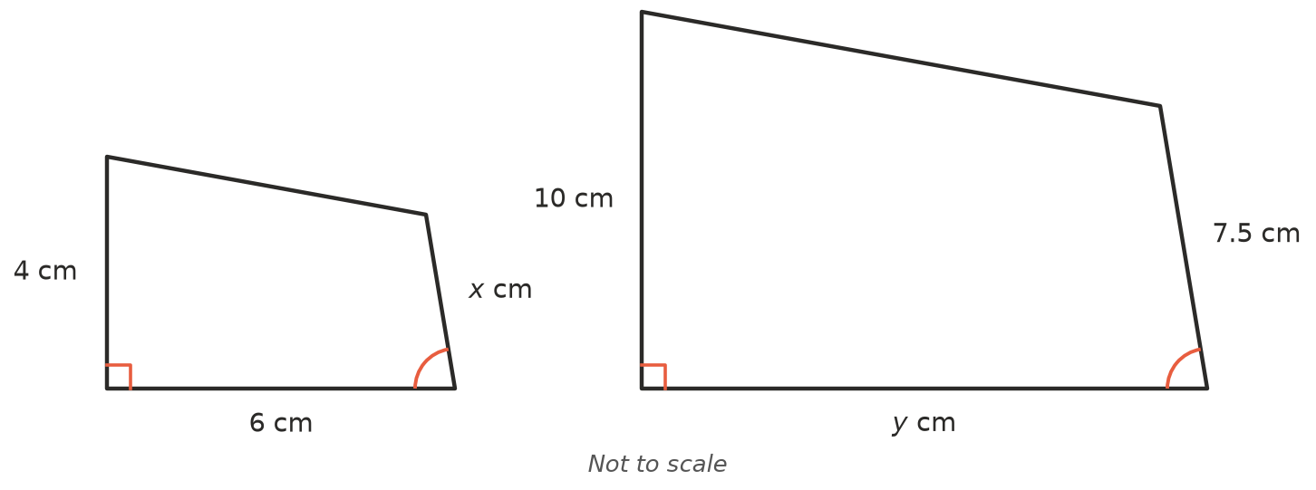
  - Find the scale factor from the small shape to the large shape. ______________
  - Find $y$. ______________ c) Find $x$. ______________
- Enlarge triangle ABC with a scale factor of 3 and centre of enlargement O. For each corner, the image is 3 times as far from O, along the same line. Label the image A′B′C′.
- 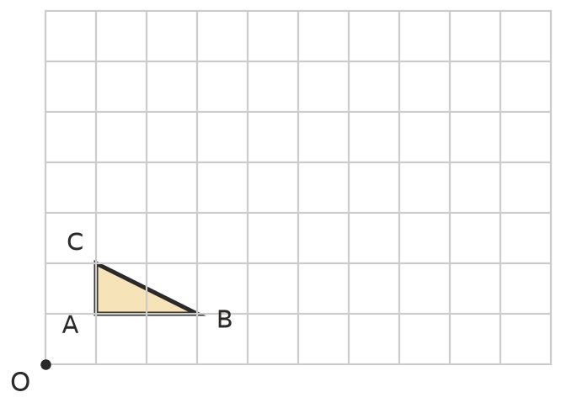
  - How many times as long is A′B′ as AB? ______________
  - What do you notice about the directions of AB and A′B′? ______________
- Complete the table. (1 m = 100 cm and 1 km = 100 000 cm.)
Scale | Distance on the map or plan | Real distance
1 : 200 | 3.5 cm
1 : 25 000 | 8 cm
1 : 50 000 |  | 4.5 km
1 : 500 |  | 30 m

- Two similar triangles have perimeters of 18 cm and 45 cm.
  - Find the scale factor from the small triangle to the large one. ______________
  - The shortest side of the small triangle is 4 cm. Find the shortest side of the large triangle. ______________

 Reasoning
- Write each scale as a ratio 1 : $n$. Change to the same units first.
  - 2 cm on the plan represents 10 m. ______________ b) 5 cm on the map represents 1 km. ______________
  - 1 cm on the model represents 2.5 m. ______________
- Jai shrinks a picture so that a side 12 cm long becomes 8 cm long. He says the scale factor is 1.5. Explain his mistake and give the correct scale factor.

- Are the two rectangles similar? Explain using scale factors.
  - 4 cm × 6 cm and 6 cm × 8 cm ______________

  - 4 cm × 6 cm and 10 cm × 15 cm ______________

 Problem solving
- Model trains are often built at a scale of 1 : 87. A real carriage is 21.75 m long. How long is the model carriage, in centimetres?

- A photo 12 cm × 18 cm is enlarged so that its short side is 30 cm. The photo keeps its shape.
  - Find the scale factor and the length of the long side. ______________
  - Will the enlargement fit inside a frame 30 cm × 40 cm? Explain. ______________
- On a road map with a scale of 1 : 250 000, two towns are 7.2 cm apart.
  - Find the real distance between the towns in kilometres. ______________
  - How long will it take to drive between them at an average speed of 90 km/h? Give your answer in minutes. ______________

