7.02 Scale factors
Year 9 Maths · A5 question sheet · Level 3 · Challenge
This worksheet practises finding a centre of enlargement and scale factor, combining scale factors, working backwards with algebra, and solving plan, map and model problems. Tip: two enlargements in a row multiply, they don’t add. Enlarging by 2 and then by 3 is the same as enlarging by 6.

 Understanding
- Explain why all squares are similar to each other, but not all rectangles are. Give an example of two rectangles that are not similar.
- Triangle P′Q′R′ is an enlargement of triangle PQR.
- 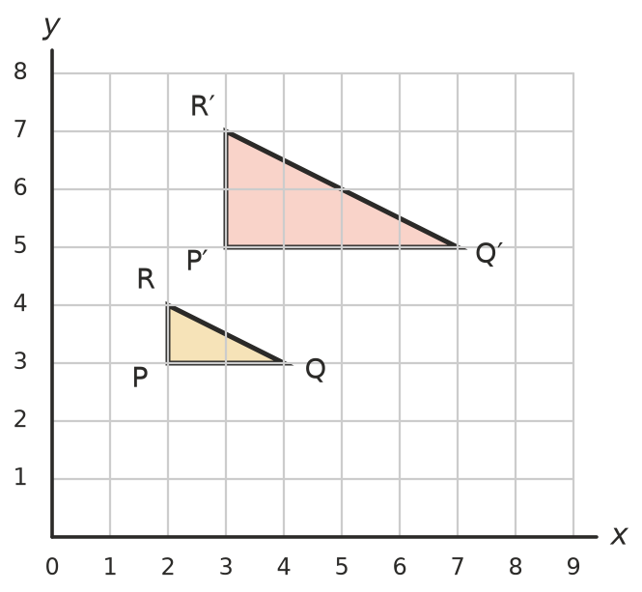
  - Find the scale factor.
  - Draw lines through P and P′, Q and Q′, and R and R′. Write the coordinates of the centre of enlargement.
  - The point S(3, 3) is enlarged in the same way. Find the coordinates of its image S′.
  - Complete the rule for this enlargement: ($x$, $y$) → (______________, ______________)
- Use similar triangles OAB and OA′B′ to explain why every side of an enlargement is parallel to the matching side of the original shape. (O is the centre of enlargement, and A′ and B′ are the images of A and B.)

 Fluency
- Two similar rectangles have sides in matching order. The small rectangle is 4 cm by $x$ cm and the large rectangle is 10 cm by ($x$ + 9) cm. Find $x$ and the size of both rectangles.
- A photo is enlarged to 150% on a photocopier. The copy is then reduced to 80%.
  - What single scale factor gives the same result?
  - A side of the original photo was 15 cm. How long is it on the final copy?
  - What scale factor would turn the final copy back into the original size?
- Write each scale as a ratio in simplest form.
  - 1 cm on a map represents 2.5 km.
  - A model of an ant is built so that 4 cm on the model represents 1 cm on the real ant.
  - The real ant in part b) is 6 mm long. How long is the model?
- A walking track is 6.5 cm long on a map with a scale of 1 : 40 000.
  - Find the real length of the track in kilometres.
  - How long does the walk take at 5.2 km/h?
  - How long would the track be on a map with a scale of 1 : 25 000?

 Reasoning
- Write True or False, and explain.
  - Enlarging by a scale factor of 2 and then by 3 is the same as enlarging by 5.
  - Enlarging by 4 and then by $\frac{1}{4}$ gives back the original shape.
  - If two triangles are similar, the ratio of their perimeters equals the scale factor.
- Two similar triangles have perimeters of 24 cm and 40 cm. The longest side of the large triangle is 17.5 cm. Find the longest side of the small triangle.

 Problem solving
- A floor plan has a scale of 1 : 50. A rectangular lounge room measures 9.6 cm by 7.2 cm on the plan.
  - Find the real length and width of the room.
  - Skirting board is fitted along the bottom of every wall except a doorway 0.9 m wide. How many metres are needed?
  - Skirting board costs $12.50 per metre. Find the cost.
- A4 paper measures 210 mm × 297 mm. A3 paper measures 297 mm × 420 mm, and A5 paper measures 148 mm × 210 mm.
  - Find the scale factor from A4 to A3 using the short sides, and then using the long sides. Give each to 3 decimal places.
  - Are A4 and A3 sheets similar? Explain.
  - A photocopier enlarges A4 to A3 and reduces A4 to A5. What percentage setting is used for each?
- A model of Sydney Tower is built at a scale of 1 : 400. The real tower is 309 m tall.
  - How tall is the model, in centimetres?
  - A model person 1.8 m tall is added at the same scale. How tall is the model person, in millimetres?

