7.02 Scale factors
Year 9 Maths · A5 question sheet · Level 2 · Core
This worksheet practises finding and using scale factors, enlarging shapes from a centre of enlargement, and using scales written as ratios on plans, models and maps. Tip: always divide image by original. Going from a big shape to a small one gives a scale factor less than 1, not a bigger number.

 Understanding
- Complete each sentence.
  - The scale factor from a shape to its image is found by dividing ______________ by
  - An enlargement with scale factor $k$ makes every length ______________ times as long.
  - If 0 < $k$ < 1, the image is ______________ than the original.
- Trapeziums A, B and C are similar. Use the grid to find each scale factor.
- 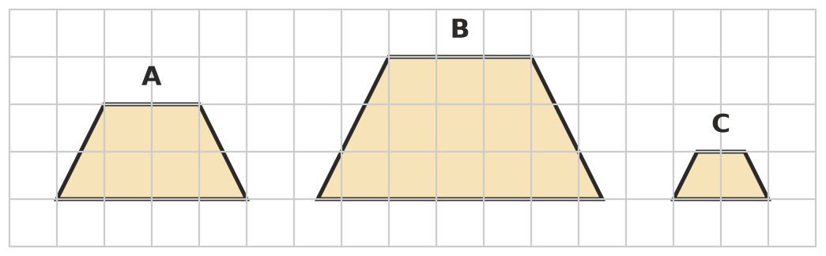
  - from A to B ______________ b) from B to C ______________ c) from C to A
- A shape is enlarged with a scale factor of 2.5. For each feature, write Same, or describe how it changes.
Feature
the size of each angle
the length of each side
the perimeter
the ratio of two sides, such as length ÷ width
parallel sides

 Fluency
- The two quadrilaterals are similar. Matching angles are marked.
- 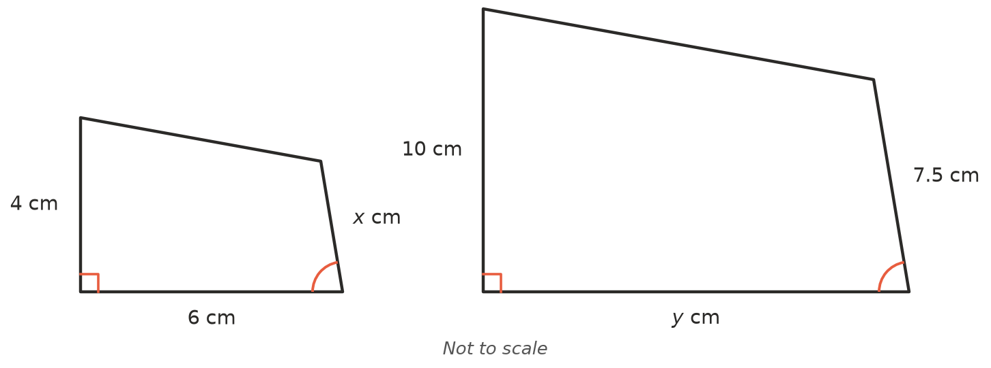
  - Find the scale factor from the small shape to the large shape.
  - Find $y$. ______________ c) Find $x$.
- Enlarge triangle ABC with a scale factor of 3 and centre of enlargement O. For each corner, the image is 3 times as far from O, along the same line. Label the image A′B′C′.
- 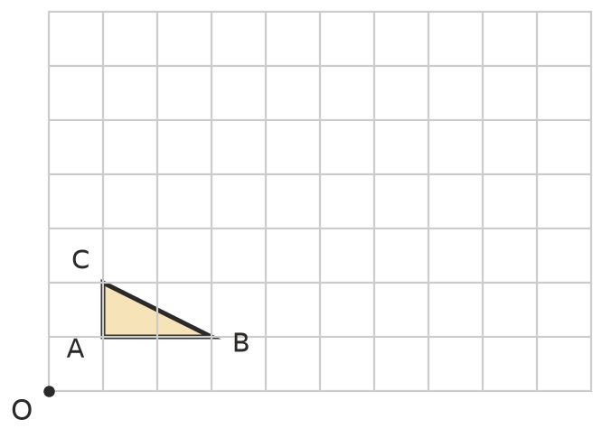
  - How many times as long is A′B′ as AB?
  - What do you notice about the directions of AB and A′B′?
- Copy and complete the table. (1 m = 100 cm and 1 km = 100 000 cm.)
Scale | Distance on the map or plan | Real distance
1 : 200 | 3.5 cm
1 : 25 000 | 8 cm
1 : 50 000 |  | 4.5 km
1 : 500 |  | 30 m

- Two similar triangles have perimeters of 18 cm and 45 cm.
  - Find the scale factor from the small triangle to the large one.
  - The shortest side of the small triangle is 4 cm. Find the shortest side of the large triangle.

 Reasoning
- Write each scale as a ratio 1 : $n$. Change to the same units first.
  - 2 cm on the plan represents 10 m. ______________ b) 5 cm on the map represents 1 km.
  - 1 cm on the model represents 2.5 m.
- Jai shrinks a picture so that a side 12 cm long becomes 8 cm long. He says the scale factor is 1.5. Explain his mistake and give the correct scale factor.
- Are the two rectangles similar? Explain using scale factors.
  - 4 cm × 6 cm and 6 cm × 8 cm
  - 4 cm × 6 cm and 10 cm × 15 cm

 Problem solving
- Model trains are often built at a scale of 1 : 87. A real carriage is 21.75 m long. How long is the model carriage, in centimetres?
- A photo 12 cm × 18 cm is enlarged so that its short side is 30 cm. The photo keeps its shape.
  - Find the scale factor and the length of the long side.
  - Will the enlargement fit inside a frame 30 cm × 40 cm? Explain.
- On a road map with a scale of 1 : 250 000, two towns are 7.2 cm apart.
  - Find the real distance between the towns in kilometres.
  - How long will it take to drive between them at an average speed of 90 km/h? Give your answer in minutes.

