7.02 Scale factors
Year 9 Maths · A5 question sheet · Level 1 · Warm-up
This worksheet practises finding and using scale factors for enlargements and reductions, drawing an enlargement on a grid, and working with scales on plans, models and maps. Tip: scale factor = new length ÷ original length. If the answer is more than 1 the shape got bigger; if it is less than 1 the shape got smaller.

 Understanding
- Complete each sentence.
  - A scale factor of 3 makes every length ______________ times as long.
  - A scale factor of $\frac{1}{2}$ makes every length
  - A scale factor of 1 makes a shape that is
  - A scale factor greater than 1 gives an ______________ and a scale factor between 0 and 1 gives a
- Triangles A, B and C are similar. Count the grid squares to find each scale factor.
- 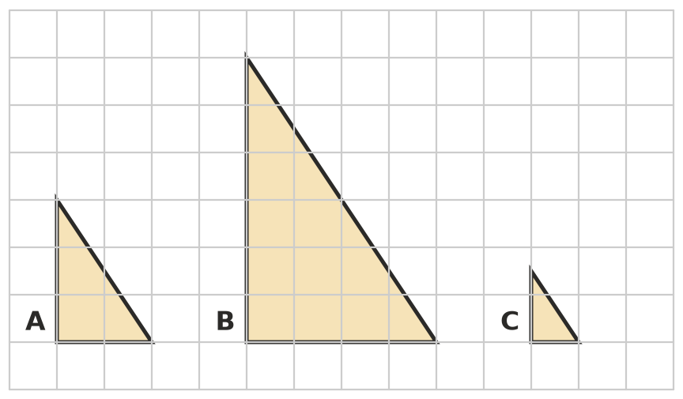
  - from A to B ______________ b) from A to C
  - from B to A ______________ d) from B to C
- A shape is enlarged with a scale factor of 2. Write Same or Changes for each feature.
Feature
the size of each angle
the length of each side
the shape
the perimeter
length ÷ width

 Fluency
- Find the scale factor from the original to the image.
  - original 4 cm, image 12 cm ______________ b) original 10 cm, image 5 cm
  - original 6 m, image 15 m ______________ d) original 8 mm, image 2 mm
- A rectangle 5 cm long and 3 cm wide is enlarged with a scale factor of 4.
  - What are the length and width of the new rectangle?
  - Find the perimeter of each rectangle. ______________ and
  - How many times bigger is the new perimeter?
- The two shapes are similar.
- 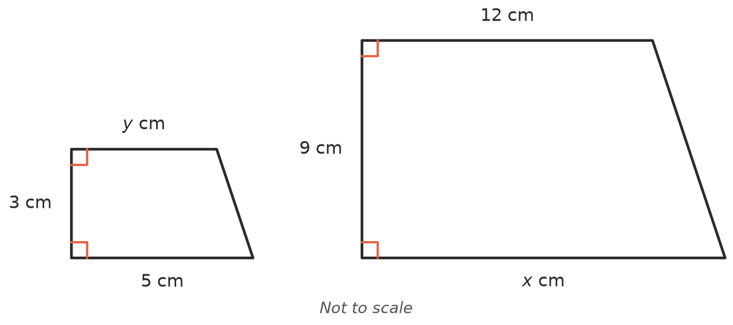
  - Find the scale factor from the small shape to the large shape.
  - Find $x$. ______________ c) Find $y$.
- Enlarge triangle ABC with a scale factor of 2, using A as the centre of enlargement. A stays where it is; make AB and AC twice as long, then join the ends. Label the new corners B′ and C′.
- 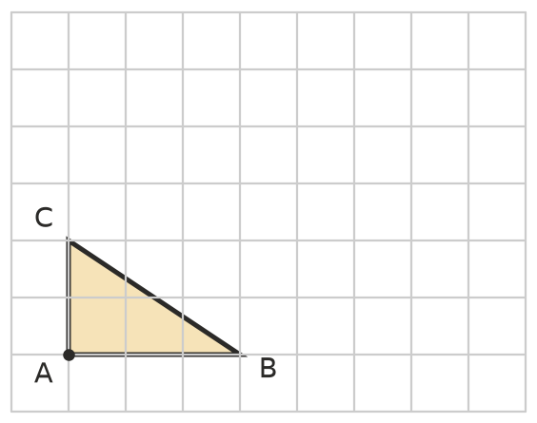

 Reasoning
- A house plan uses a scale of 1 : 100.
  - 1 cm on the plan stands for ______________ cm, which is ______________ m, in real life.
  - A bedroom is 4.5 cm long on the plan. How long is the real bedroom?
  - The real kitchen is 3.2 m wide. How wide is it on the plan?
- A model car is built at a scale of 1 : 20.
  - The model is 21 cm long. How long is the real car, in metres?
  - The real car is 1.8 m wide. How wide is the model, in centimetres?

 Problem solving
- A photo 10 cm wide and 15 cm high is enlarged to make a poster 30 cm wide. The photo keeps its shape.
  - What is the scale factor? ______________ b) How high is the poster?
- A bushwalking map has a scale of 1 : 50 000. On the map, the walk from the car park to the lookout is 6 cm long.
  - How many centimetres does 6 cm on the map stand for in real life?
  - Change your answer to kilometres. (1 km = 100 000 cm)

