Investigation: Guessing distance
Year 9 Maths · Worksheet
Name: ____________________ Date: ______________
How tall is that gum tree? How far away is the back fence? Surveyors use expensive instruments, but you can make a good estimate with a ruler, a mirror and your own thumb, because each method makes a pair of similar triangles. In this investigation you’ll try three methods outside, then judge how good each model is. You’ll need a metre ruler, a tape measure (or trundle wheel), a small flat mirror, a calculator and a partner.

Part A: The shadow method
On a sunny day, the sun’s rays hit the ground at the same angle everywhere nearby. An upright metre ruler and a tall object make two similar right-angled triangles with their shadows.
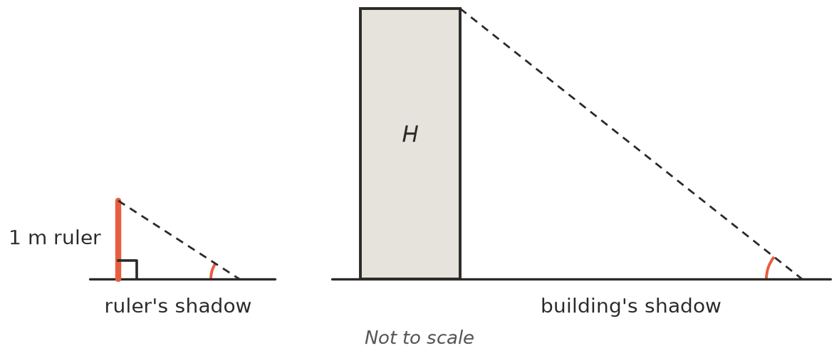
- Explain why the two triangles are similar.

- Practise first. At 10 am, a 1 m ruler casts a shadow 1.4 m long. At the same time, a building casts a shadow 16.8 m long.
  - Find the scale factor from the ruler’s triangle to the building’s triangle. ______________
  - Find the height of the building. ______________
- Now go outside. Stand the metre ruler upright and measure its shadow. Then quickly measure the shadows of three tall objects (a flagpole, a goalpost, a tree, a light pole). Work out each height.
Object | Ruler’s shadow (m) | Object’s shadow (m) | Scale factor | Estimated height (m)

Part B: The mirror method
Put a mirror flat on the ground between you and a tall object. Walk backwards until you can just see the top of the object in the middle of the mirror. Light bounces off a mirror at the same angle it arrives, so the two angles marked $a$ are equal.
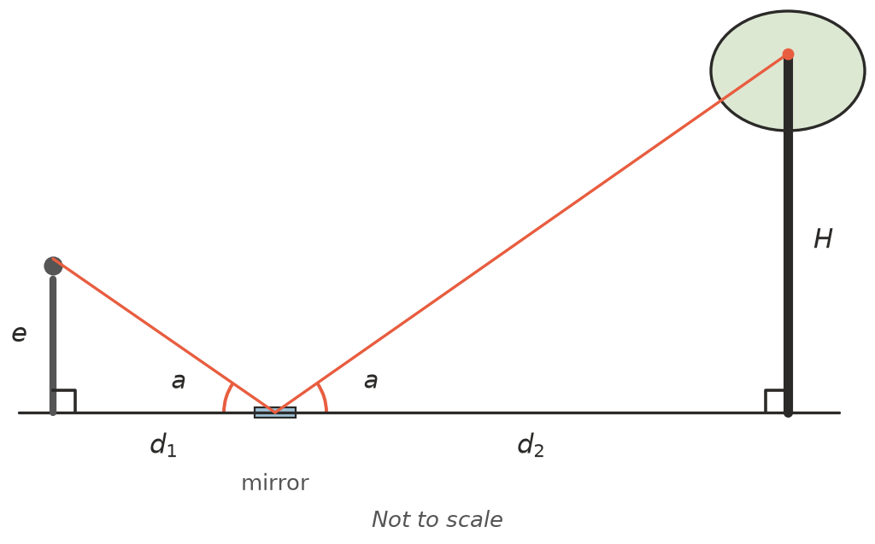

  - Explain why the two right-angled triangles are similar.

  - Show that the height of the object is $H=\frac{e×d_{2}}{d_{1}}$, where $e$ is the height of your eyes.

- Practise first.
  - Ella’s eyes are 1.5 m above the ground. She sees the top of a tree in the mirror when she is 2 m from the mirror and the mirror is 18 m from the tree. How tall is the tree? ______________
  - A goalpost is 9 m tall. Tom’s eyes are 1.6 m above the ground, and he stands 1.2 m from the mirror. How far from the goalpost should the mirror be? ______________
- Now go outside with a partner. Your partner measures the distances while you look. Find the heights of two objects. If you can, use an object from Part A so you can compare the methods.
Object | Eye height $e$ (m) | You to mirror $d_{1}$ (m) | Mirror to object $d_{2}$ (m) | Estimated height $H$ (m)

Part C: The thumb jump
Hold your arm straight out with your thumb up. Close your left eye and line your thumb up with something far away. Now swap eyes: your thumb seems to jump sideways. The picture shows this from above.
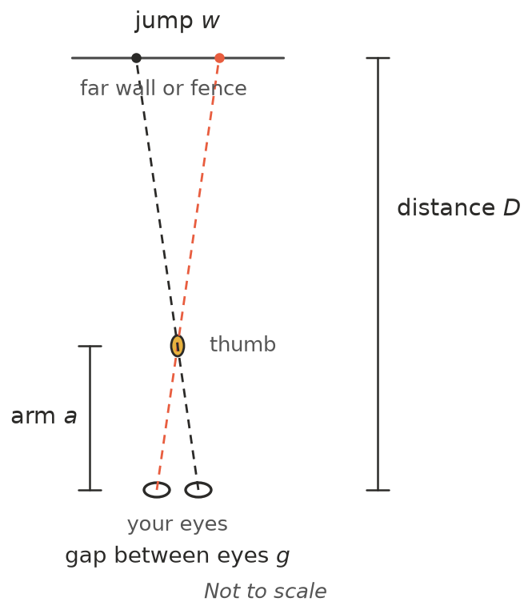
- Measure your own arm and eyes.
  - Your arm length $a$: from your eye to your thumb (cm). ______________
  - The gap between the centres of your eyes $g$ (cm). (Ask your partner to measure, looking straight ahead.) ______________
  - Work out $a$ ÷ $g$. For most people it is close to 10. ______________
- The two thin triangles in the picture meet at your thumb. Use them to explain why the distance to the far object is about $D=\frac{a}{g}×w$.

- Practise first. Kai’s arm is 60 cm long and his eyes are 6 cm apart. When he does the thumb jump at a car park, his thumb seems to jump the length of 2 cars, about 9 m in total. About how far away are the cars? ______________
- Now use the thumb jump to estimate the distance to three things. Choose things whose width you can guess, such as a car (about 4.5 m), a door (about 1 m) or a soccer goal (about 7 m). Then check each distance by pacing it out or using a trundle wheel.
Object | Width of the jump $w$ (m) | Estimated distance (m) | Measured distance (m)

Part D: How good are the models?
- Choose your best result from Part A, B or C where you know (or can measure) the true value. Find the percentage error: (difference ÷ true value) × 100.

- Every model makes assumptions. List one assumption or source of error for each method.
  - Shadow method: ______________
  - Mirror method: ______________
  - Thumb jump: ______________
- Which method would you use in each situation? Give a reason.
  - A cloudy day, to find the height of the school hall. ______________
  - The height of a tall tree in an open paddock on a sunny day. ______________
  - The distance across a river to a boat shed. ______________
- Write a short report (three or four sentences) for a classmate who missed the lesson: which method was most accurate for you, which was quickest, and how you could make your best method more accurate.

