7.01 Similar right-angled triangles
Year 9 Maths · Worksheet · Level 2 · Core
Name: ____________________ Date: ______________
This worksheet practises proving that right-angled triangles are similar, naming the hypotenuse, opposite and adjacent sides, finding missing sides, and noticing that side ratios stay the same for a given angle. Tip: when the triangles face different ways, match the sides by where they sit: the hypotenuse is opposite the right angle, and the other two sides are named from the marked angle.

 Understanding
- Explain why two right-angled triangles are similar if just one pair of acute angles is equal.

- Are the two right-angled triangles similar? Write Yes or No, and give a reason.
  - ______________
- 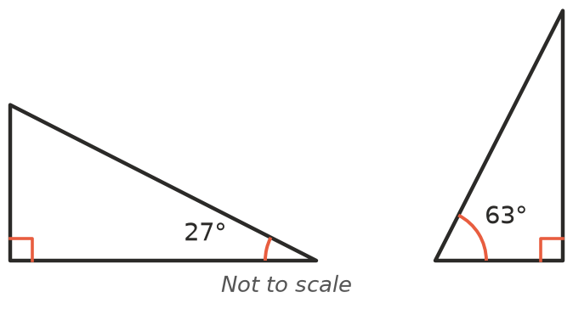
  - ______________
- 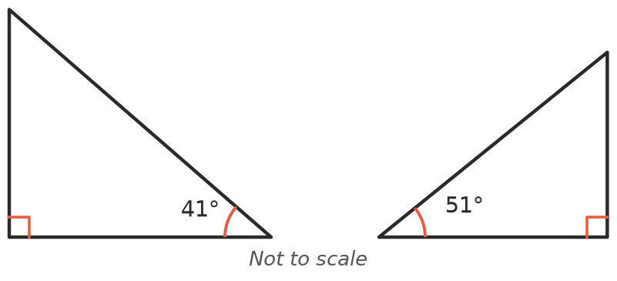
  - ______________
- 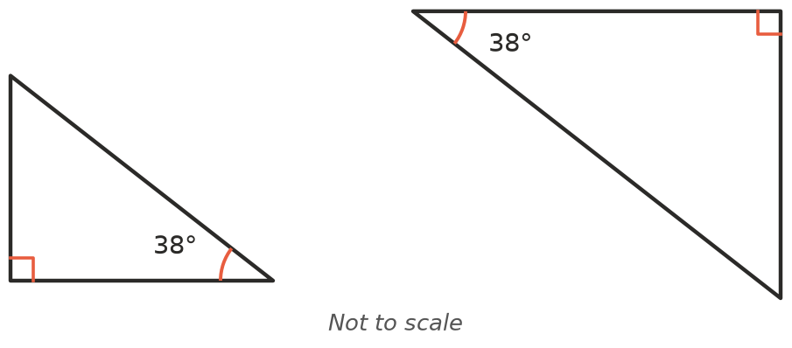
- Name the hypotenuse, the side opposite θ and the side adjacent to θ in each triangle.
- 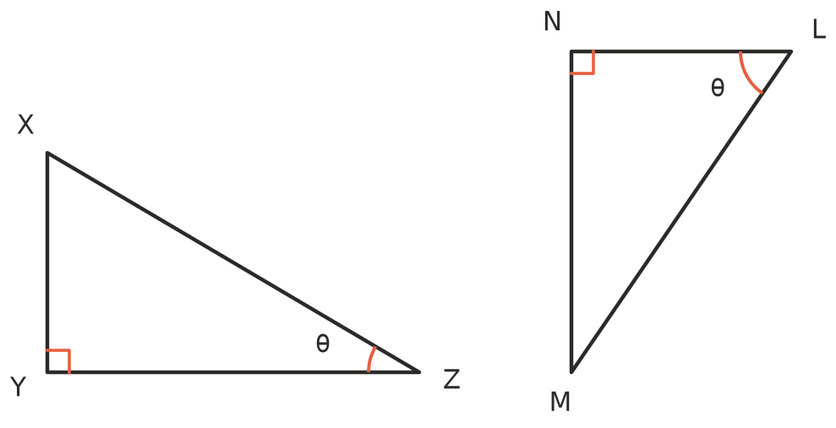
  - △XYZ: hypotenuse ______________ opposite ______________ adjacent ______________
  - △LMN: hypotenuse ______________ opposite ______________ adjacent ______________

 Fluency
- △ABC is similar to △DEF. The matching angles are marked.
- 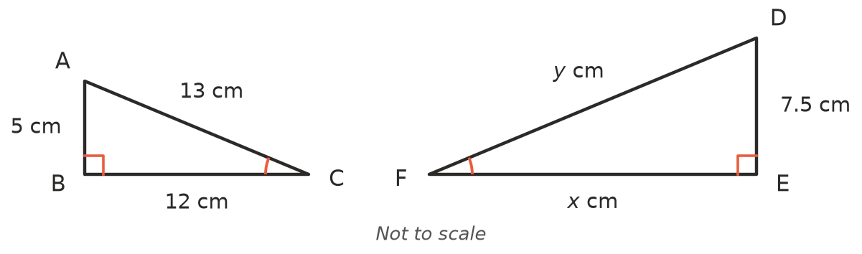
  - Which side of △DEF matches AB? ______________ b) Find the scale factor from △ABC to △DEF. ______________
  - Find $x$. ______________ d) Find $y$. ______________
- In the diagram, DE is at right angles to AC, and BC is at right angles to AC.
- 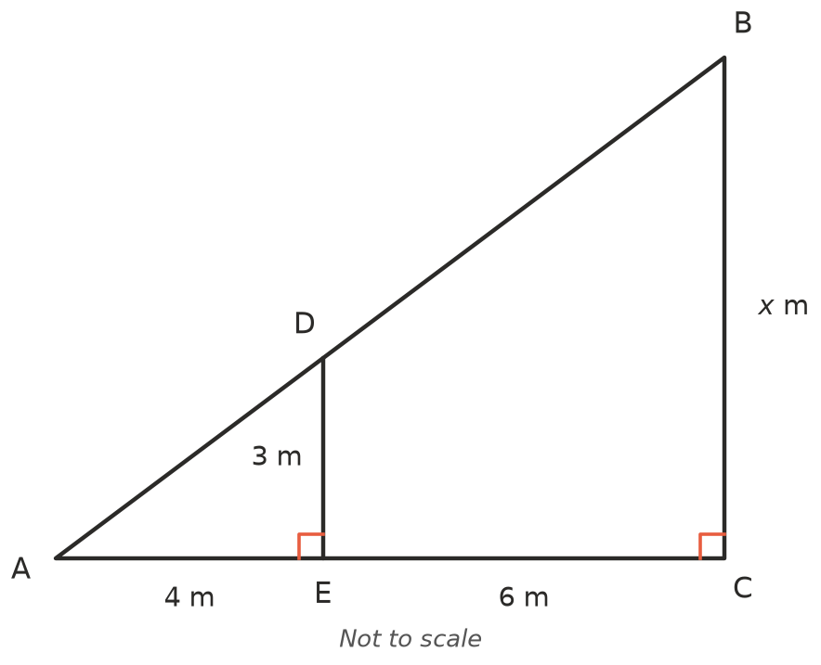
  - Explain why △AED is similar to △ACB.

  - Find the scale factor from △AED to △ACB. ______________
  - Find $x$. ______________ d) Use Pythagoras’ theorem to find AD. ______________
  - Use the scale factor to find AB. ______________
- △PQR and △STU are right-angled at Q and U. Angle P matches angle T (marked).
- 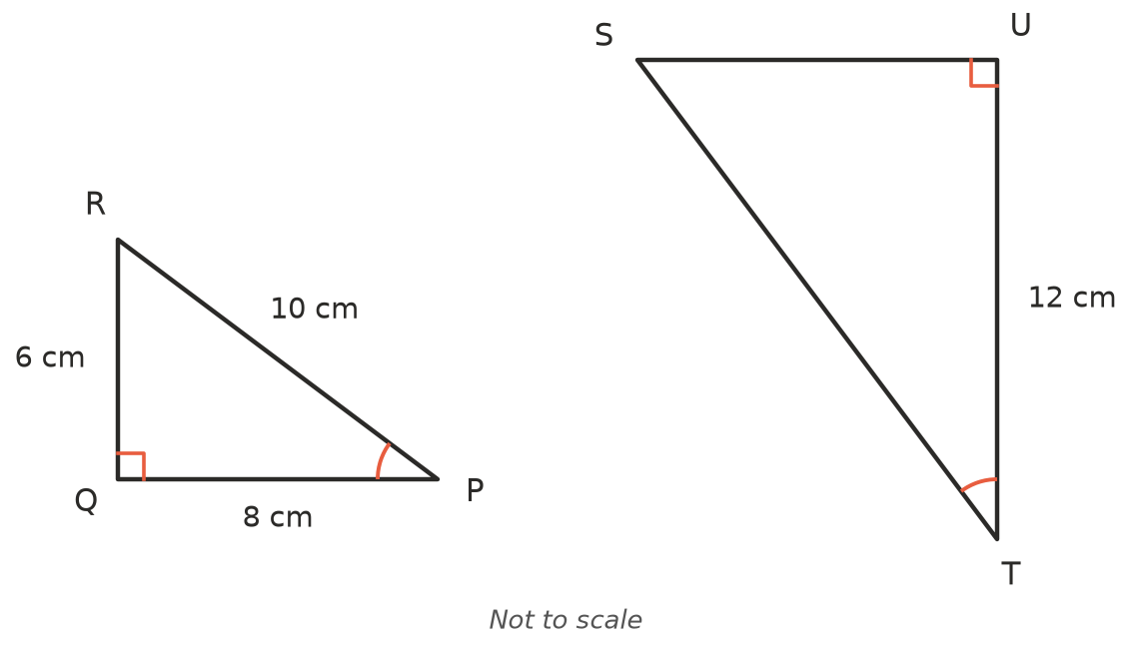
  - Which side of △STU matches PR? ______________ b) Which side of △STU matches QR? ______________
  - Find the scale factor from △PQR to △STU. ______________
  - Find SU. ______________ e) Find ST. ______________
- △KLM is similar to △XYZ, with the vertices in matching order, and both have their right angle at the middle letter (L and Y). KL = 2.4 cm, LM = 3.2 cm, KM = 4 cm and XZ = 10 cm. Find XY and YZ.

 Reasoning
- The three triangles below all have the same angle θ.
- 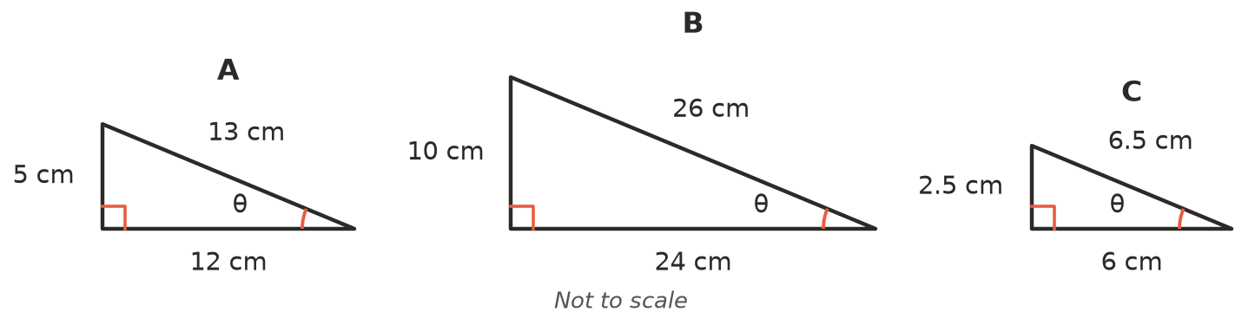
  - Complete the table. Write each ratio as a fraction in simplest form.
Triangle | Opposite ÷ hypotenuse | Adjacent ÷ hypotenuse | Opposite ÷ adjacent
A
B
C

  - Explain why every right-angled triangle with angle θ gives the same three ratios.

- Write True or False, and give a reason or an example.
  - Any two right-angled triangles are similar. ______________
  - Any two right-angled isosceles triangles are similar. ______________
  - Two right-angled triangles with hypotenuses of 10 cm and 20 cm must be similar. ______________
  - A right-angled triangle with shorter sides 3 cm and 4 cm is similar to one with shorter sides 6 cm and 8 cm. ______________
- In a right-angled triangle with angle θ, the side opposite θ divided by the hypotenuse is 0.6. A second right-angled triangle has the same angle θ and a hypotenuse of 35 cm.
  - Find the side opposite θ in the second triangle. ______________
  - Use Pythagoras’ theorem to find the side adjacent to θ. ______________
  - Find adjacent ÷ hypotenuse for the second triangle. Will it be the same for every triangle with angle θ? ______________

 Problem solving
- At 3 pm, a student 1.6 m tall casts a shadow 2 m long. At the same time, the school flagpole casts a shadow 9.5 m long. Draw a sketch, then find the height of the flagpole.

- To find the width $w$ of a river, Ruby uses a tree T on the far bank. She stands at A, directly opposite the tree. She walks 40 m along the bank to O and puts in a stick, then walks another 10 m to B. From B she walks 6 m away from the river, at right angles to the bank, until she reaches D, where the stick at O lines up exactly with the tree.
- 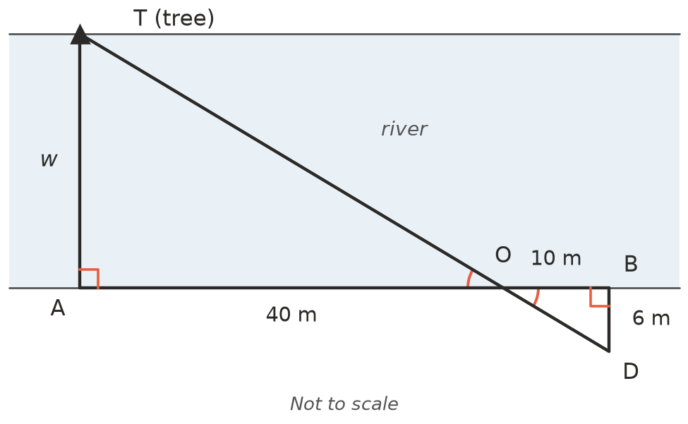
  - Explain why △TAO is similar to △DBO.

  - Find the width of the river, $w$. ______________
- A wheelchair ramp rises 0.75 m over a horizontal distance of 9 m. Vertical support posts hold up the ramp.
  - How tall is the post that stands 3.6 m (horizontally) from the low end of the ramp? ______________
  - Another post is 0.5 m tall. How far from the low end of the ramp does it stand? ______________

