7.01 Similar right-angled triangles
Year 9 Maths · Worksheet · Level 1 · Warm-up
Name: ____________________ Date: ______________
This worksheet practises spotting similar right-angled triangles, matching their sides, and using a scale factor to find missing lengths. Tip: two right-angled triangles are similar as soon as one pair of acute angles is equal, because the right angles already match.

 Understanding
- Complete each sentence.
  - The three angles in any triangle add to ______________ °
  - A right-angled triangle has an angle of 35°. Its third angle is ______________ °
  - The longest side of a right-angled triangle is opposite the right angle. It is called the ______________
  - Similar triangles have the same shape. Their matching angles are ______________ and their matching sides are in the same ______________
- Find the missing acute angle in each right-angled triangle. Then decide which two triangles are similar.
- 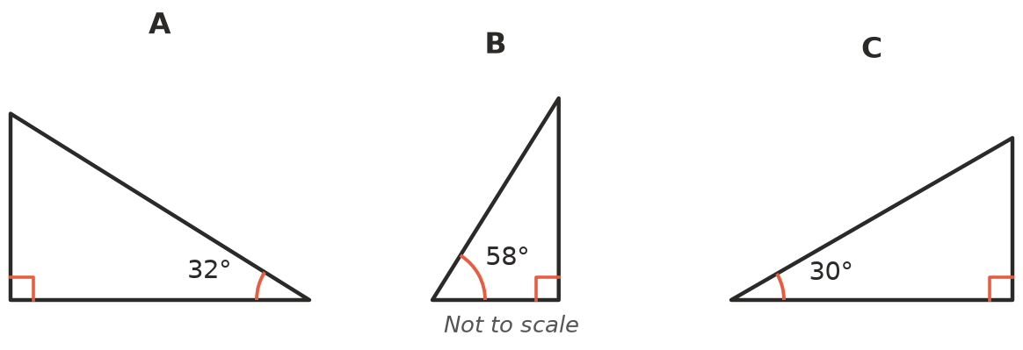
  - Triangle A: the other acute angle is ______________ °
  - Triangle B: the other acute angle is ______________ °
  - Triangle C: the other acute angle is ______________ °
  - Which two triangles are similar? ______________
- In a right-angled triangle, the sides are named from a marked angle θ. The hypotenuse is opposite the right angle, the opposite side is across from θ, and the adjacent side is next to θ (but is not the hypotenuse).
- 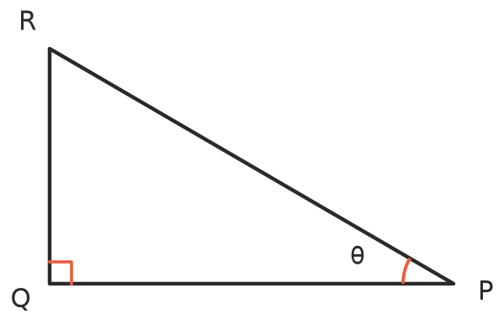
  - The hypotenuse is ______________ b) The side opposite θ is ______________ c) The side adjacent to θ is ______________

 Fluency
- The two right-angled triangles are similar. The matching angles are marked.
- 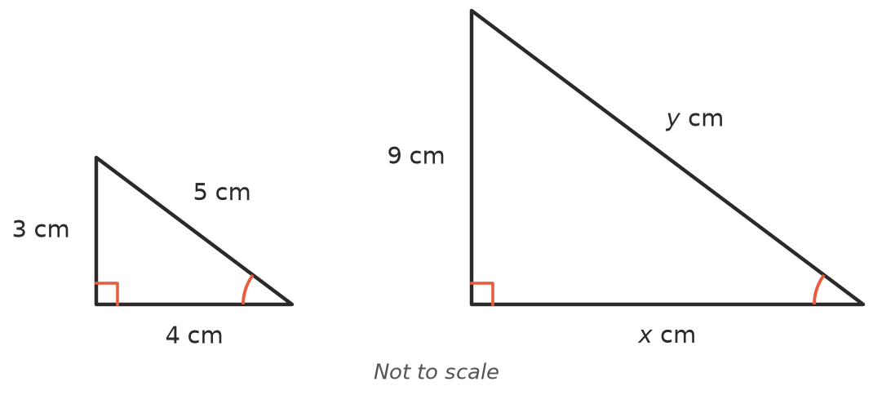
  - Find the scale factor from the small triangle to the large triangle. ______________
  - Find $x$. ______________ c) Find $y$. ______________
- The two right-angled triangles are similar.
- 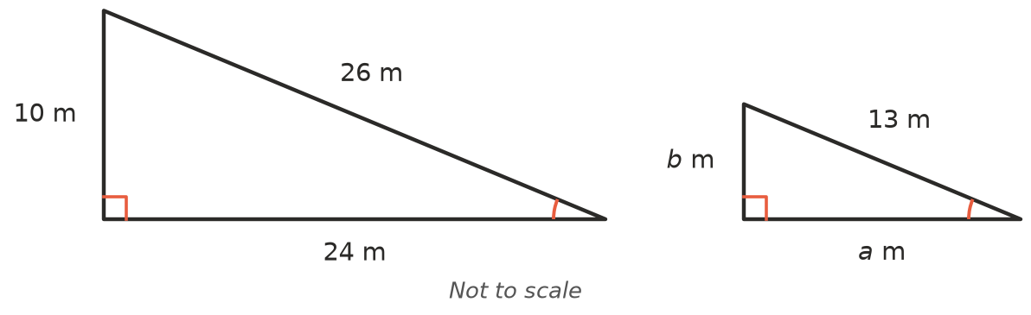
  - The hypotenuse goes from 26 m to 13 m. Find the scale factor from the large triangle to the small triangle. ______________
  - Find $a$. ______________ c) Find $b$. ______________
- △ABC and △PQR are similar right-angled triangles. Angle A matches angle Q (marked), and the right angles are at B and R.
- 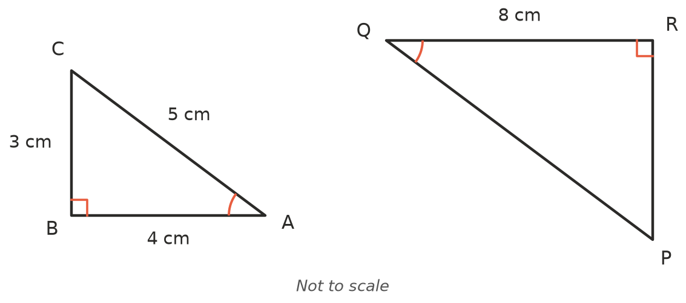
  - Which side of △PQR matches AB? (Hint: both sides join the marked angle to the right angle.) ______________
  - Which side of △PQR matches BC? ______________ c) Which side matches AC? ______________
  - Find the scale factor from △ABC to △PQR. ______________
  - Find PR. ______________ f) Find PQ. ______________

 Reasoning
- The three right-angled triangles all have the same angle θ.
- 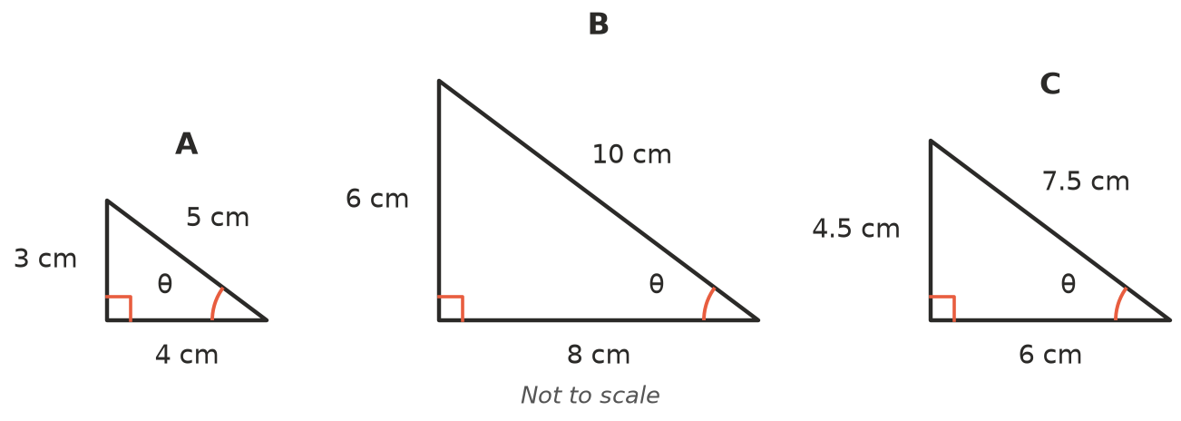
- Complete the table. Write each ratio as a decimal.
Triangle | Opposite θ | Adjacent to θ | Hypotenuse | Opposite ÷ hypotenuse | Opposite ÷ adjacent
A | 3 cm | 4 cm | 5 cm
B
C

- Look at your table in Question 7. What do you notice about the ratios? Why does this happen?

- Mia says: “Any two right-angled triangles that both have an angle of 50° must be similar.” Is she right? Explain.

 Problem solving
- At the same time of day, a post 2 m tall casts a shadow 3 m long, and a flagpole casts a shadow 12 m long. The sun’s rays make the same angle with the ground at both, so the two triangles are similar.
- 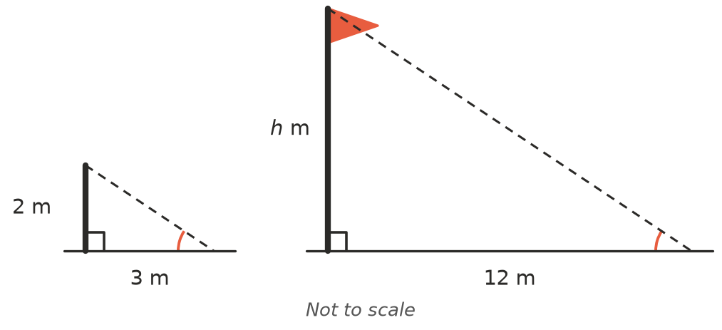
  - Find the scale factor from the post’s triangle to the flagpole’s triangle. ______________
  - Find the height of the flagpole, $h$. ______________
- A ramp rises 0.5 m over a horizontal distance of 4 m. A longer ramp is built at exactly the same angle and covers a horizontal distance of 12 m. How high does the longer ramp rise?

- Two ladders lean against a wall at the same angle. The first ladder reaches 3 m up the wall and its foot is 1 m from the wall. The second ladder reaches 4.5 m up the wall. How far is the foot of the second ladder from the wall?

