7.01 Similar right-angled triangles
Year 9 Maths · A5 question sheet · Level 3 · Challenge
This worksheet practises proving that right-angled triangles are similar, using the constant side ratios for a given angle, and solving problems with overlapping triangles, shadows and algebra. Tip: when triangles overlap or share a side, redraw them separately, the same way round, and label the matching angles before you write any ratios.

 Understanding
- In △ABC, the angle at A is a right angle and AD is at right angles to BC.
- 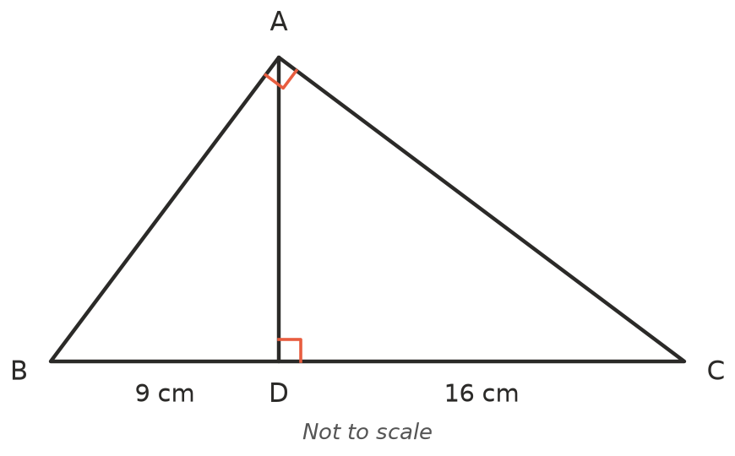
  - Let ∠B = $x$°. Write ∠BAD, ∠C and ∠DAC in terms of $x$.
  - Explain why △DBA, △DAC and △ABC are all similar to each other.
  - Use the similar triangles △DBA and △DAC to find AD.
  - Find AB and AC.
- In a right-angled triangle with angle θ, the ratio of the side opposite θ to the side adjacent to θ is $\frac{7}{24}$. A second right-angled triangle has the same angle θ and a hypotenuse of 75 cm.
  - Find the hypotenuse of a triangle with opposite side 7 and adjacent side 24.
  - Find the side opposite θ and the side adjacent to θ in the second triangle.
  - Write opposite ÷ hypotenuse for angle θ as a fraction and as a decimal.

 Fluency
- Two similar right-angled triangles have their shorter sides in matching order. The small triangle’s shorter sides are 4 cm and 6 cm. The large triangle’s shorter sides are $x$ cm and ($x$ + 5) cm. Find $x$, and the scale factor.
- A ladder rests on the top of a fence and reaches a wall behind it. The fence and the wall are vertical and the ground is level.
- 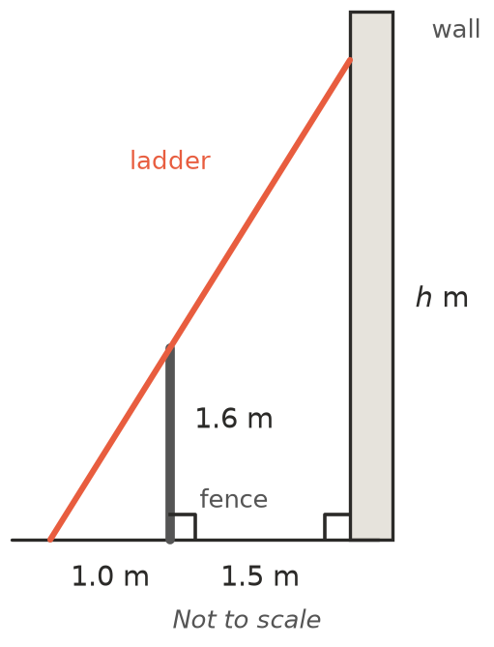
  - Find $h$, the height where the ladder touches the wall.
  - Find the length of the ladder, correct to the nearest centimetre.
- The red line passes through O(0, 0), A(4, 3) and B(8, 6). Dashed lines drop from A and B to the $x$-axis.
- 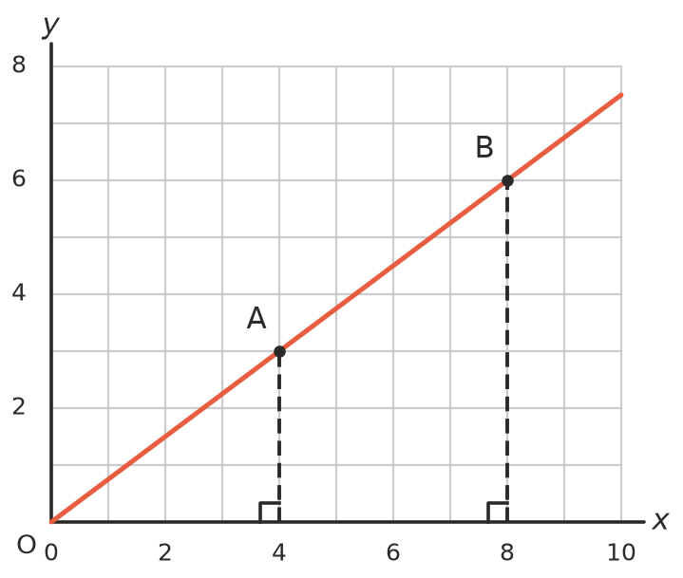
  - Explain why the two right-angled triangles under the line are similar.
  - Use similar triangles to find the $y$-value on the line when $x$ = 14.
  - Find the $x$-value on the line when $y$ = 12.
  - What do the similar triangles tell you about the gradient of a straight line?
- A girl 1.8 m tall stands 7 m from a street light that is 6 m tall. The light makes her shadow.
- 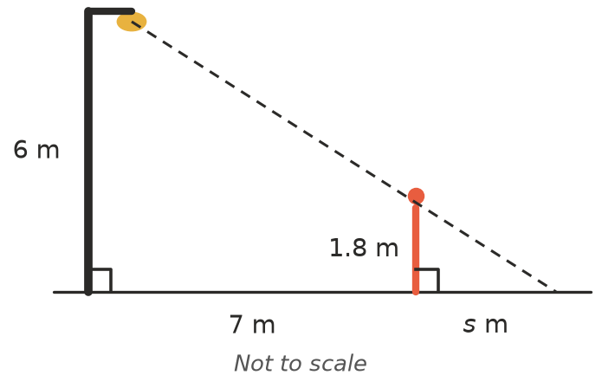
  - Find the length $s$ of her shadow.
  - How far from the street light must she stand for her shadow to be 4.5 m long?

 Reasoning
- Use side ratios to decide which of these right-angled triangles are similar. Show your working.
- Triangle P: 6 cm, 8 cm, 10 cm Triangle Q: 9 cm, 12 cm, 15 cm Triangle R: 5 cm, 12 cm, 13 cm
- Ali says: “If I draw a bigger right-angled triangle with the same angle θ, the side opposite θ divided by the hypotenuse will be bigger, because the sides are longer.” Explain what is wrong with Ali’s thinking.
- An equilateral triangle with sides of 2 units is cut in half by its height.
  - What are the angles in each half?
  - Explain why, in every right-angled triangle with a 30° angle, the side opposite the 30° angle is half the hypotenuse.
  - A right-angled triangle has a 30° angle and a hypotenuse of 14 cm. Find the side opposite the 30° angle, and the third side correct to 2 decimal places.

 Problem solving
- A straight cable runs from the top of a 24 m tower to an anchor in the ground 32 m from the base of the tower.
  - Find the length of the cable.
  - A vertical post 1.5 m tall is placed under the cable so that it just touches it. How far is the post from the anchor?
  - A bird sits on the cable 9 m above the ground. How far along the cable is it from the anchor?
- Jack holds a ruler upright at arm’s length, 60 cm from his eye. A building 50 m away is exactly covered by 24 cm of the ruler. The ruler and the building are both vertical. Draw a sketch and find the height of the building.
- Look again at the triangle in Question 1, where AD is at right angles to BC.
  - Use △DBA and △DAC to show that $AD^{2}$ = BD × DC.
  - If BD = 4 cm and DC = 25 cm, find AD.
  - If AD = 6 cm and BD = 4 cm, find DC.

