Real numbers: Practice test 2
Year 9 Maths · Test · Test 2
Name: ____________________ Date: ______________
Time: 45 minutes
Total: 40 marks
Show your working in the boxes. Then write each final answer on the answer sheet on the last page.

 Section A: No calculator
- Is each number rational or irrational? Give a reason for each.
  - $\sqrt{0.25}$ (1 mark)

  - $\frac{π}{2}$ (1 mark)

  - $(\sqrt{7})^{2}$ (1 mark)

- Answer each of these.
  - Between which two consecutive whole numbers does $\sqrt{130}$ lie? (1 mark)

  - Without a calculator, find $\sqrt{40}$ correct to 1 decimal place. Show how you decided. (2 marks)

- Answer each of these.
  - Write $\frac{5}{11}$ as a decimal. Use dot notation for the recurring digits. (1 mark)

  - Write $0.\dot{1}\dot{2}$ as a fraction in simplest form. (1 mark)

  - Write $2.1\dot{5}$ as an improper fraction in simplest form. Show your working. (2 marks)

- Evaluate each of these.
  - 7 + (−12) − (−3) − 10 (1 mark)

  - (−3) × (−4) × (−5) ÷ 6 (1 mark)

  - $(−1)^{101}+(−1)^{100}$ (1 mark)

  - 64 ÷ $(−2)^{3}$ − (−5) (1 mark)

- Evaluate −2 × [15 − (−3)] ÷ (−9 + 3). Show each step. (2 marks)

- Evaluate each of these. Write your answers as fractions in simplest form.
  - $−\frac{3}{4}+\frac{5}{6}$ (1 mark)

  - $−\frac{2}{3}×\left(−\frac{9}{10}\right)$ (1 mark)

- A submarine is at −180 m (180 m below sea level). It rises 35 m each minute for 4 minutes, then dives 20 m each minute for 3 minutes. What is its position now? (2 marks)

- Jo says that $−3^{2}$ = 9. Explain Jo’s mistake and give the correct value. (2 marks)

- Let x = $0.\dot{9}$ = 0.999… Use the method for changing recurring decimals to fractions to show that x = 1. (2 marks)

- In this magic square, every row, every column and both diagonals add to −3. Find the missing numbers. (2 marks)
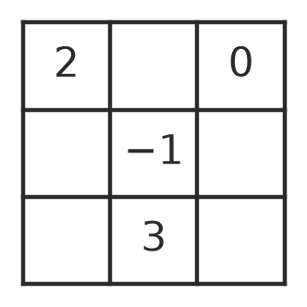

- This spiral is made of right-angled triangles. The outside edge of each triangle is 1 unit long.
- 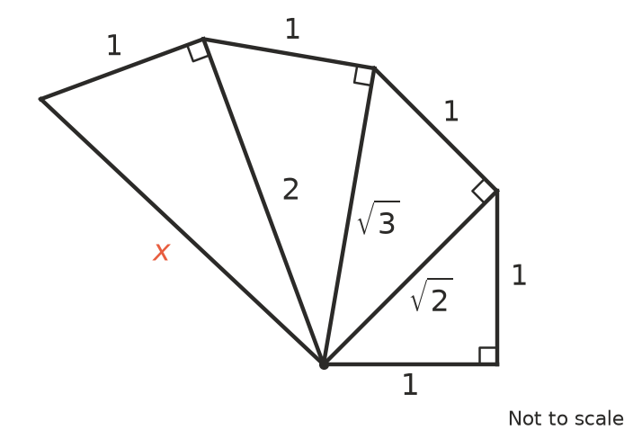
  - Find the exact value of x. (1 mark)

  - The spiral keeps going in the same way. Which triangle (counting from the first, smallest triangle) is the next one after the third triangle to have a whole-number hypotenuse? (1 mark)

 Section B: Calculator allowed
- Use your calculator to evaluate each of these.
  - $\frac{3+\sqrt{19}}{4}$, correct to 3 decimal places (1 mark)

  - $(−1.6)^{3}$ + 2.5 (1 mark)

- A circular pond has a circumference of 18 m.
  - Find the diameter of the pond, correct to 2 decimal places. (1 mark)

  - Is the exact diameter rational or irrational? Explain. (1 mark)

  - Find the area of the pond, correct to 1 decimal place. (1 mark)

- A share in a company is worth $4.85 on Monday morning. Over the week the value changes by −$0.37, +$0.12, −$0.58 and +$0.21.
  - What is the value of one share at the end of the week? (1 mark)

  - Zoe owns 350 shares. By how much did the total value of her shares change over the week? Write your answer as a positive or negative amount. (2 marks)

- A wheelchair ramp rises 0.6 m over a horizontal distance of 4.2 m.
  - Find the exact length of the sloping surface of the ramp, as a square root. (1 mark)

  - Find the length of the ramp, correct to 2 decimal places. (1 mark)

- How many integers lie between $−\sqrt{50}$ and $\sqrt{120}$? Show how you worked it out. (2 marks)

 Answer sheet
Name: ____________________
Write your final answer for each question in the table.
Question | Answer | Marks | Question | Answer | Marks
1a |  | /1 | 8 |  | /2
1b |  | /1 | 9 |  | /2
1c |  | /1 | 10 |  | /2
2a |  | /1 | 11a |  | /1
2b |  | /2 | 11b |  | /1
3a |  | /1 | 12a |  | /1
3b |  | /1 | 12b |  | /1
3c |  | /2 | 13a |  | /1
4a |  | /1 | 13b |  | /1
4b |  | /1 | 13c |  | /1
4c |  | /1 | 14a |  | /1
4d |  | /1 | 14b |  | /2
5 |  | /2 | 15a |  | /1
6a |  | /1 | 15b |  | /1
6b |  | /1 | 16 |  | /2
7 |  | /2
 |  |  |  | Total | /40

